Navigating Moodle

Dashboard
Once you log in, the Moodle Dashboard will be displayed. Courses that you are enrolled in will appear in the Course Overview section of the dashboard.
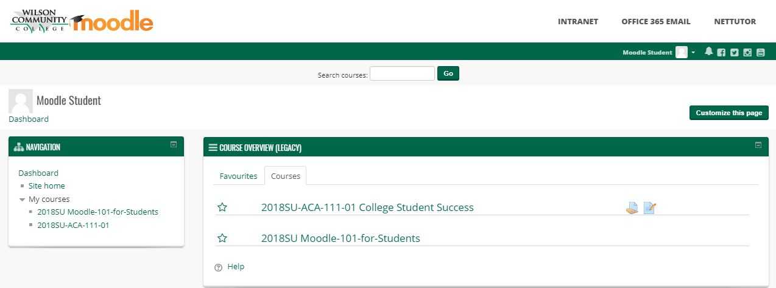

Accessing Courses
To enter a course, click on the link for that course.
This will take you to the course homepage.
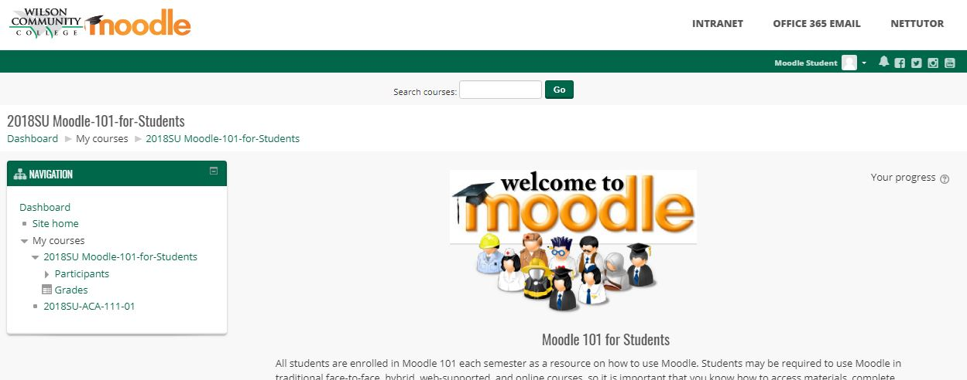

Breadcrumb Trail
Once you are in your Moodle course, you can use the breadcrumb trail to navigate within your course. Clicking any of the links in the breadcrumb trail will take you to that location in the course. The breadcrumb trail can be found beneath the course name.
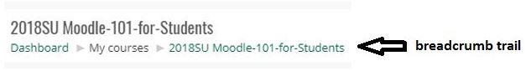

Returning to the Dashboard or Site Home
To get back the Dashboard to see your course listings, or to get to the Site Home page, click the Dashboard or Site Home links in the Navigation block.
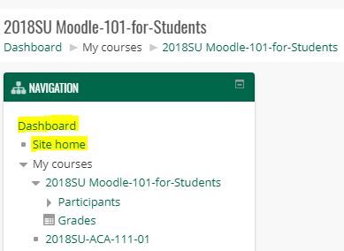

Site Home
The Site Home page has a lot of useful resources to assist students. Explore all of the resources to become familiar with what is available.
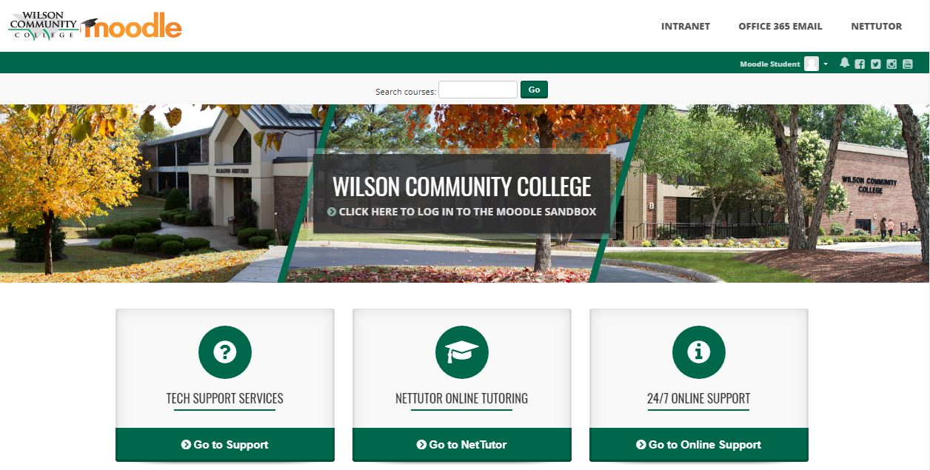

User Menu
The User Menu provides quick access to the most commonly used features of Moodle. Access the User Menu by clicking on the down arrow next to your name in the banner at the top of the page.
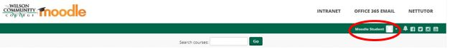
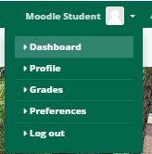
Dashboard takes you back to your Moodle Dashboard.
Profile allows you to view and edit your Moodle Profile.
Grades allows you quick access to the gradebook for each course you are currently enrolled in.
Preferences allows you to view and edit various Moodle settings.
Log out, logs you out of Moodle.

Navigating a Moodle Course
Most of your courses in Moodle will have a similar look and feel. On the main page of your course, you will find the name and section of your course, a Course Description, Learning Outcomes, and a Welcome Message from your instructor.
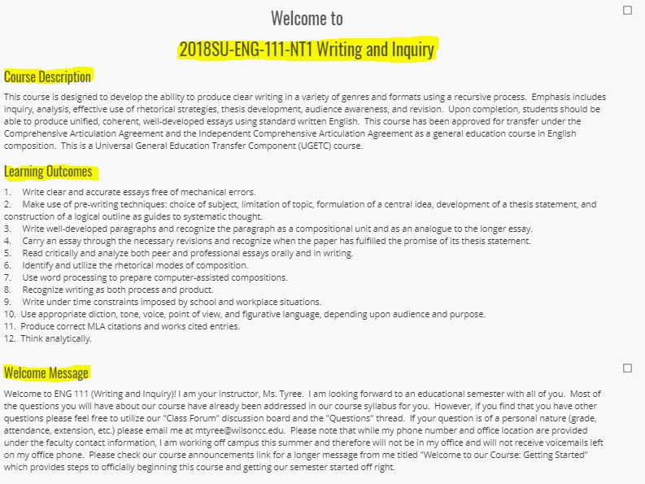
Below these items, there will be links to important information you will need to review at the beginning of your course.
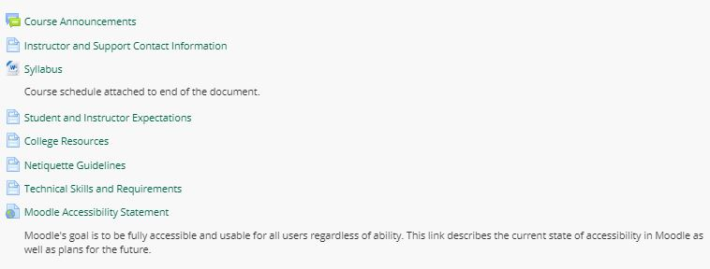
Each course will be organized into sections, either by week, topic, module, or chapter.
To open a section, click on the section heading.
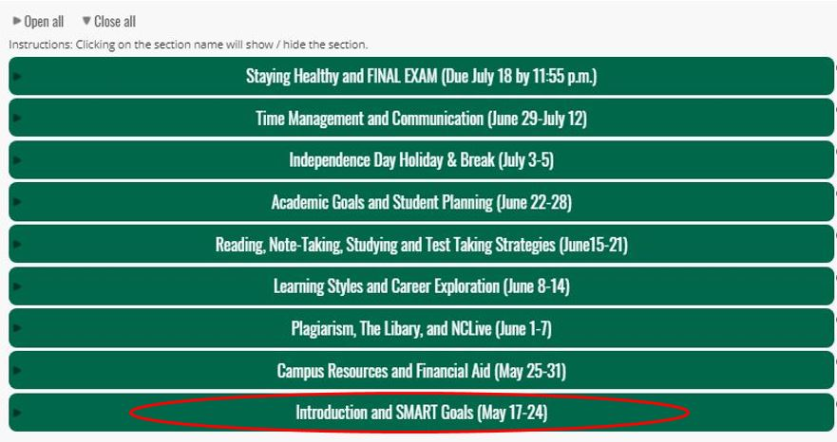

In the section, you will find lesson materials and resources, as well as activities and assignments.
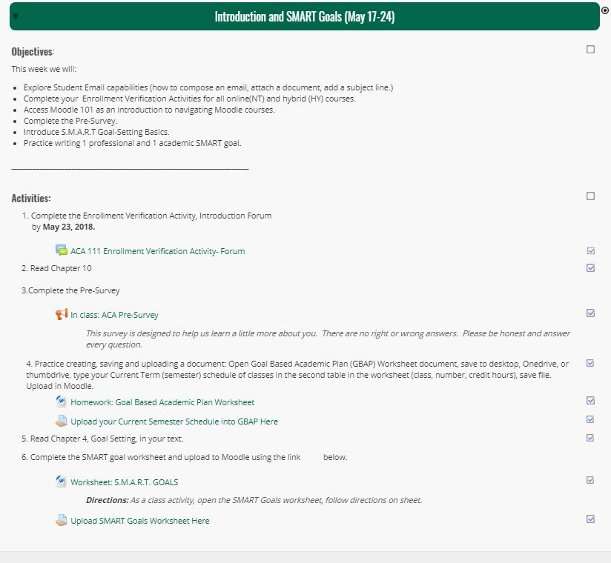
To close a section, just click on the arrow on the left side of the section heading.
