Student Planning
Quick Start Guide
The following topics are covered:
- How to access Student Planning
- Plan and schedule courses
- Register for classes
- Print your registration statement and schedule
- View your Financial Aid Information

How to Access Student Planning
Access Student Planning on the college website at www.wilsoncc.edu.
Select the Student Planning link at the top of the homepage.
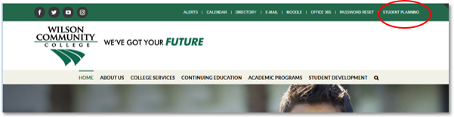
Log in using your username and password.
Username – first name initial, last name initial, last four digits of WCC Student ID number.
Example: jd3456

Plan and Schedule Courses
Select the STUDENT PLANNING box to search for classes, plan your semester schedule, register, and to track your progress towards graduation.
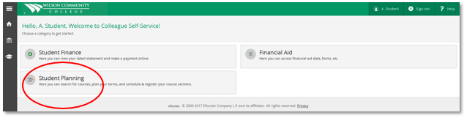
Select box 2 to view your complete schedule, add classes, and register.
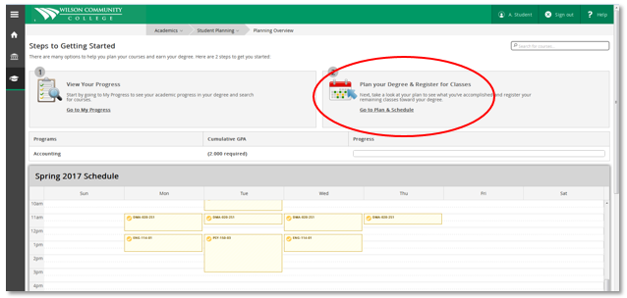
Use the search bar located at the top right of any screen to search for a specific class.
EX: ENG 111
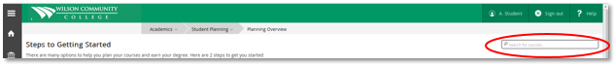

From the list of results, choose the section you want to add to your schedule by selecting ADD SECTION to SECHEDULE.
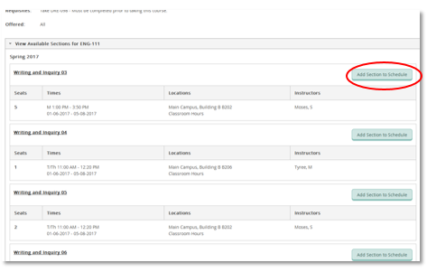
Seated courses are listed first with a section number (01) after the course abbreviation.
Hybrid courses are listed next with an HY.
Online or net courses are listed with a NT.
Web Based courses are listed with a WB.
To view the class or classes you added to your schedule select STUDENT PLANNING, then PLAN & SCHEDULE from the drop down menu.

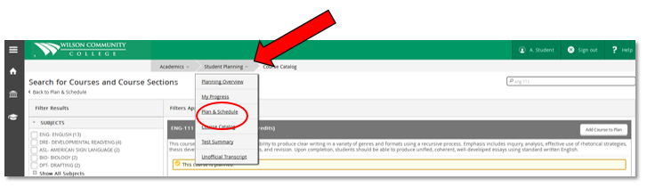
Use the arrow buttons to toggle between semesters.
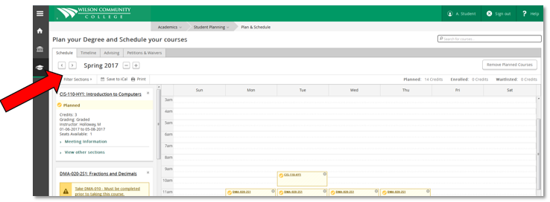

Register for classes

To register click REGISTER NOW (after you have met with your advisor and only during registration periods).

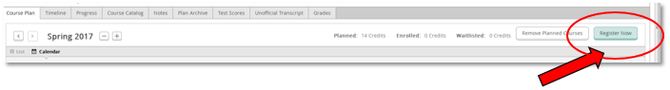

Classes that you have successfully registered for will appear in GREEN. Planned courses that you are NOT registered for will appear in YELLOW.
View and print your registration statement and schedule.
Select the HOME button at any time to take you to the main menu.
Next, select the student finance box to view and print your schedule and tuition statement.
(You will only be able to view and print if you are registered for classes)
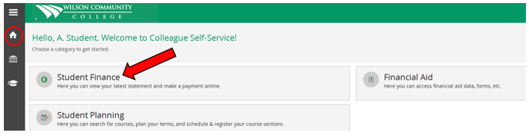
Select Account Activity, from this screen you will be able to view/print your statement.
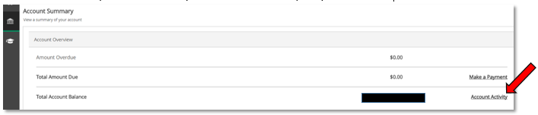
View your Financial Aid Information
Select the Home button to return to the main menu. Select the Financial Aid box.
From here you can manage your financial aid information and accept your award letter.
