Viewing Grades in Moodle

Viewing Grades from the Moodle Dashboard
You can view your current average in all of your courses from the Moodle Dashboard.
Access the User Menu by clicking on the down arrow next to your name in the banner at the top of the page, select Grades.
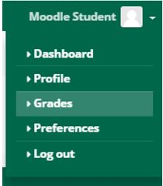
Each course you are currently enrolled in will be listed, along with your current average.

Viewing Grades Within a Course
To view all of your grades in a particular course, access the course and click Grades in the Navigation block.
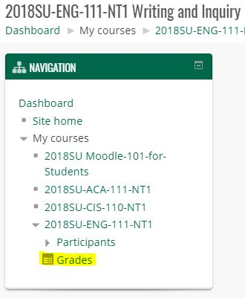
Your grades will look similar to the following image.
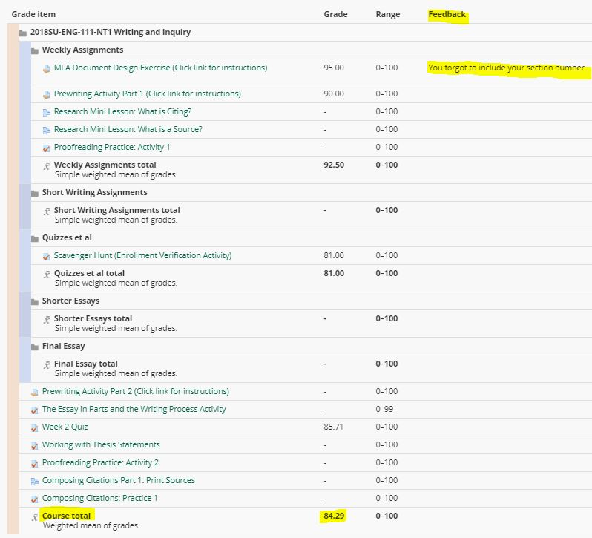
If your instructor has provided feedback, you will find it in the Feedback column.
The Course total is your current average in the course. Note that until the instructor finalizes grades at the end of the semester, the course total is simply an estimation of where you currently stand in the course.
Final grades are available in WebAdvisor and Student Planning at the end of the semester.

