CCP APPLICATION OPTIONS

Option 1: Traditional
- Open the document, type content in all fields (boxes).
- Once complete, print document, then the student and parent should sign and date at the bottom.
- Take a picture or send a scanned, completed application to Trish Holsten, secondary partnership director at WCC: pholsten@wilsoncc.edu; or fax to 252-246-1444.

Option 2: Digital Signature
- To access the application and sign with a digital signature, you will need Adobe Acrobat Reader DC. If you do not have Adobe Reader on your personal computer, download it for free from the Adobe download site (get.adobe.com/reader/)

Be sure to uncheck the boxes for the McAffee Security products so that this does not download onto your computer.
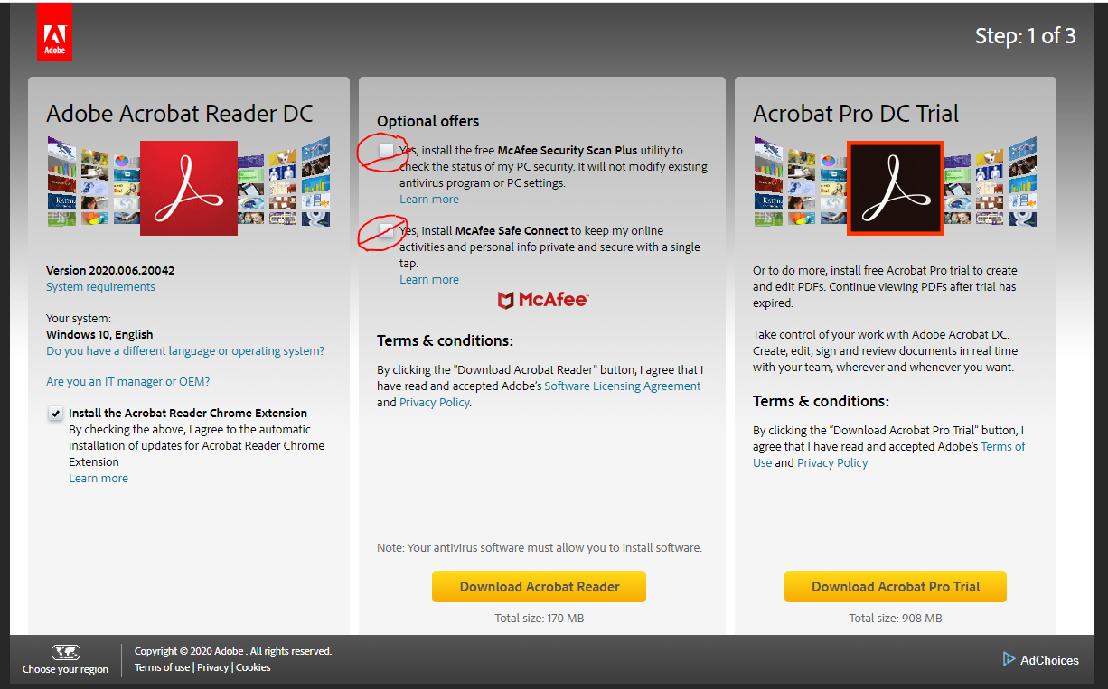
- First, download and save the document to your computer, a digital signature will not work in an internet browser preview. Then, navigate to where you saved the document and right click to “open with,” and choose Adobe reader DC.
- Complete all fields (boxes).
- To sign the application, both student and parent will need to create a digital signature
- Click on the line above “signature”:
- A box will appear that says “Digital ID Configuration Required”, click on the button that says “Configure Digital ID.”
- In the next screen, choose the item “Create a new Digital ID.” Then click on Continue.
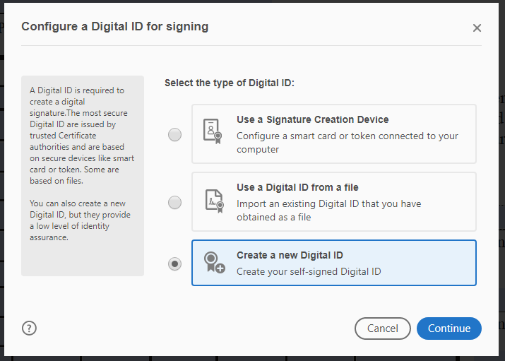
- Next, you will choose where you want to save your Digital ID. Then click on Continue.
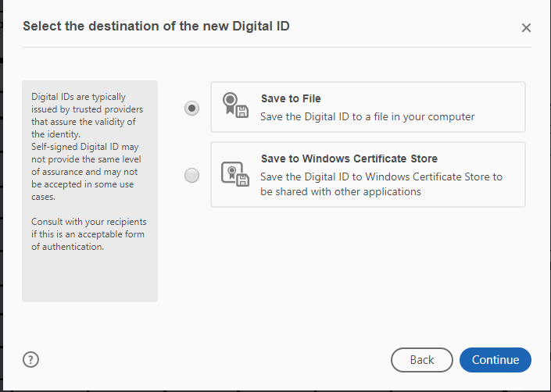
- In the next screen, fill out your name and organization information to create your self-signed Digital ID. Then click on Continue.
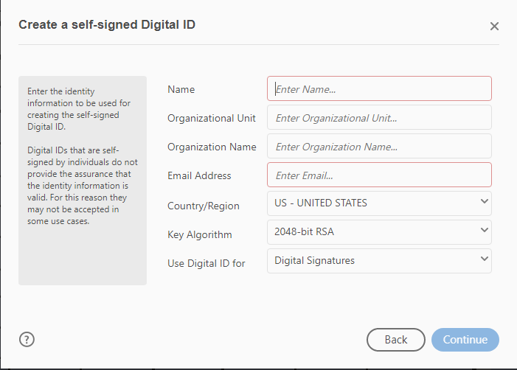
- The next screen will prompt you for a password to protect your Digital ID. Enter your password and then enter it again in the second block to confirm. Then click on Continue.
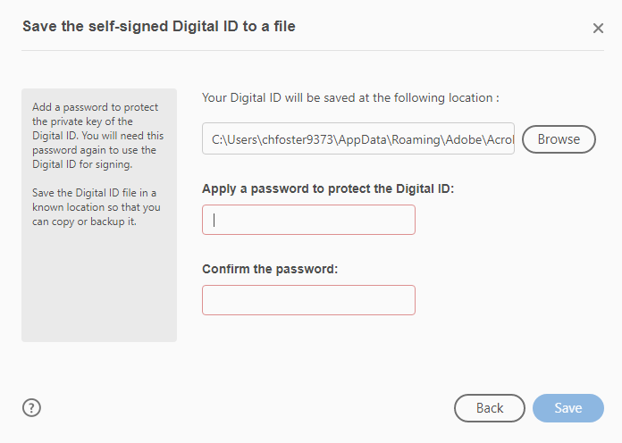

- You will then choose your Digital ID for signature and click on Continue.
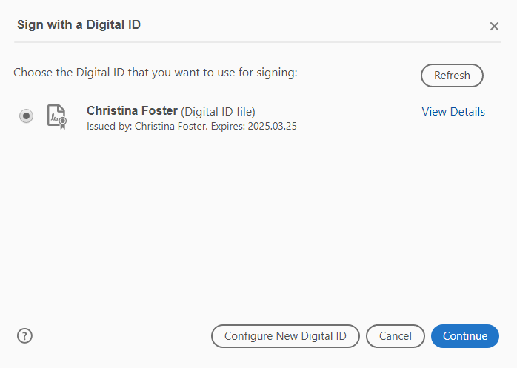

- The Signature block will populate with your Digital signature and date, like the example in the picture below.
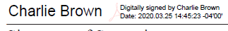

- Once you have completed and signed your form, Save the document.
- Finally, email pholsten@wilsoncc.edu or fax 252-246-1444the application.

