Accessibility Primer for Faculty

What you need to know…

Accessible Design is giving equal access and opportunities to everyone wherever possible, and reducing and overcoming barriers that may occur in: (1) digital content, (2) teaching and learning activities, and (3) assessment.

Considerations for Accessible Design
- Visual - learners need text-based alternatives to consume visual content.
- Hearing - learners need captions, transcripts, or other alternatives to audio.
- Motor - learners need content formatted for keyboard and assistive technologies.
- Cognitive - learners need multiple modes of information and a clutter-free experience.

Universal Design for Learning (UDL) is a framework to improve and optimize teaching and learning for all people based on scientific insights into how humans learn.

UDL is accomplished by providing multiple means of:
- engagement - stimulate interest and motivation for learning
- representation - present information and content in different ways
- action and expression - differentiate the ways students can express what they know

What you need to do…

Accessible Text
- Use sans serif fonts such as Arial, Calibri, Tahoma, etc.
- Use high contrast color - don’t use color text or highlighting to emphasize importance; use bold or italics or the word “important”.
- Use the built-in headings (rather than increasing text size) to break up text and create structure for easy reading and scanning.
- Use bulleted or numbered lists
  - Important - Do not copy and paste bulleted text from a Word document into Moodle. This action may bring in formatting that Moodle doesn’t understand and could lock your course, preventing you from being able to edit any content.
  - Instead - “un-bullet” text, copy, and paste it into Moodle, then add the bullets once the text is in Moodle.

Built-in Text Editing Accessibility Features
The text editing toolbar in Moodle has several built-in accessibility features:

Accessibility Checker checks the content in the area you are editing.
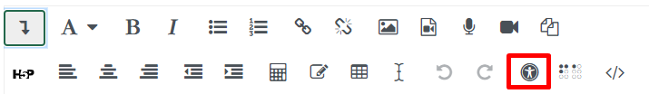

Screenreader Helper checks the content in the area you are editing for screenreader compatibility.
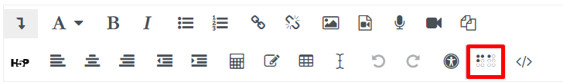

Equation Editor - use this tool to insert equations into Moodle, rather than images of equations.
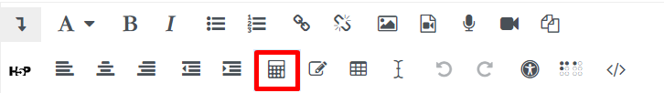

Accessible Tables
Use the table builder in Moodle to create accessible tables, do not copy and paste tables into Moodle as they are nearly impossible to make accessible.
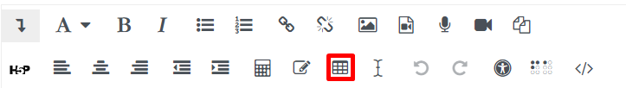
- Tables should be simple and used to present data, not to format text for visual layout.
- Screen readers can not navigate merged cells.
- Column and row headers must be included and accurately identified.
- No nested tables.

Accessible Images
- No flashing features.
- Use alternate text descriptions.
- If the image contains text, the text should be included in the alt text.
- If the image conveys a lot of information, such as an infographic, a full description or transcript should be provided to fully explain what the image is intended to convey.
- If an image is purely decorative, then say so in the alt text.
- Avoid using an image as the sole means of conveying importance, such as an image of an exclamation point.

Accessible Video
- The video player must have controls to play, pause, and mute. Examples that meet these criteria include YouTube, Screencast-o-matic, and Vimeo. There may be more, but make sure you verify this before using it in your course.
- Videos used in a course must contain closed captioning AND a transcript.

Accessible Links
- Do
  - Use descriptive links (good linking example below)
    - In the Accessibility Article by Yale, researchers found…
  - Tell users if the link will open in a new window
- Don’t
  - (Don’t) Use the url as a link (poor linking example below)
    - Read the Yale accessibility article https://usability.yale.edu/web-accessibility/articles
  - (Don’t) Use “click here”

