Collaborate Engagement Features

Blackboard Collaborate has several built-in features to allow an instructor to engage with students and promote interaction during a class session.
- Raise hand – Allows students to indicate they have a question or can be used to keep students on task by prompting “everyone raise your hand when you’re ready to move to the next topic”, for example.
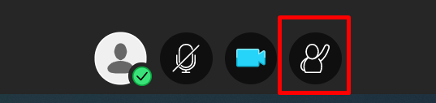
- Feedback (at the My Status and Settings icon) – Allows instructors to check for understanding and allows students to indicate their opinion on a topic being discussed or give feedback on the pace of the lesson. This is useful when the instructor issues a call to action for the class to provide one of the feedback types listed.
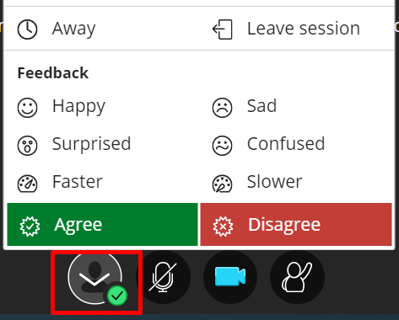
- Polling – allows instructors to ask the class a “Yes/No” or “Multiple Choice” question and then have a discussion based on the responses.
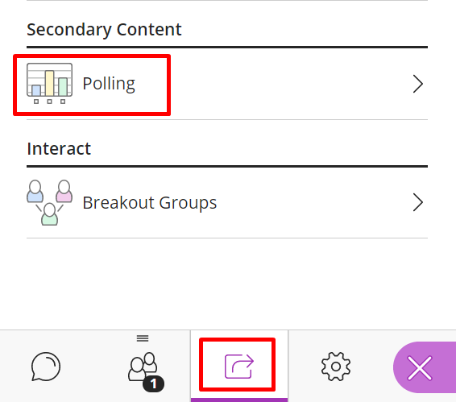

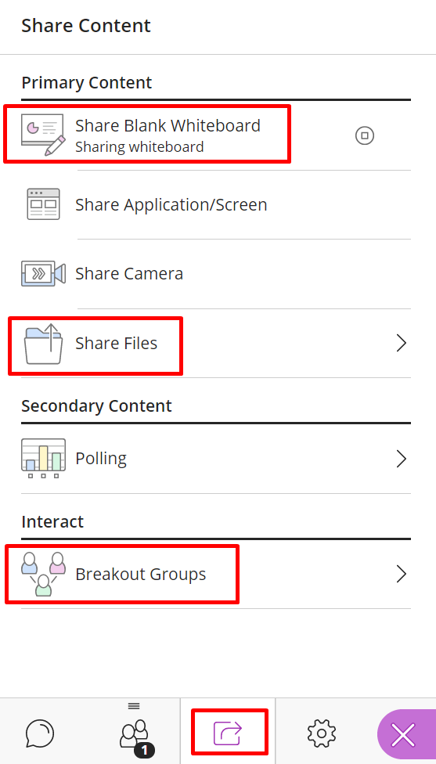
- Share blank whiteboard – provides a space where the instructor and/or students can interact by drawing shapes, adding text, or drawing freehand.
  - Open the Collaborate Panel
  - Click Share Content
  - Share Blank Whiteboard
  - The drawing tools are at the top of the screen.
- Share files and annotate by adding text, boxes, or freestyle pencil marks over the content:
  - Open the Collaborate Panel
  - Click Share Content
  - Click Share Files
  - Drop file (only allows png, jpg, ppt and pdf files)
  - Select file
  - Click Share Now
  - The annotation tools will be present at the top of the screen.
- Breakout Groups – allows the instructors to divide the class into smaller groups in order to discuss topics amongst only those in their group.
  - Open the Collaborate Panel
  - Click Share Content
  - Click Breakout Groups

