Collaborate Instructions for Students
- When students enter the Collaborate session, they will need to click the Join Session button.
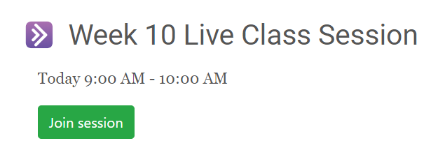
- The Collaborate window allows you to control the interactive environment using the Session menu in the top left, the Collaborate panel in the bottom right, and the user controls in the bottom middle.
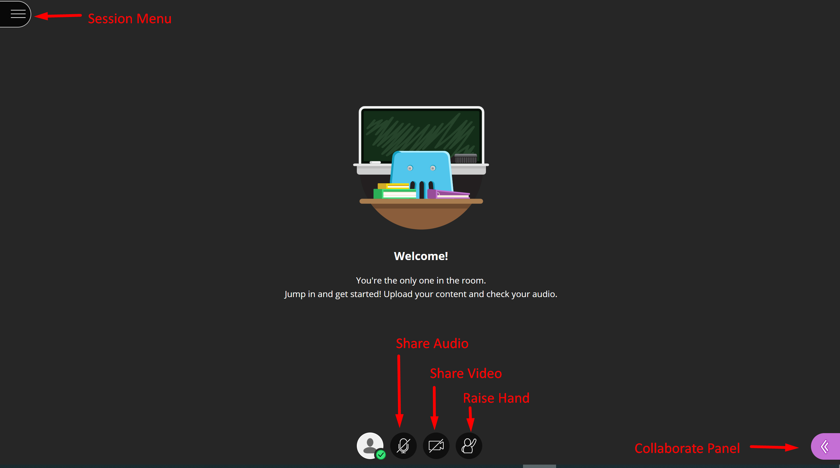
- The tools that are available depend on the permissions set by the moderators.
Tool | Description
 | Open the Session Menu – moderator can start recording, attendees can get help, and leave the session.
 | Share Audio – toggles on/off
 | Share Video – toggles on/off
 | Raise Hand – allows attendees to ask the moderator a question using audio to prevent talking over one another if audio is enabled.
 | Open the Collaborate Panel – access chat, view attendees, share screen, adjust session settings.

- When you enter a session, you will need to Share Audio and open the Collaborate Panel to view attendees and chat.
- You may raise your hand to ask a question, or type a question in the chat (Collaborate Panel).

Collaborate Panel
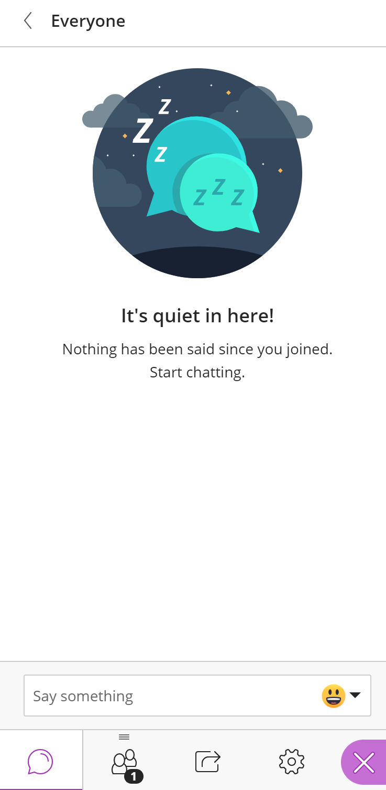

- After a session is completed, students can view the recorded session. The recording may take up to two hours to show in the collaborate link. Find the Collaborate activity in your course and select it. All recordings for that activity appear at the bottom of the page.
- Select the recording to view it. 