Communicating in Moodle

How to Communicate Online
Communicating online is much different than communicating in person, and the tools we use online to interact can vary. Your instructor may post some requirements on how to interact properly in specific courses, so be sure to follow those requirements. If not, the following recommendations should help you get started. Similar best practices are often referred to as "netiquette."
- Write clearly and concisely. Use full sentences, including proper grammar and spelling. In other words, avoid texting acronyms and abbreviations.
- Avoid plagiarism. Always express yourself using your own words. When using someone else's words to help describe or support your point, quote or credit your source. If you're unsure of what constitutes plagiarism, please see the Web site Plagiarism.org.
- Create Drafts. When composing long messages, emails, or discussion responses, you may want to draft them offline first to avoid any possibility of losing your work. You can also take advantage of spell and grammar checkers when drafting offline. An example of an application to use to create offline documents is Microsoft Word.
- Email Properly. Always include a subject for each email and always sign your name at the end to inform your instructor that you are the one sending the message. Some spam filters block messages with blank subjects. It is best to include the course name and section number of the course you are enrolled in (for example, ACA-111-01), because instructors often teach multiple courses and multiple sections of the same course.

Types of Communication
Communication in your course may include the following Moodle tools:
- Course Announcements forum
- Discussion forums
- Chat

Course Announcements
The Course Announcements forum is a special forum for your instructor to share information with you through general announcements. By default, only instructors and administrators may post to this forum. Information posted to the Course Announcements forum may also be sent to your college e-mail account.

Discussion Forums
The Discussion Forum is an asynchronous communication tool, meaning the discussion is not held in real time, but occurs over a period of time, usually several days or longer.
Discussion forums are designed for you to provide your thoughts and opinions on a topic, or respond to a set of questions, or engage in interactions with your classmates. You will be asked to post responses to the forum and you may be required to respond to your classmate’s posts.
To open a discussion forum, click on the Discussion Forum link (highlighted below).
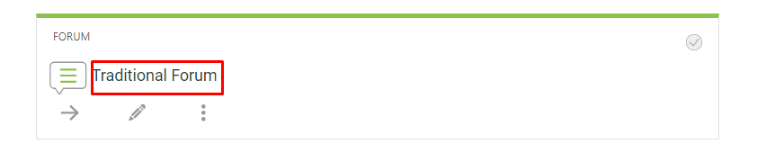
You will be taken into the discussion forum, where further instructions will be displayed.
Click the Add a New Discussion Topic button to post your response.
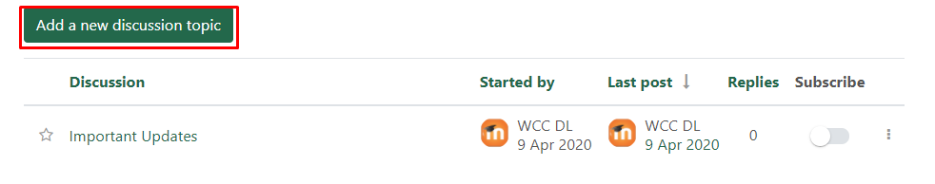
Click advanced to view more options for posting your forum.
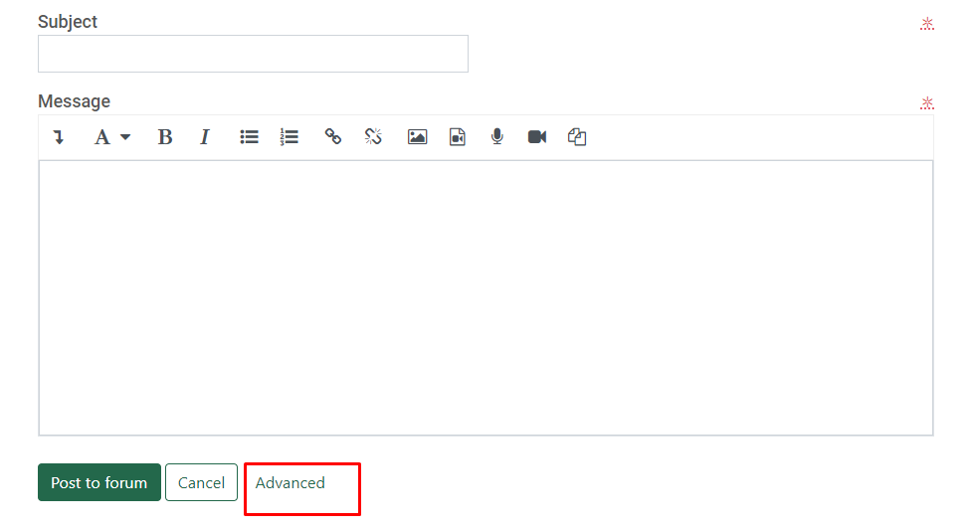
Type a meaningful subject that describes the contents of your response. In some cases, your instructor will give specific instructions as to the content of your subject line.
Type your message.
Uncheck the subscribe box if you do not want to receive an email each time another student posts to this forum.
Add a file under the Attachment area if this is something required in the discussion instructions by selecting “add”
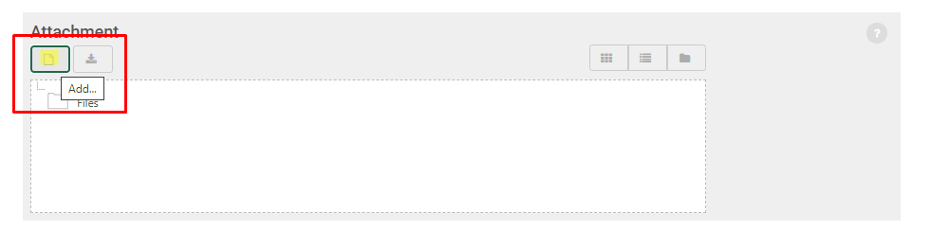
Select “choose file” and then locate the file that you wish to upload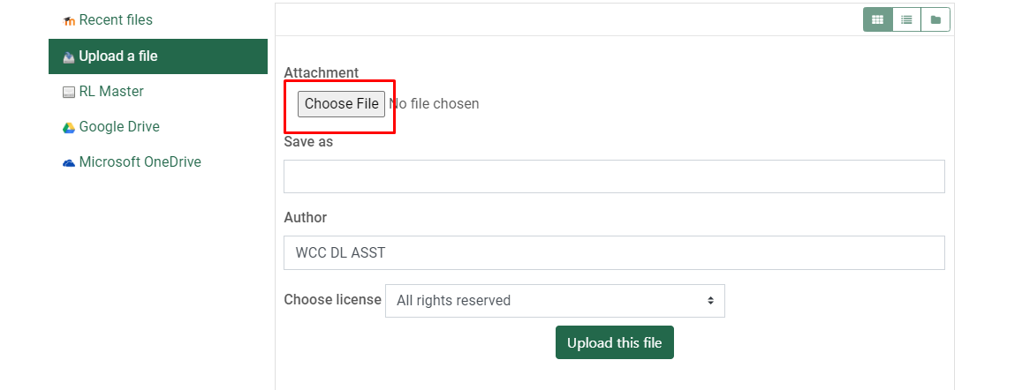
Then select “upload this file” in the attachment area. Your file should then appear in the forum editing area
Click the Post to Forum button to post your response.
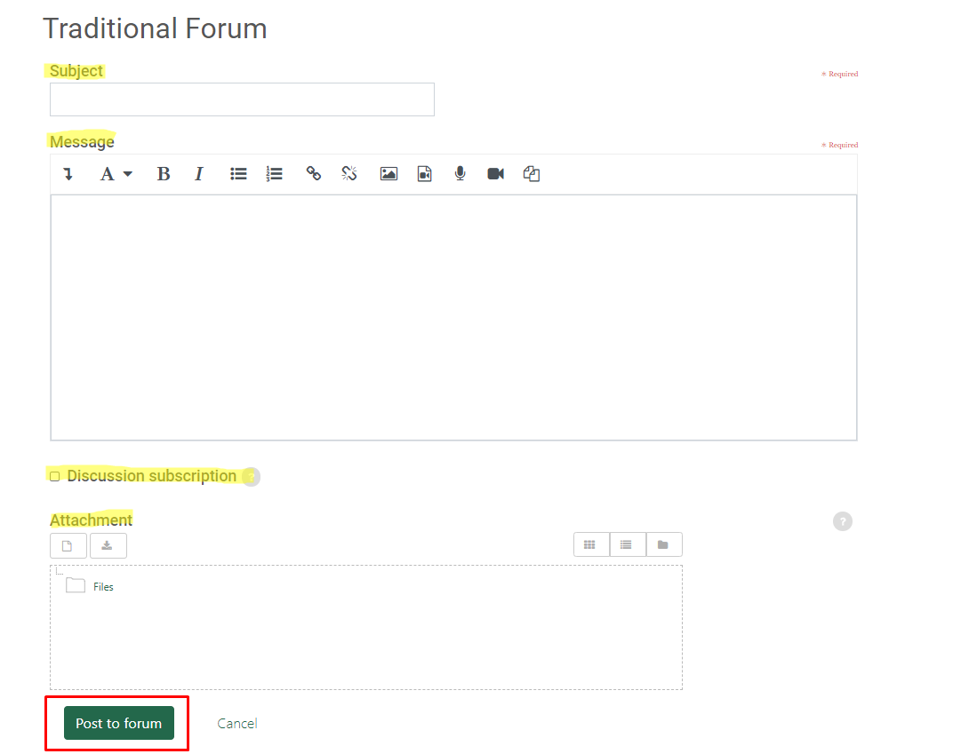
Posts from other students in the course will be listed beneath the discussion forum instructions.
To view a student post, click on the title of the post in the Discussion column.

Chat
The Chat activity allows participants to have a real-time synchronous discussion in a Moodle course. Chats differ from discussion forums in that chats take place in real-time or "live".
Your instructor will have to set up a chat within your Moodle course in order for you to access it. Not all courses will utilize the chat feature in Moodle.
To join a chat, within your Moodle course, click on the chat link set up by your instructor (see image of an example chat below).
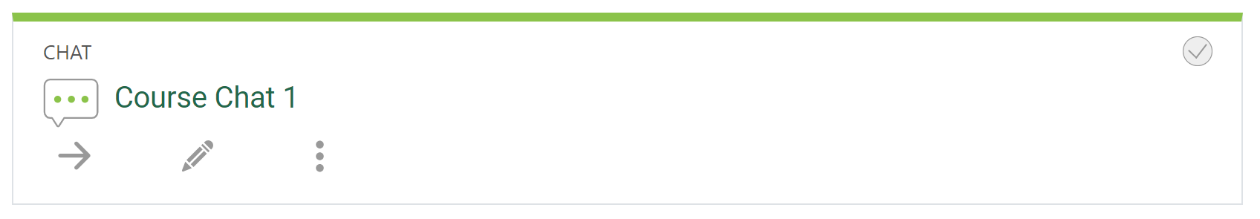
When you click the chat link you will see a couple of options:
- Click here to enter the chat now: This takes you to the chat using the default chat method.
- Use more accessible interface: This gives a simpler chat room without frames and JavaScript.
- View past chat sessions, if any: This allows you to view any previous chats that occurred while you did not join the session
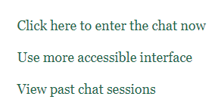
Once you click to enter the chat, a chat box will open and you will be able to see a list of students in the chat on the right, and you will be able to participate in the current discussion by clicking and typing in the box at the bottom of the window.
