Completing an Assignment on Flip
How-to

- In your Moodle course, click on the URL provided (you may need to click to open in a new tab/window).
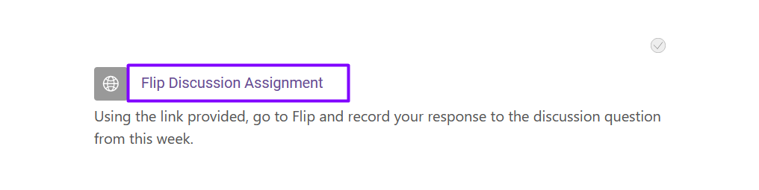
- Once Flip opens, you may be required to sign up/in. Continue using your Microsoft 365 credentials.
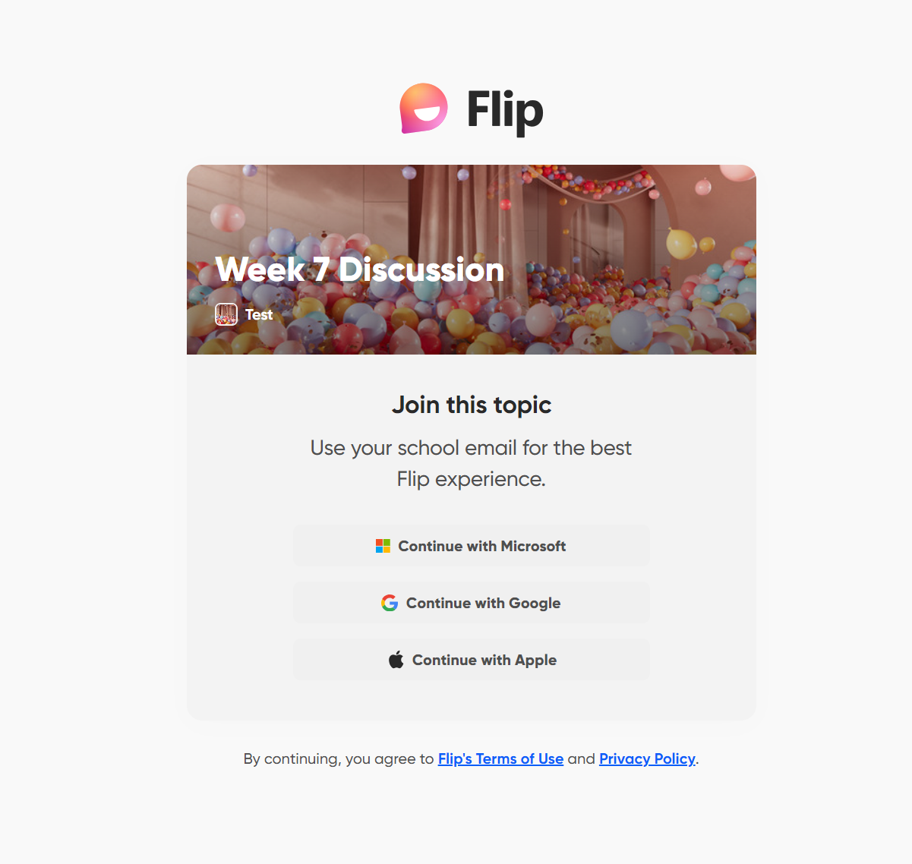
- Once on your topic, review all instructions, and click the “Record” button when you’re ready.
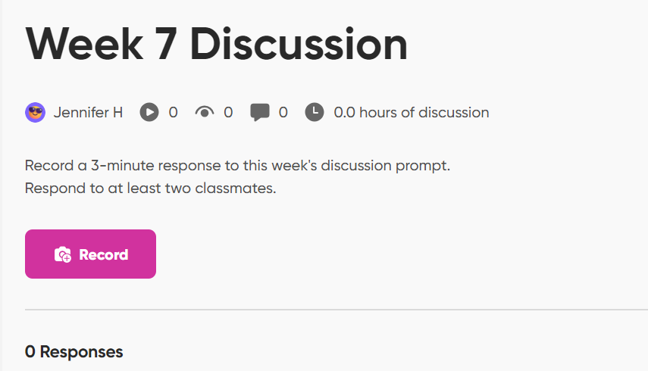

- When you get to the recording screen, you may need to allow access to your camera and microphone. At the bottom, you’ll see the type of recording you’ll be completing (create, record, audio). Press the circular button above “Record” when ready to begin.
On the right hand side, you have options to add to your recording. You can add/use text boxes, draw, emojis, and more. You can also adjust the look of your video using filters (right) or backgrounds (bottom).

- Once the video is complete, click “Next” in the bottom right-hand corner. This action will take you to the editing tool where you can trim or delete any of the video, add text, emojis, music, or pictures.
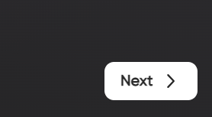
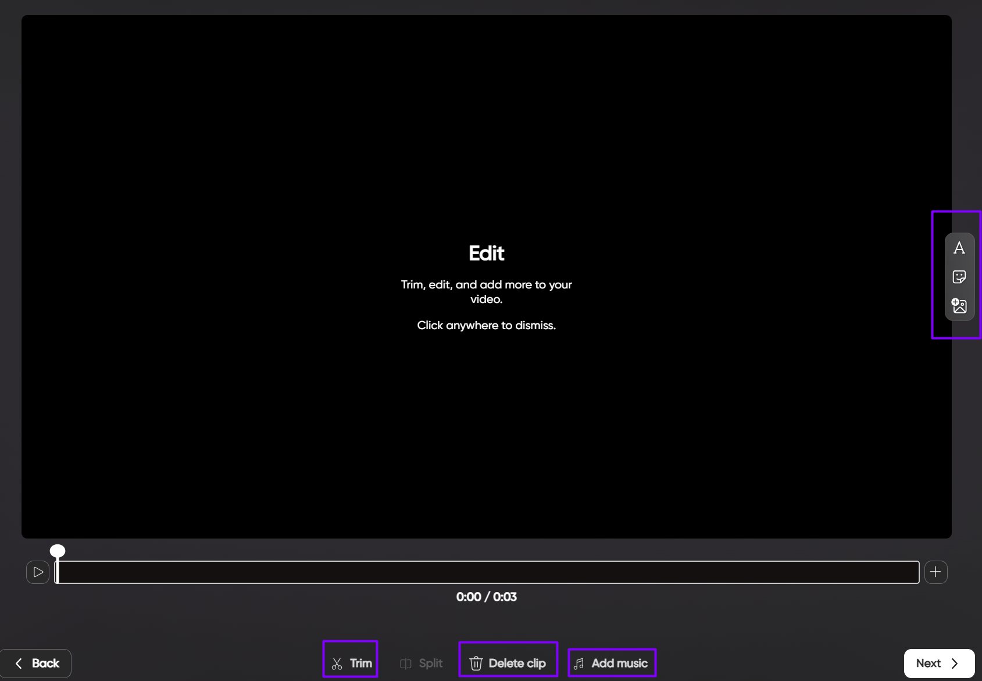

- Click “Next” again once you’re ready to post/submit your video. This will bring you to the final section prior to posting where you can add any additional information such as captions, or an additional link (if needed). “Post to topic” can be chosen once you are ready to submit.
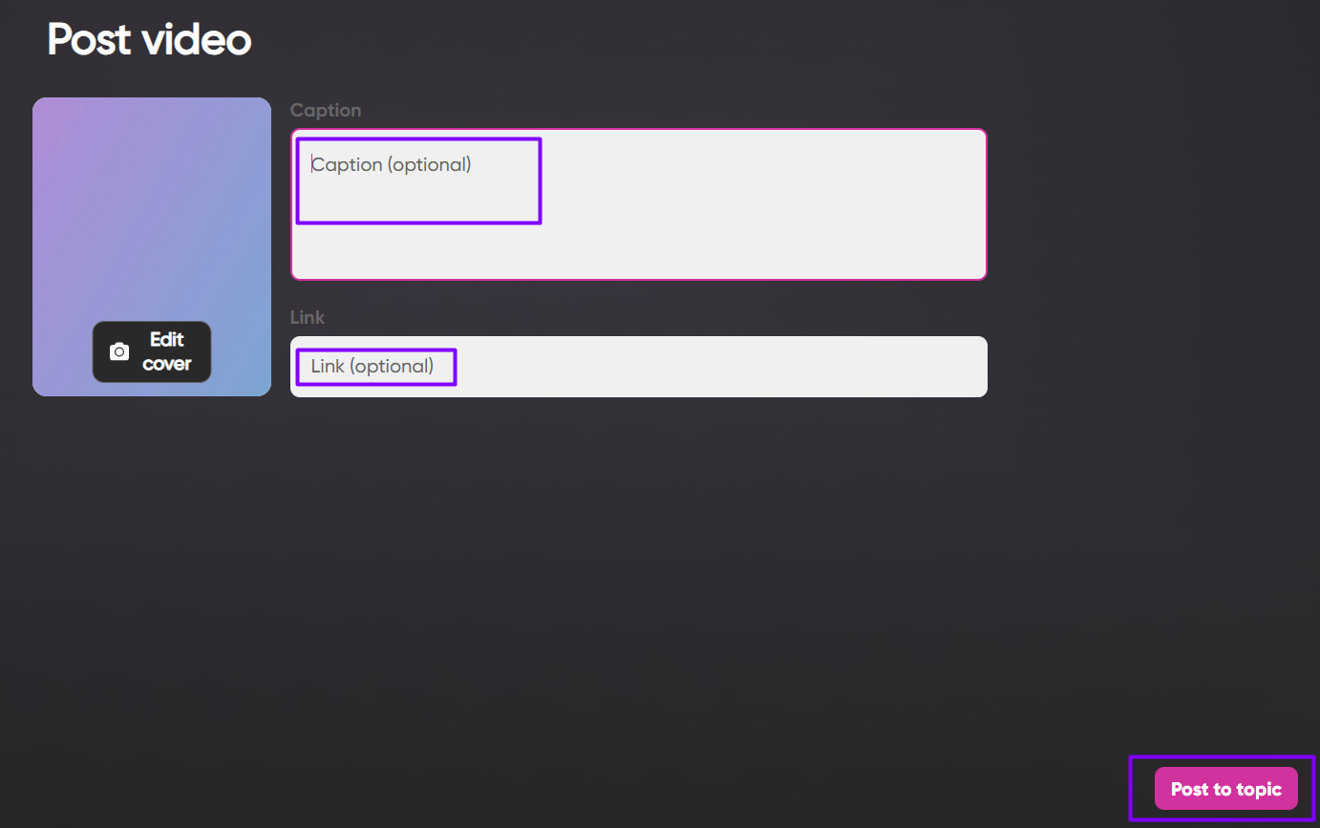

- You’ll receive a confirmation message when your video has been uploaded. You can also check by clicking on the “Go to topic” button.
