Course Grade Settings

0 decimal default

In Gradebook Setup, the Course Grade Settings determines how the gradebook appears for all participants in the course.
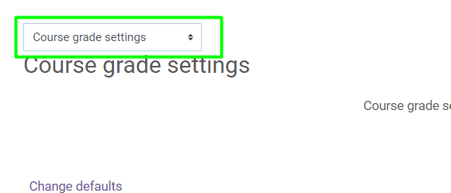
In the Grade item settings category, choose and set the Overall decimal places to the default of 0. If you use grades with decimals, you will need to change this to the number of decimal places you want it to round to in the gradebook.
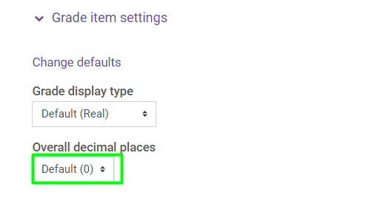
Make sure to click the Save changes button.
Instructors are encouraged to click the question mark for each setting and read the information provided to become familiar with the settings available.

