Course Navigation
To enter a course, click on the block for that course from the My Courses page (pictured below).
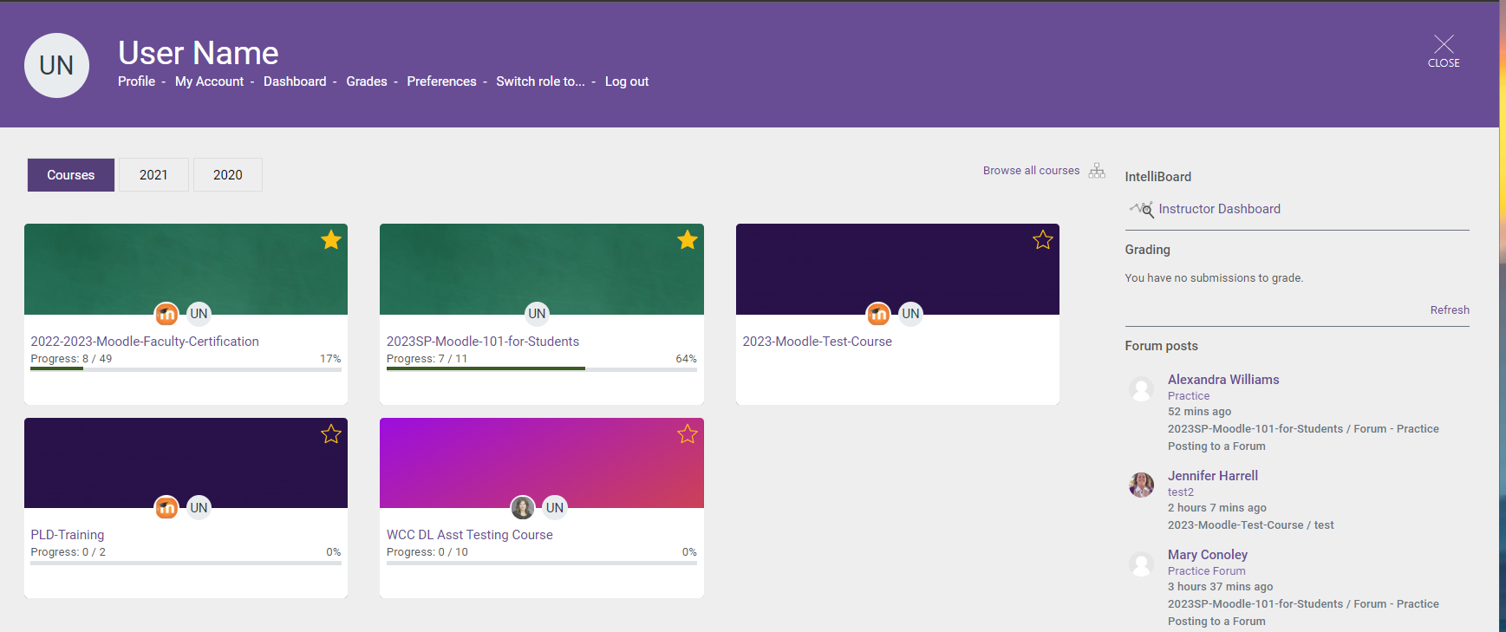
Clicking on a course block will take you to the homepage of that course (example course pictured below).
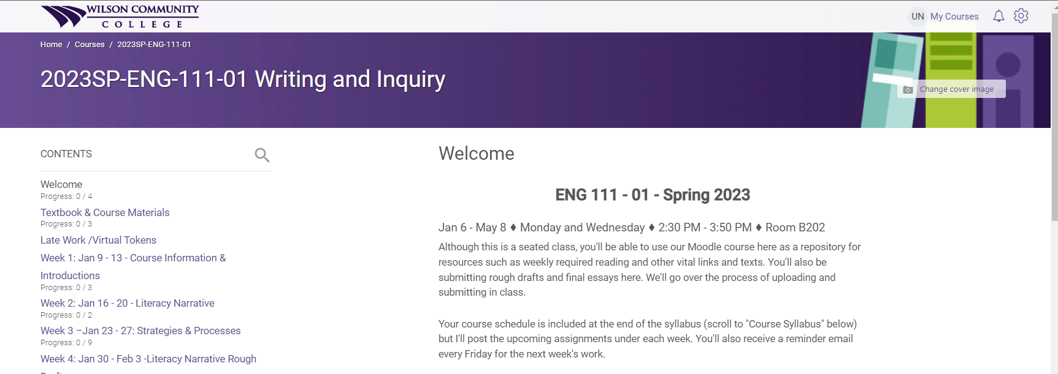

Contents
The Contents (outlined in the image below) on the left side is the main navigation for the course. When you click on a “section” in the Contents, the information in that section will be displayed on the right.
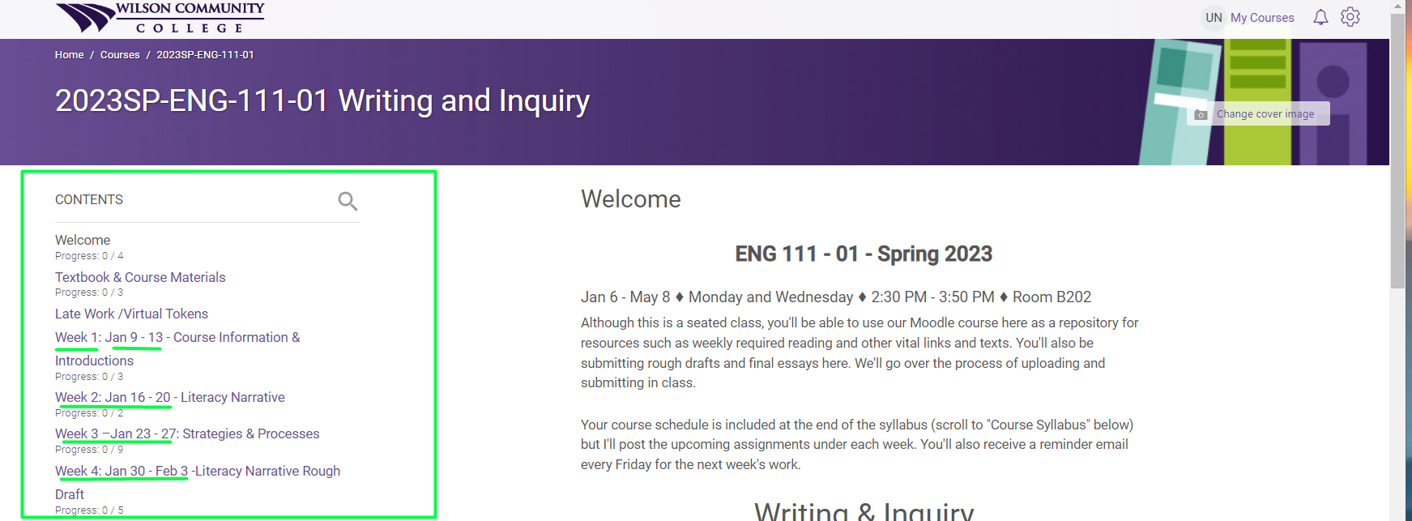

Breadcrumb Trail
Once you are in a Moodle course, and you have navigated to a particular section in the Contents, you can use the breadcrumb trail (see arrow in the image below) to navigate back to previously visited sections within the course, or you can click the course name to get back to the course home page.
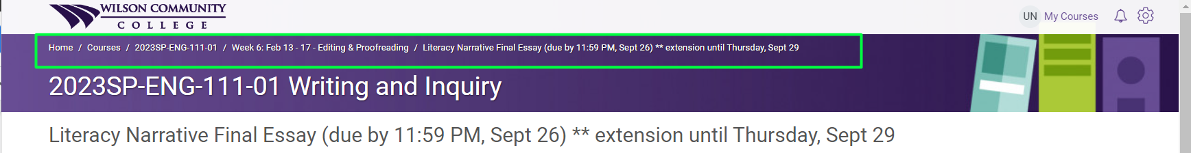

Course Dashboard
The link to access the course dashboard is located at the bottom of the Contents section.
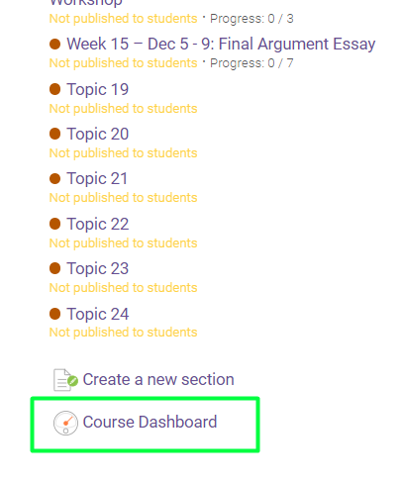
The course dashboard allows you quick access to features in Moodle.
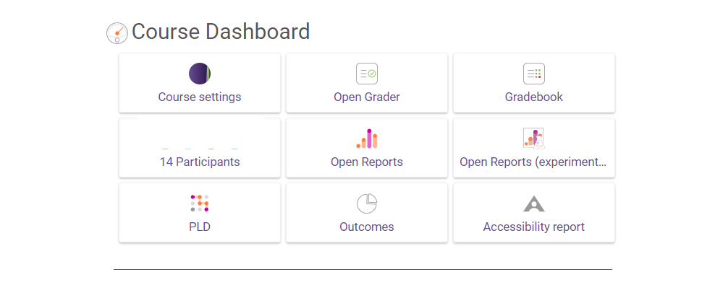
The following are the most commonly used features:
Course Settings: This option allows you to change configuration settings for an individual course. This feature is explained in more detail in the Course Setup and Configuration lesson.
Gradebook: This tool allows you to view and update grades for an individual course. This feature is explained in more detail in Module 4.
Participants: This option allows you to view the participants in an individual course. This feature is explained in more detail in Module 3.

