Course Setup and Configuration

Course Settings
Access the Course Dashboard by clicking the link at the bottom of the Contents area in your course. Then click on the Course Settings block.
Note that any other options not discussed here can be left at the default setting. Any areas marked in gray cannot be changed by the instructor. Areas that are highlighted may contain settings that instructors wish to change, although all settings can be left at their defaults.
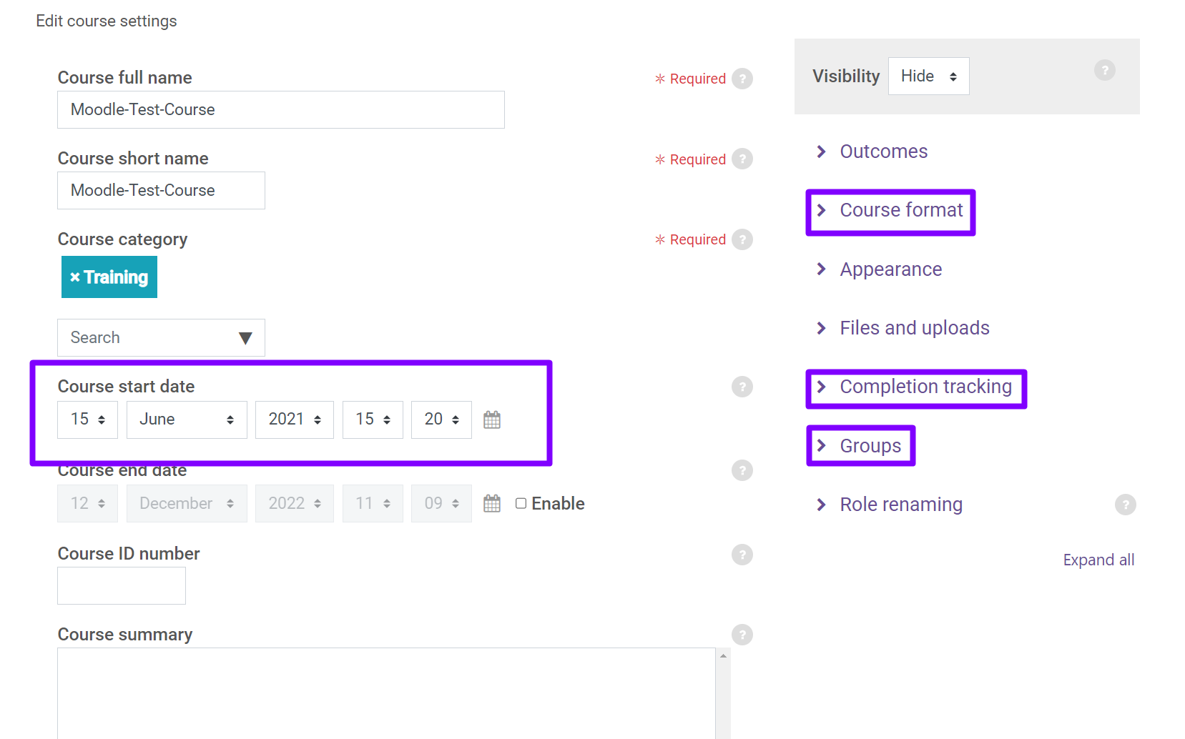
Course Category: Do not change.
Course Start Date: The course start date determines the date that course logs will be tracked for a course. This date should always be the first day of the semester (not the first day a class meets). The start date also determines what date appears in the first section title of the course if using the "Weekly" course format.
Visibility: This cannot be changed by the instructor. Courses will be made available to students on the first day of classes by 8:00 a.m.
Outcomes: Not used.
Course Format: Each course is organized into sections that an instructor can assign titles to. The Format setting here determines what will be displayed as your section title. The options are:
- Topics format: By default, the system organizes the course into topic sections.
- Weekly format - organized by week, starting with the course start date (this format can present problems when a course doesn't meet in a particular week).
Note that remaining options under Course Format can be left at the default setting.
Appearance: All of the settings in this category can be left at their default settings.
Files and Uploads: This setting determines the maximum file size that students can upload when submitting assignments in your course. 100 MB is the maximum and default setting.
Completion Tracking: This feature allows students to track their progress in a course with checkboxes in the main content area and within each section of your course. If enabled, the checkboxes will appear. You may also have to enable completion tracking within each resource or activity you add to the course.
Note that this is also the setting that determines if the progress bar is displayed under each section in the Contents.
The default setting is “Yes”, which enables Completion Tracking. If you choose not to use this feature in your course, you must set this to “No”.
Note that setting Completion Tracking in a course to “No” will prevent use of the Activity Completion and Restrict Access features.
Groups: If you choose to use groups in your course, this is where you would start to set that up. More information on Groups is available in Module 3.
Role Renaming: Not used.

Editing Section Names
To edit the name of a section, go to that section in the Contents, then click the “Edit Section” icon under the section name. Changing the section name will also change the name used in the Contents.
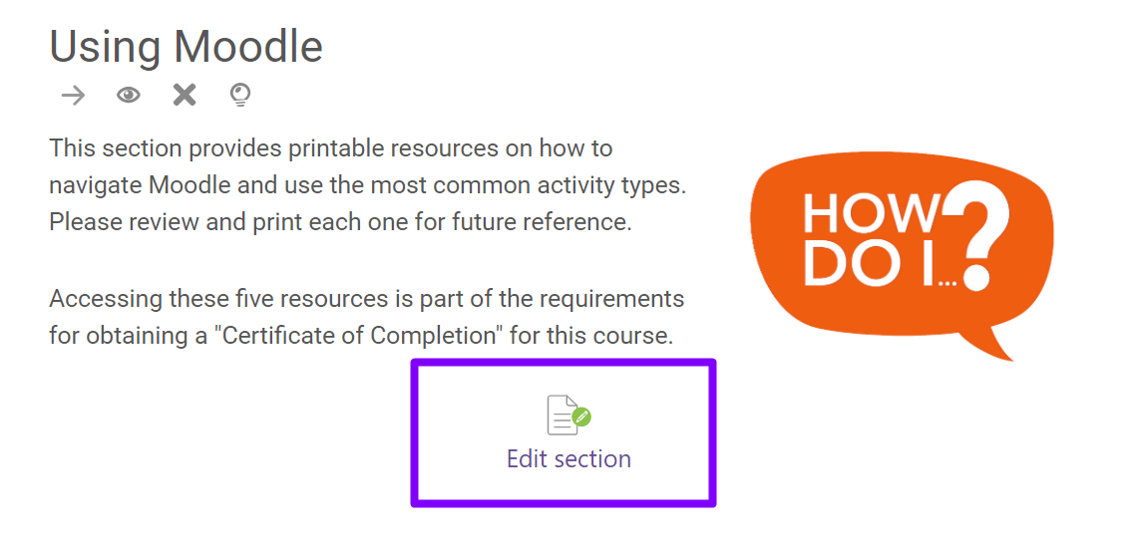

Creating New Sections
The number of sections available in the Contents can be increased by clicking the “Create a new section” link at the bottom of the Contents.
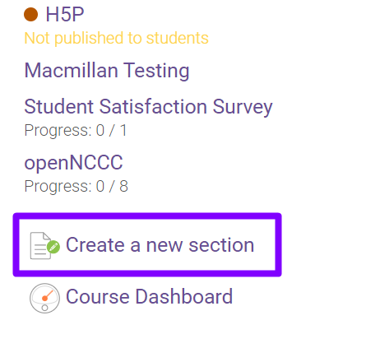

Deleting Sections
To delete a section, go to that section in the Contents, then click the “X” icon under the section name.
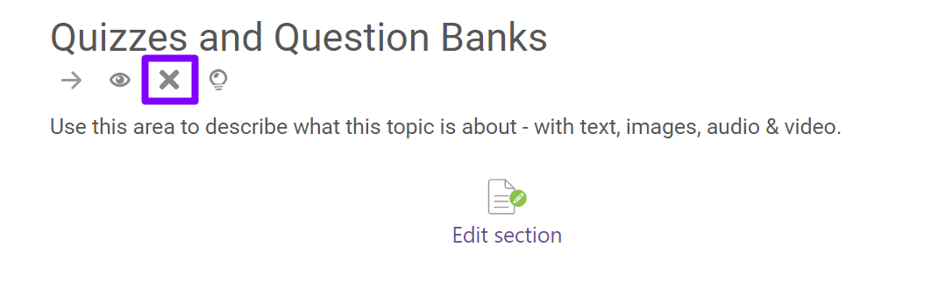

Hiding and Making Sections Available to Students
To make an entire section of course content unavailable or hidden from students, go to that section in the Contents, then click the “eye” icon under the section name.
Note that by default, all sections of the course will be available to students.
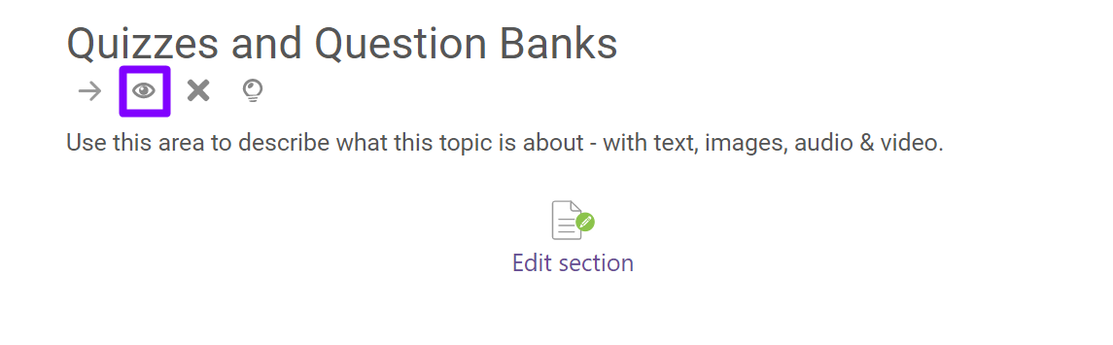
Sections that are hidden from students will have an orange dot in front of them in the Contents and will state “not published to students”.
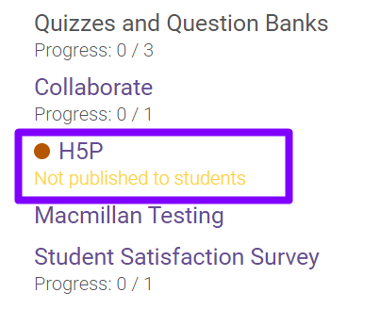

Hiding and Making Content Items Available to Students
In addition to making sections hidden or available to students, you can also make individual activities or resources within a section hidden or available to students. Go to the section in the Contents that contains the activity or resource you want to hide, click the “three vertical dots” icon below the activity name, and then click “hide”.
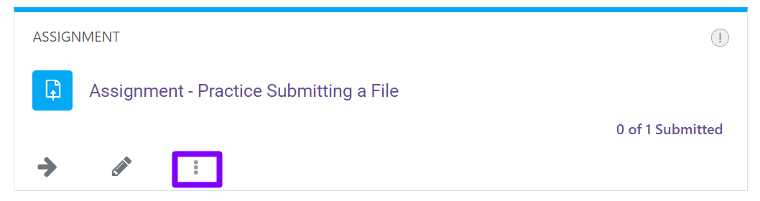
An activity or resource that is hidden from students will have the text “Not published to students” beneath it.
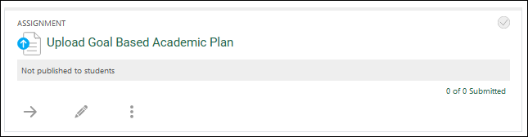
To make an activity or resource available to students, click the “three vertical dots” icon below the activity name and then click “show”.

