Creating a Web-based Collaborate Session for Virtual Office Hours
Recommended browser: Firefox for moderators, participants may use other browsers.
- Go to https://us.bbcollab.com and login using the credentials provided.
If this is your first time using the web-based version of Collaborate, request a login from Kelly Ellis at kellis@wilsoncc.edu. Change your password after initial login by clicking your name in the menu on the left.
- Click “Create Session”.
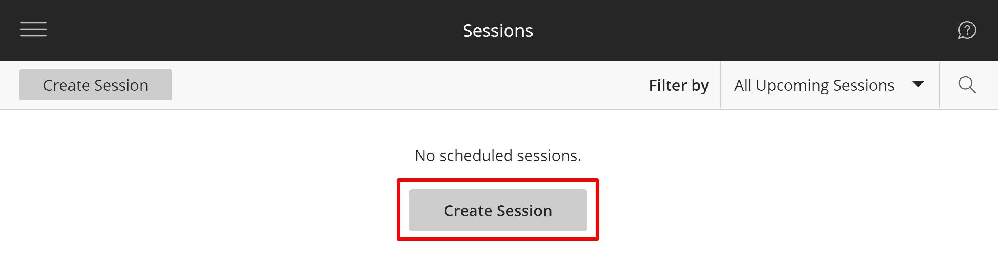
- Enter a “Session name” such as “Firstname Lastname’s Virtual Office”.
Check to allow “Guest access”.
Check “No End (open session)” to make this virtual space available indefinitely.
Click “Create”.
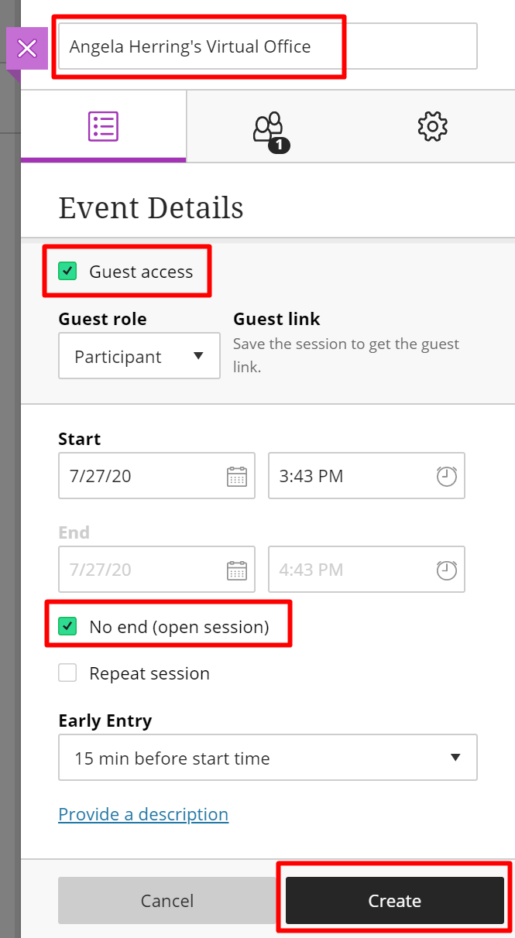
- An email will be generated to you from “Blackboard Collaborate Support”. Save this email.
The email will contain two links:
  - To join your Virtual Office meeting click “Your link”.
  - Send the “Guest link” and “Session dial-in” info to others.
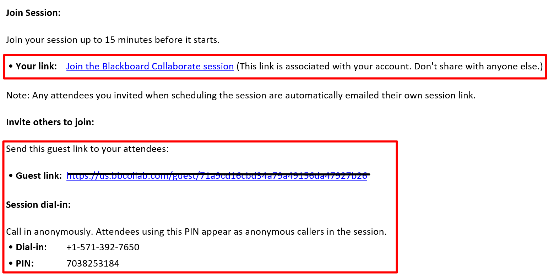

This is essentially a perpetual room that you can use over and over again. I recommend setting up a new one for each semester.
You can add this info to your signature line in your email.
Example Signature line:
