Forums Vs. Open Forums

The primary difference between Forums and Open Forums is **Forums** allow instructors to set Availability dates.

* Forum is the best option for forums that instructors want students to complete during a particular week or time period.

**Open Forums** display recent posts on the course page, without requiring a student to click in the forum to know that a new post has been added.

* Course Announcements should be an Open Forum by default.
* Open Forum is also good for an “Ask a Question” forum.

The screenshot below shows a traditional Forum and an Open Forum with the same post added to each one.

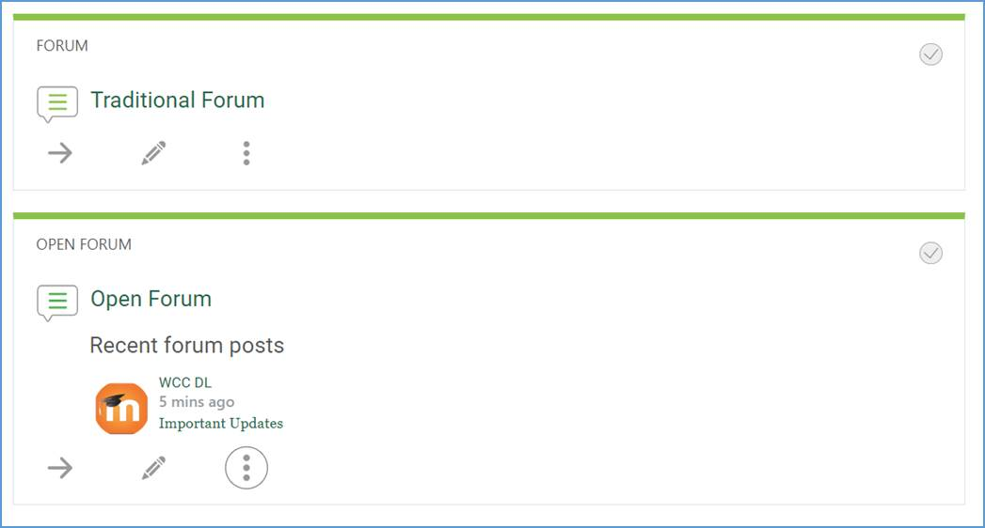

*Note: If you do not have an “Announcements” or “Course Announcements” forum in your course, let someone in Distance Learning know. This is the only forum type that is built into the course (unless deleted) and cannot be added back by the instructor.*