Adding H5P Interactive Content in Moodle
There are two Parts to using H5P content (1) Creating the content, and (2) Adding the content to your Moodle course.

(1) Creating H5P Interactive Content Using the Accordion Type
- In your Moodle course, go to the Admin gear, click Content Bank.
- Click the Add button.
- Select the Accordion type.
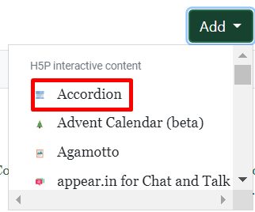
- Enter the following information:

  - (Main) Title – this is what your resource will be named
  - (Panel) Title – this is title for your first item (panel)
  - Text – this the text for your first item (panel).

- To add another item with text, click Add Panel and repeat steps b and c from step 4.
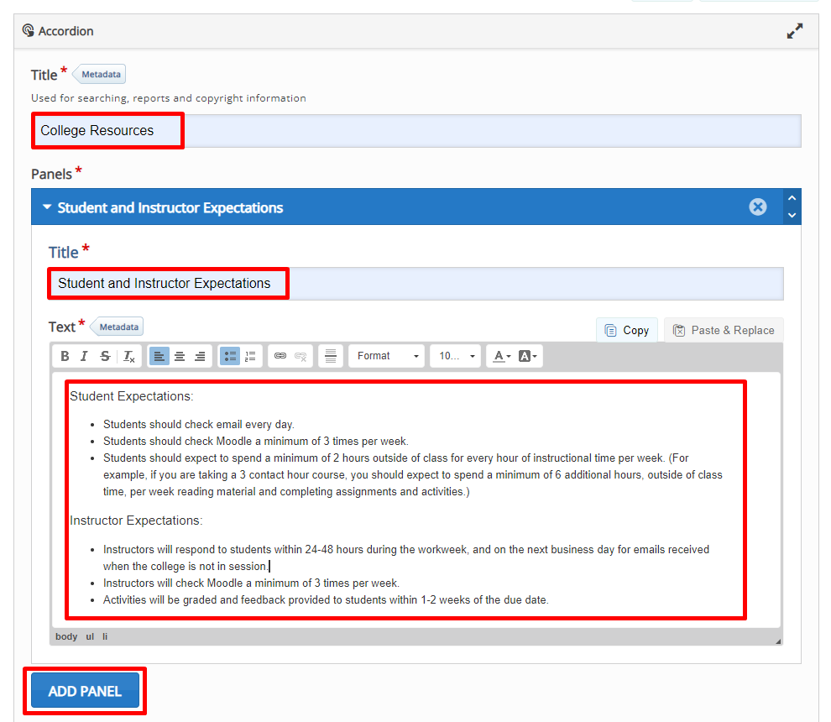
- Once you have created all of your items (panels) click Save.
- This allows you to view the H5P Interactive Content you have created.
- You can now either Edit the content or Close.
- Return to your Moodle course and go to the section you where you want to insert the H5P content.

(2) Adding H5P Interactive Content to a Moodle Course
- Click the Create learning activity button link at the bottom of the section you want the activity to appear in.
- Select the Activities tab, and click the H5P Interactive Content icon.
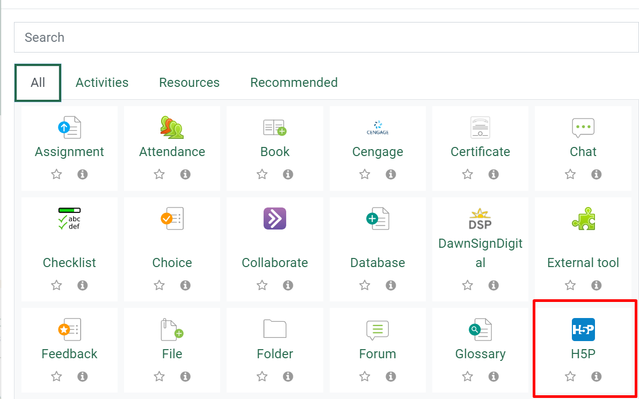
- Enter a name and description (provide instructions for students regarding what your expectations are for this activity) and check the box to display the description on the course page.

- Click the folder icon below the Package file.

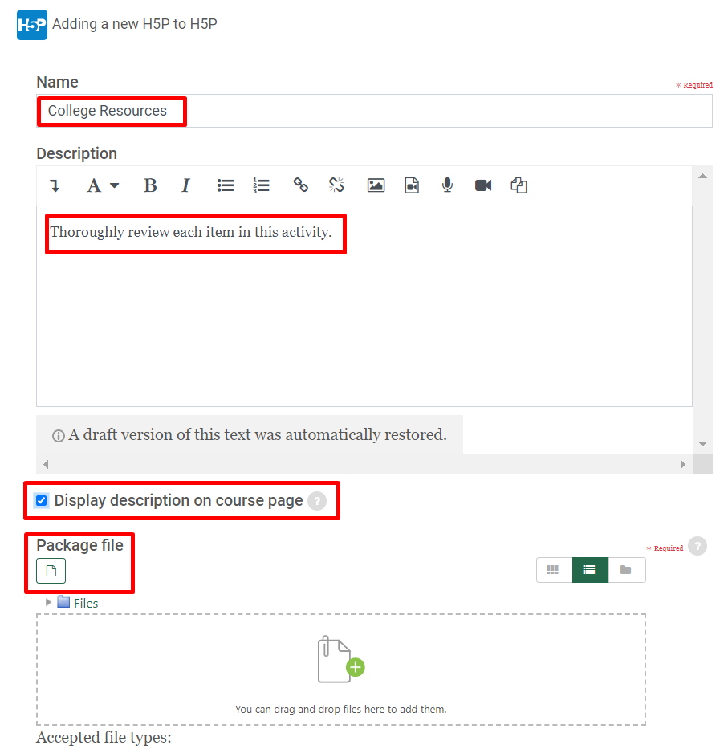
- Click the content bank repository and click the H5P content item you want to add to your course.
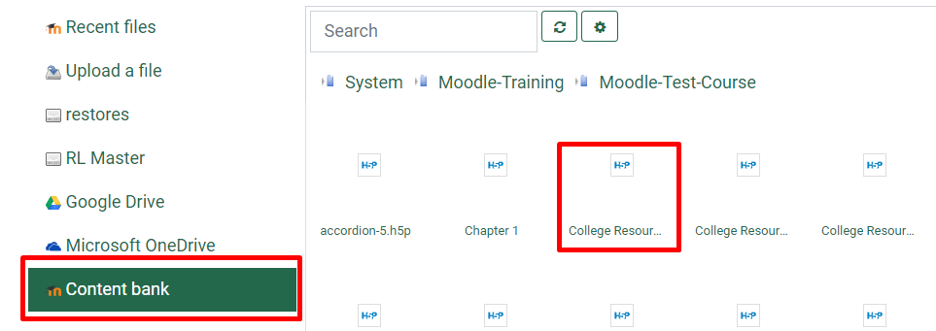
- Click Select this file.
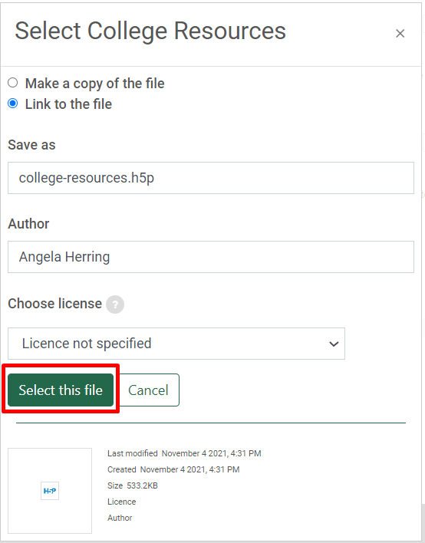
- The file will appear in your files area, click Save and return to course.
