Assignments

Adding Moodle Activities

The Assignment activity lets instructors communicate tasks, collect work, set due dates, and provide feedback and grades.
Students can either upload a file (such as a document, pdf, spreadsheet, PowerPoint, etc.), or the assignment can be set up to allow students to type text directly into a text box in Moodle.
To add an assignment, click the Create learning activity button at the bottom of the section you want the assignment to appear in.
Select the Activities tab, and click the Assignment icon.
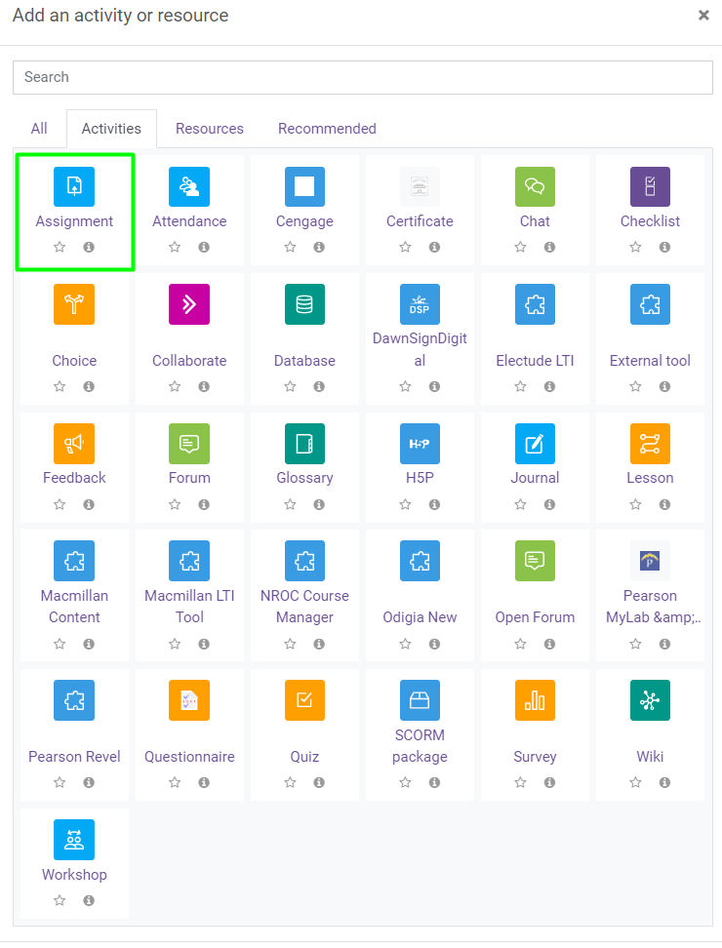
- Create a meaningful name for the assignment
- Enter a description, this is where you provide instructions for students regarding what your expectations are for this assignment.
- Check the box to display the description on the course page. This is optional, if you have lengthy instructions you may want to not check the box, students will see the instructions when they click into the assignment.
- You can add activity instructions to your assignment in the activity instructions box.
- Set a due date; submissions will still be allowed after this date, but will be marked as late.
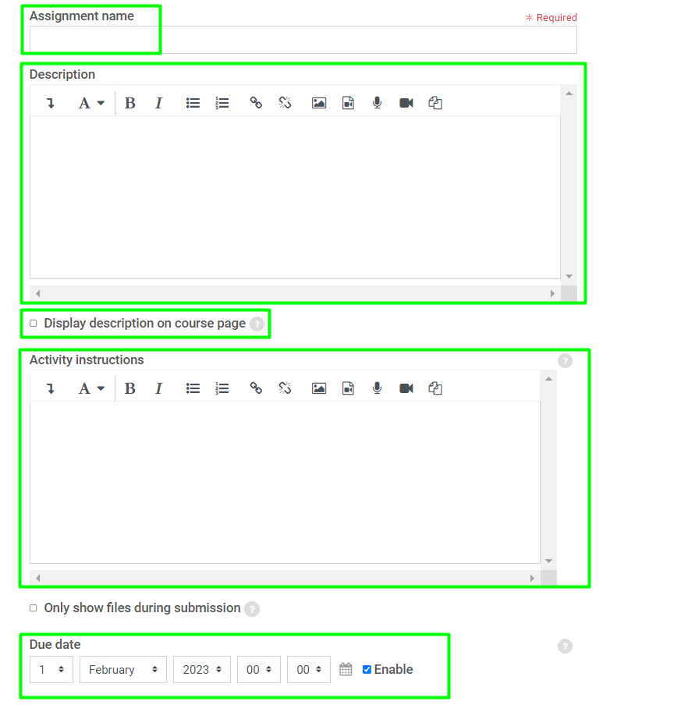
The Visibility setting allows you to make the forum content available or hidden from student view.
Availability allows you to set the date range in which students can submit this assignment.
- Allow submissions from: Start date
- Cut-off date: Submissions will not be permitted after this date
- Remind me to grade by: Optional, for instructor use only
- Always show description: Checking this allows students to see the assignment description (instructions) before the starting date set under “allow submissions from”
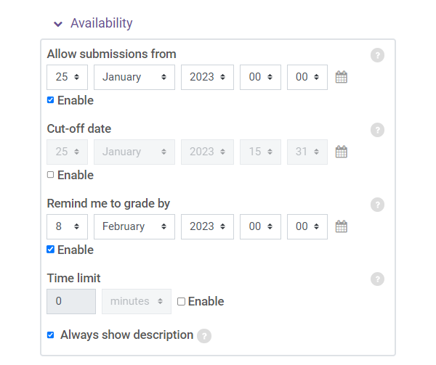
Submission types allow the instructor to determine how students submit their work.
- Online text: Provides a text box directly in Moodle where a student can type a response and submit it.
- File submissions: Allows students to upload a file into Moodle for grading.
- Maximum number of uploaded files: Change to 1 (or however many you are requesting the student to submit).
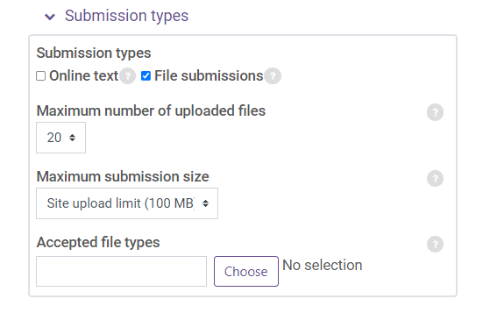
Feedback determines what options will be available to you when grading.
- Feedback comments – allows the instructor to type comments to the student, which appear directly in the gradebook.
- Feedback files – allows the instructor to provide a graded file back to the student in the gradebook.
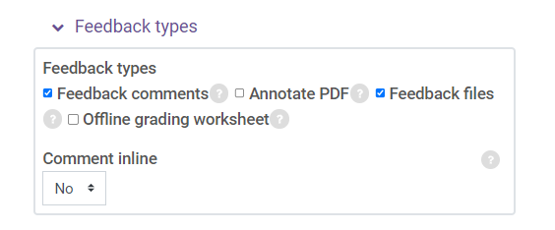
This covers the most common settings; any remaining settings are optional.
Click the Save and return to course button to save the settings.

