Files and Folders

Adding Resources to Moodle
One of the ways to share a file with your students on Moodle is to add it as a Resource. File types you can add to Moodle include PDFs, Word and other text documents, PowerPoint presentations, spreadsheets, and zip files.
If there are multiple files that you need to share that are related to each other, you may want to create a folder to group those files together. To upload several files at once, see “Adding Folders” below.

Adding Files
To add a file, click the Create learning activity button link at the bottom of the section you want the File to appear in.
Select the Resources tab, and click the File icon.
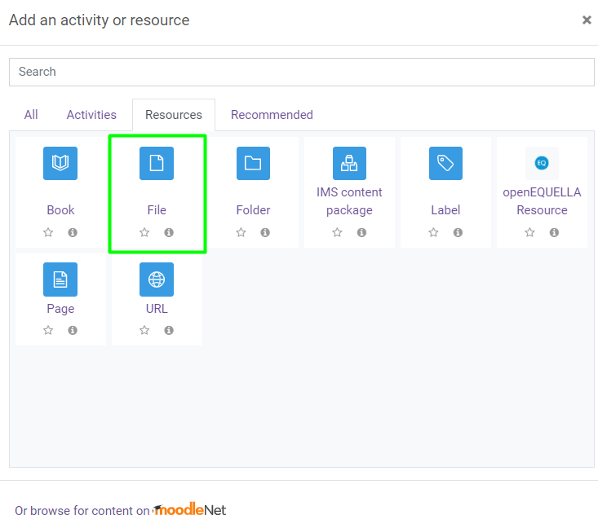
Enter a name for the link to your file; this can be the filename or a more descriptive name.
To upload your file, you can drag and drop it into the Select files area, or you can click the Add icon (outlined in the image below) to use the file picker to select the file you wish to upload.
Only one file can be uploaded using this method.
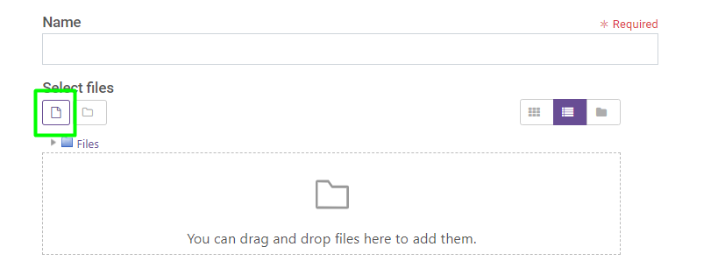
The Visibility setting allows you to make the File available or hidden from student view.
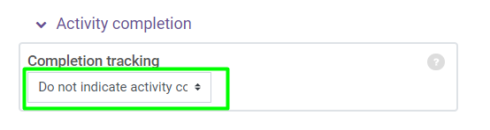
Common Module Settings allows you to add a description of the file's contents. Check the box to display the description on the course page and to show the description under the link to the file (optional).
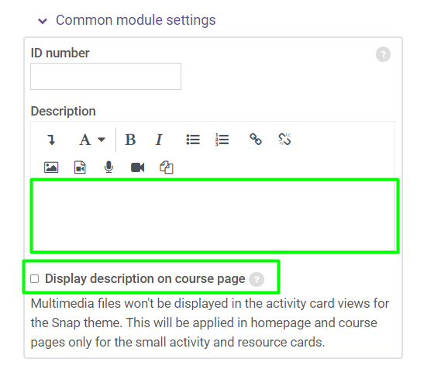
Activity completion lets you determine whether or not you want to track students that open the file.
This does not show up in the gradebook. (Note that completion tracking must be enabled for the course under Edit Settings for this option to be available.)
To disable or not use activity completion tracking, select the option “Do not indicate activity completion”.
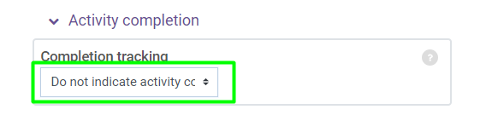
If you want to track whether students click on the file or not, use the following settings for Activity Completion:
- Show activity as completed when conditions are met
- “check” Student must view this activity to complete it.
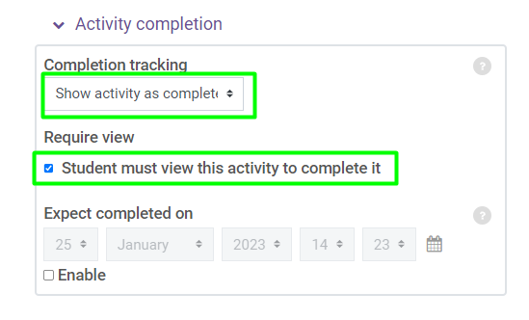
To save changes, click the Save and return to course button.

Adding Folders
If you want to add multiple related files to a course, use the Folder resource.
To add a folder, click the Create learning activity button link at the bottom of the section you want the file to appear in.
Select the Resources tab, and click the Folder icon.
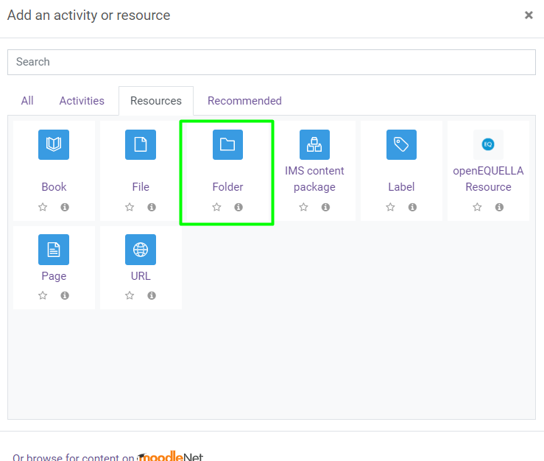
Name your folder and use drag and drop or the Add icon to add the desired files.
Click Save and return to course once you have added all of the files to this folder.

