Forums

Adding Moodle Activities

The Forum activity enables students to post and reply to comments, suggestions, and questions asynchronously.
- A forum is an area where participants discuss a topic or a group of related topics. Within each forum, participants can create many discussion topics.
- A discussion topic includes the initial post and all replies to it.
To add a forum, click the Create learning activity button link at the bottom of the section you want the forum to appear in.
Select the Activities tab, and click the Forum icon.
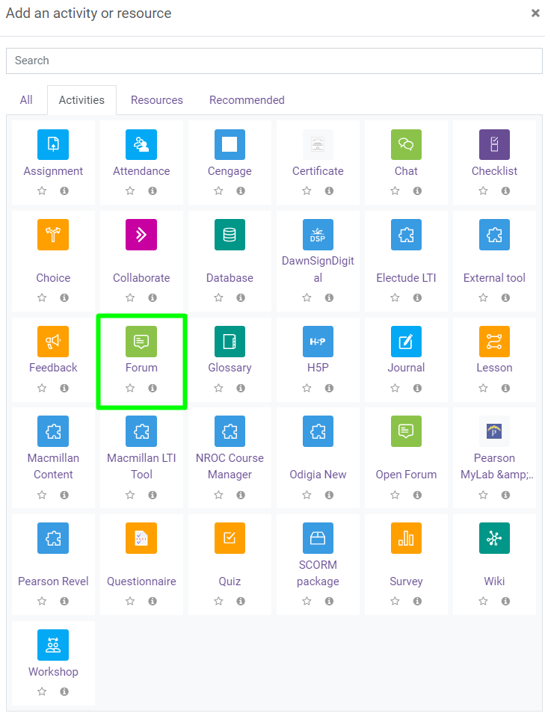
- Create a meaningful name for the forum.
- Enter a description, this is where you provide instructions for students regarding what your expectations are for this forum.
- Check the box to display the description on the course page.
- Select the forum type:
  - A single simple discussion: A single discussion topic where everyone can reply.
  - Each person posts one discussion: Each student can post exactly one new discussion topic, where everyone can reply.
  - Q and A forum: Students must first post their perspectives before they can view other students' posts. Note that this forum requires the instructor to add the first post and then students can reply to it.
  - Standard forum displayed in a blog-like format: An open forum where anyone can start a new discussion at any time, where the discussion topics are displayed on one page with Discuss this topic links.
  - Standard forum for general use: An open forum where anyone can start a new discussion at any time. Note that this is the default and most common forum type.
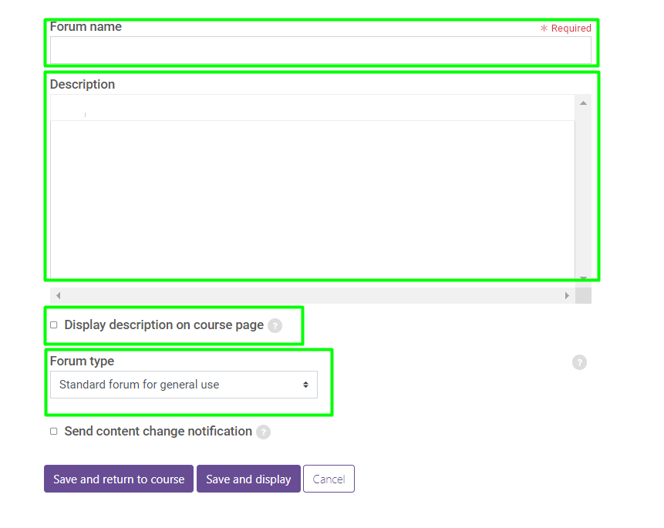
The Visibility setting allows you to make the forum content available or hidden from student view.
Availability allows you to set a due date and a cut-off date. To set the dates and times, check the enable box.
- Due date: Displays when the forum is due, but does not restrict users from adding or replying to posts.
- Cut-off date: Forum will not accept posts after this date.
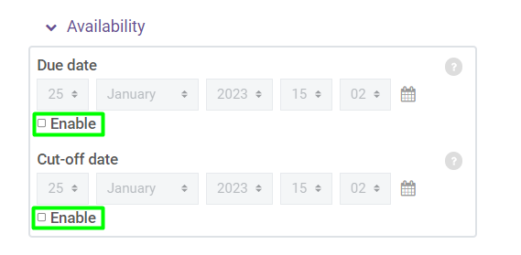
Ratings determine whether this is a graded forum or not.
- No ratings: Not graded.
- Maximum rating: Assumes student is required to only post one discussion in the forum.
- Sum of ratings: Assumes students are required to post multiple discussions, where each post is worth points toward the forum grade. For example, an initial, well-thought-out post could be worth 70 points, and three additional replies to other students could be worth 10 each.
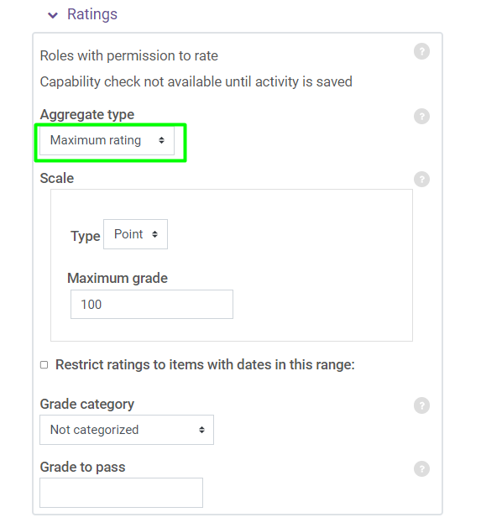
This covers the most common settings; any remaining settings are optional.
Click the Save and return to course button to save the settings.

