Labels
Adding Moodle Resources
Labels allow you to add instructional content, such as text or images, that is embedded directly into the main content area of Moodle.
To add a label, click the Create learning activity button link at the bottom of the section in which you want the label to appear.
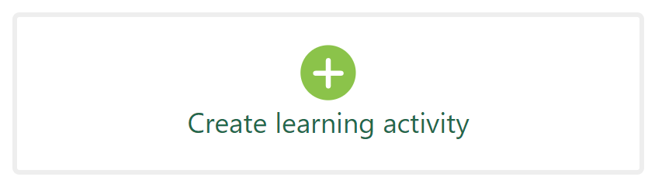
Select the Resources tab, and click the Label icon.
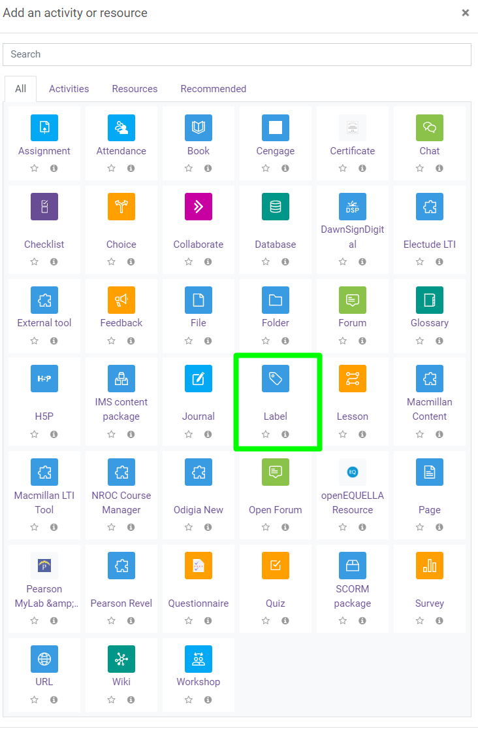
Content is typed directly into the Label text box.
To add an image to the Label text area, position your cursor where you want the image to appear, then click the image button on the formatting toolbar.
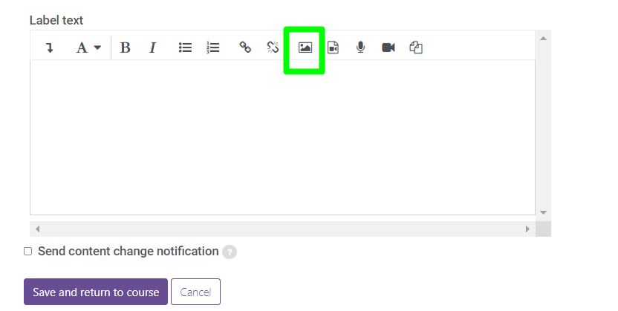
To see more text formatting options, click the Show more buttons button, which is the first button on the formatting toolbar. The formatting toolbar is shown expanded in the image below to reveal all rows of formatting options.
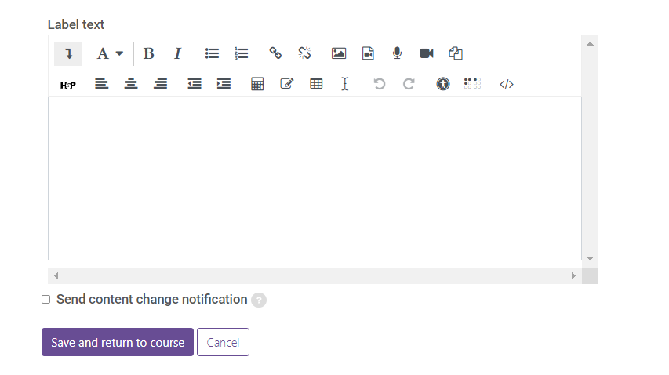
The Visibility setting allows you to make the label content available or hidden from student view.
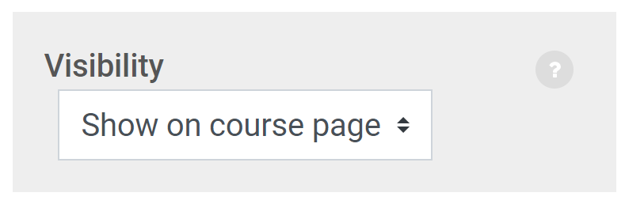
Activity completion allows you to specify whether or not you want the student to be able to check a box to keep track of what they have completed in the course. This does not show up anywhere in the gradebook; this is only for the student to track their own progress. (Note that completion tracking must be enabled for the course under Edit Settings for this option to be available.)
For labels, you will normally want to set this to “do not indicate activity completion”.
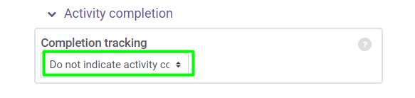
Once you have entered all of the content for the label and modified any settings (the defaults are normally sufficient for this resource type), click the Save and return to course button.

