Pages
Adding Resources to Moodle
Pages allow you to add instructional content, much like a Label, except the Page resource displays a preview of the content; the remaining content can be expanded by clicking a “read more” button.
To add a Page, click the Create learning activity button link at the bottom of the section you want the Page to appear in.
After selecting the Resources tab, click the Page icon.
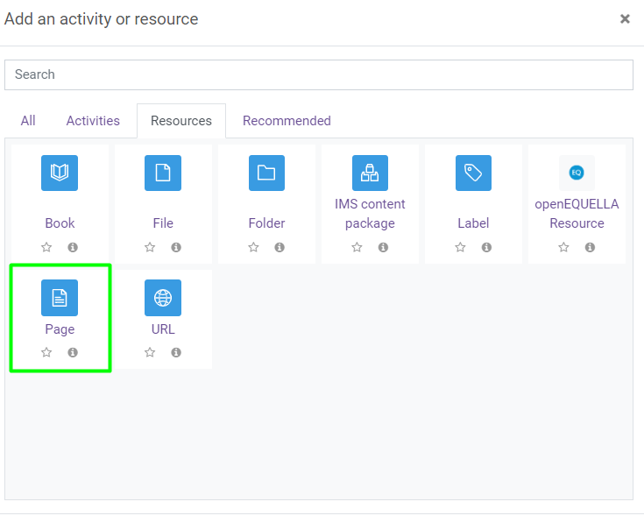

There are two places that content can be added when using the Page resource.
- Description: This content will display prior to the student expanding the Page. If left blank, the first three lines of text from the Page Content box will display instead.
- Page Content: Information added here will be available when expanded by click the “read more” button.
The Visibility setting allows you to make the Page content available or hidden from student view.
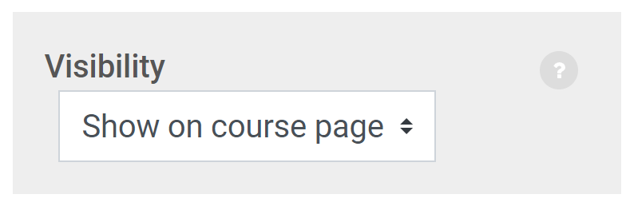
Activity completion allows you to specify whether or not you want the student to be able to check a box to keep track of what they have completed in the course. This does not show up anywhere in the gradebook; this is only for the student to track their own progress. (Note that completion tracking must be enabled for the course under Edit Settings for this option to be available.)
In most cases, you'll want to set this to "do not indicate activity completion" for Pages.
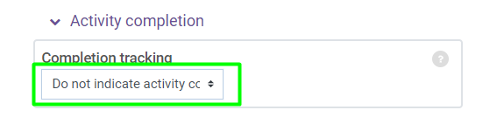
Once you have entered all of the content for the Page and modified any settings (the defaults are normally sufficient for this resource type), click the Save and return to course button.

