Adding Moodle Activities - Quiz
A quiz is an assessment tool that helps teachers understand how well students are learning course material.
Building a quiz is a three-step process: (1) creating the question bank, (2) creating the quiz activity, and (3) adding questions to the quiz from the question bank.

Part I – Creating the Question Bank
- Click the Admin gear, Question Bank, Categories.
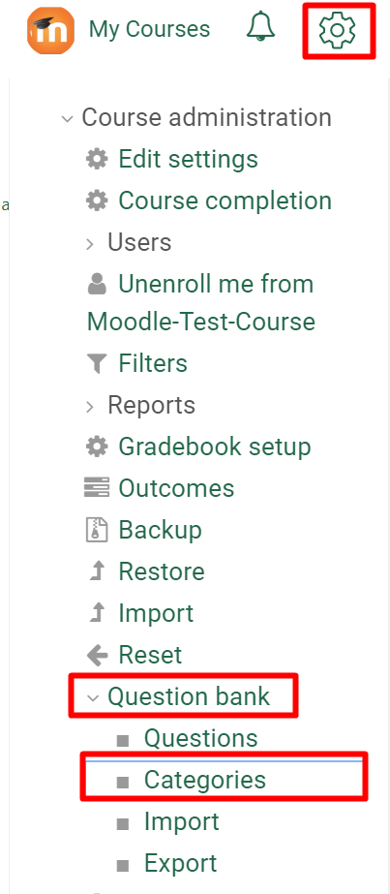

- Scroll down to the Add Category section, enter a category Name, and click Add Category.
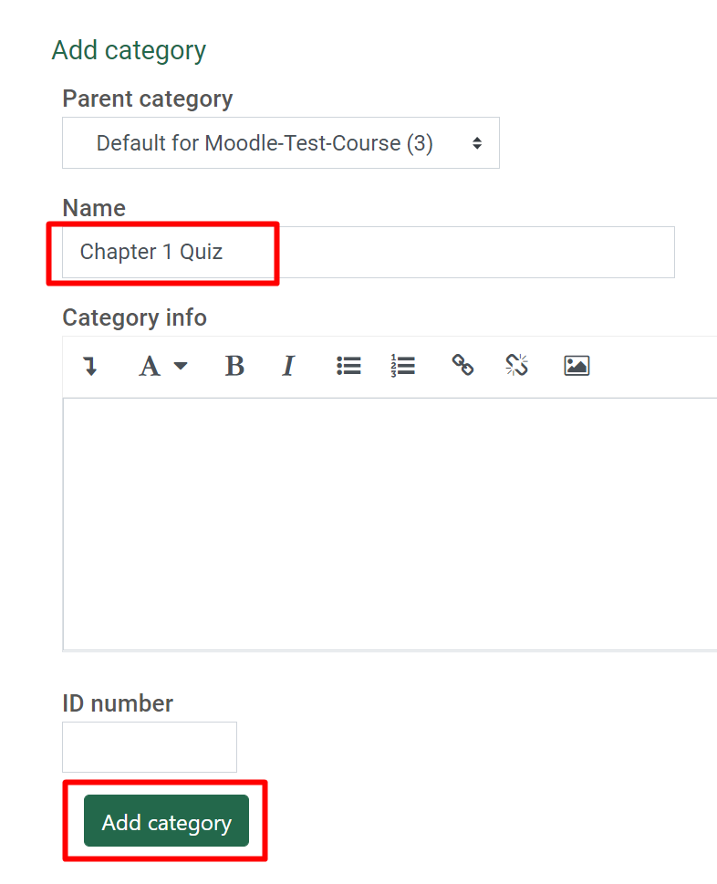
- Click on the Questions tab, select the Category you just created, click Create a new question.
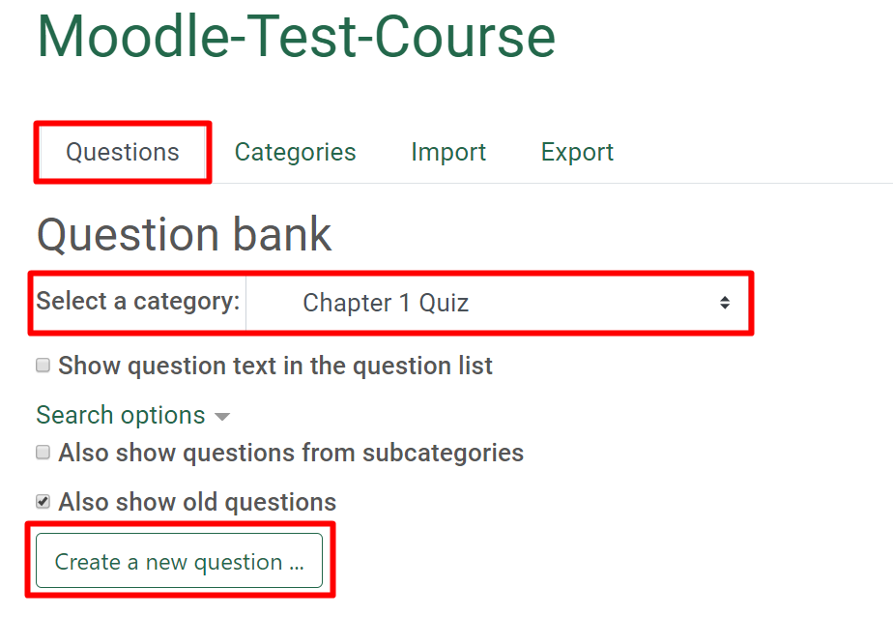
- Choose a question type. The question types outlined in red are questions that Moodle can auto-grade. If you add any of the blue outlined questions, the instructor will have to manually grade each student’s quiz.

- To add a multiple choice question, select Multiple Choice and click the Add button.
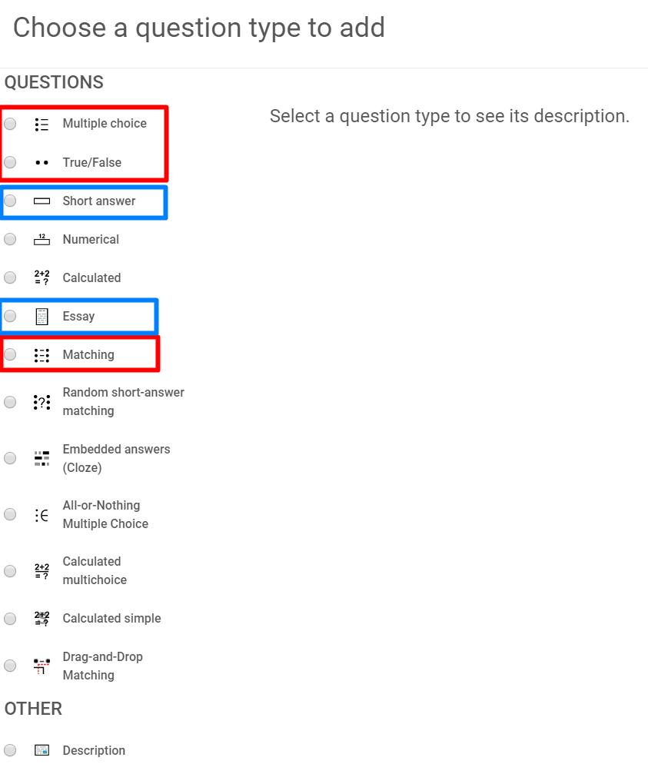
- Enter the Question Text first, then copy and paste this as the Question Name. Leave the Default Points at 1, Moodle will automatically adjust each questions point value to equal 100 based on the total number of questions you add to the quiz.
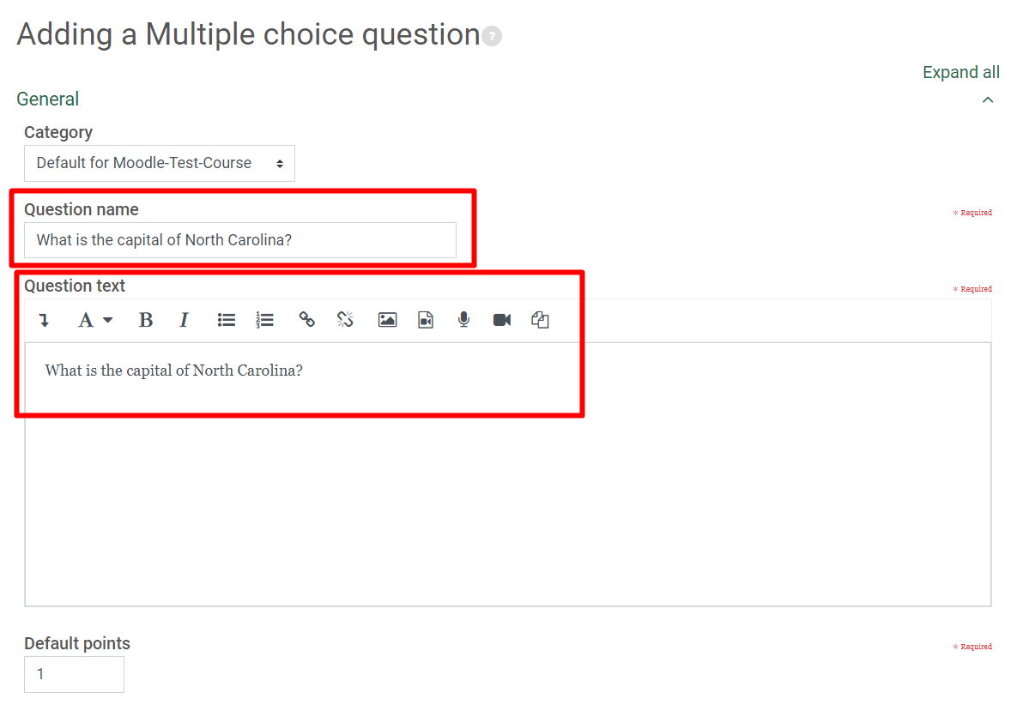

- Enter the correct answer as Choice 1 (responses will be shuffled, so order does not matter here.
- To identify this as the correct answer select 100% as the Grade.
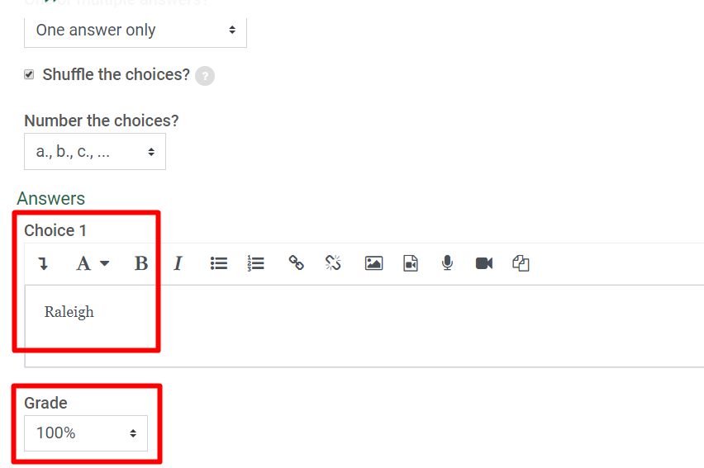
- Next, add three or more wrong answer choices. Leave the Grade at None for wrong answers.
- Scroll to the bottom and click Save Changes.
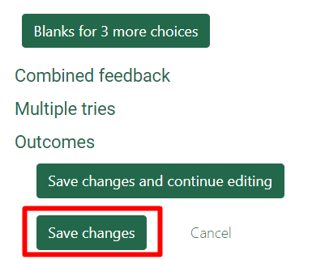
- Repeat steps 3-10 to add remaining questions.

Part II – Creating the Quiz Activity
- To create the quiz, click the Create learning activity button link at the bottom of the section you want the quiz to appear in.
- Select the Activities tab, and click the Quiz icon.
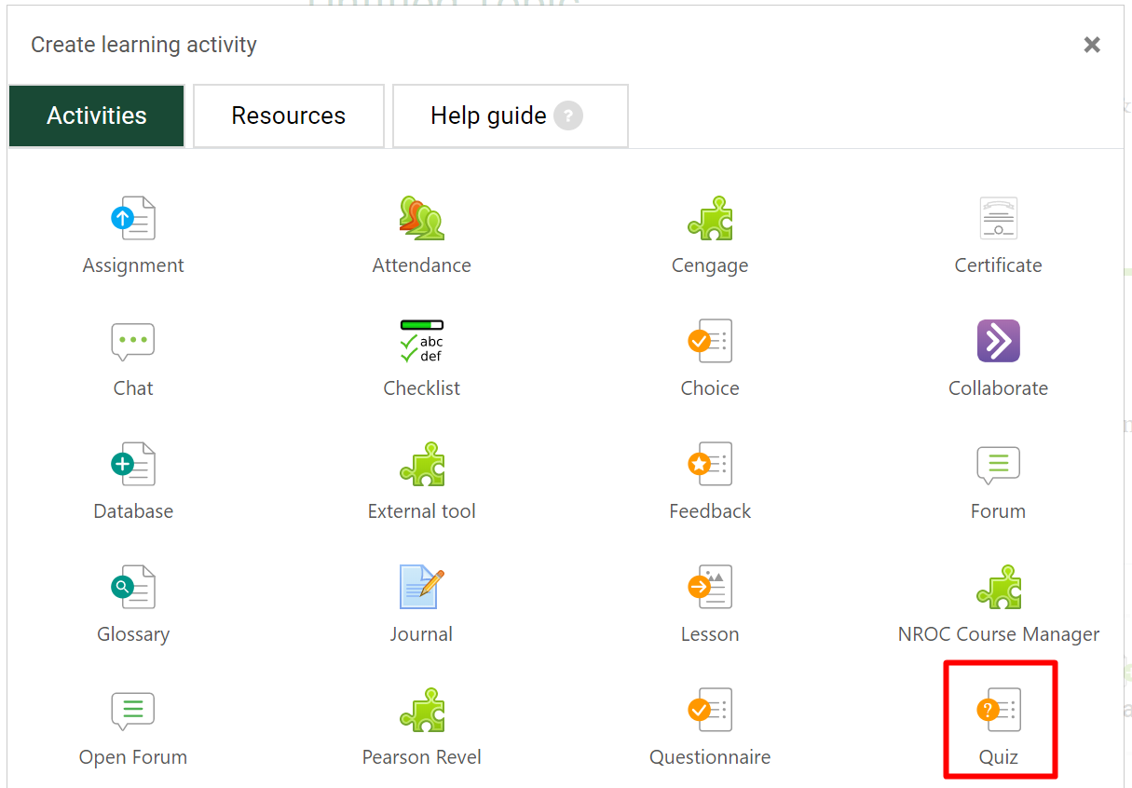
- Create a meaningful name for the quiz.
- Enter a description, this is where you provide instructions for students regarding what your expectations are for this quiz.
- Check the box to display the description on the course page. This is optional, if you have lengthy instructions you may want to not check the box, students will see the instructions when they click into the quiz.
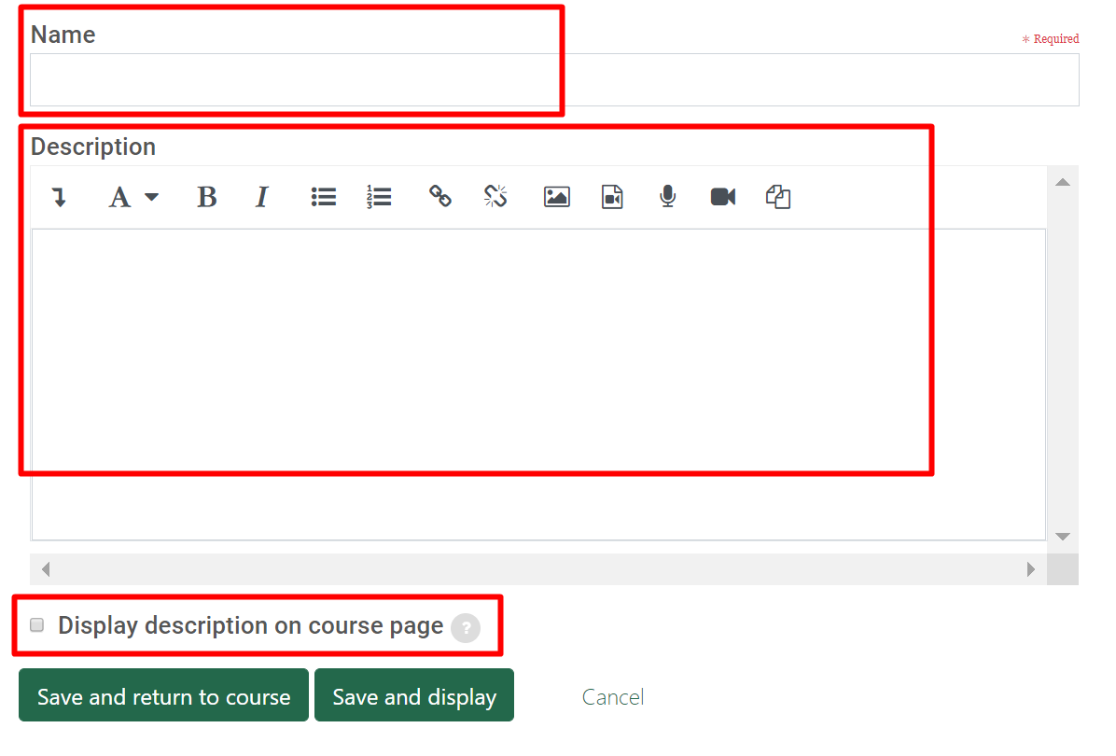
- The Visibility setting allows you to make the quiz available or hidden from student view.
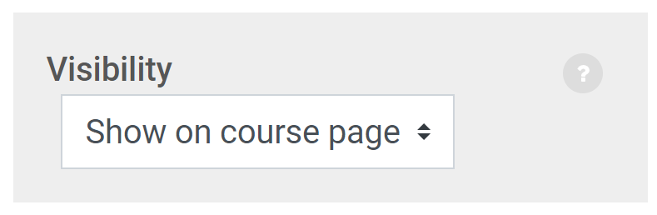
- Timing allows you to determine when the quiz opens and when it closes for students. Check the Enable box to adjust these settings. You can also enable and adjust the time limit. All other settings in this category may be left at the default.
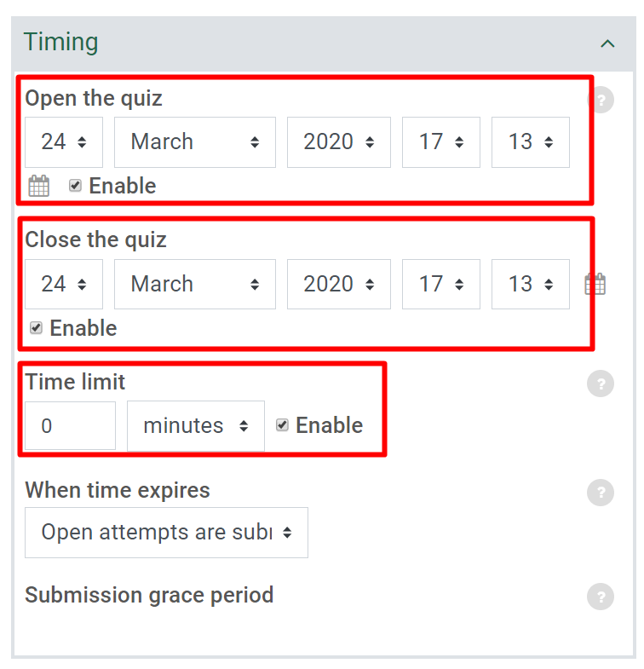
- The Grade category allows you to set the number of attempts. The most common is 1 or 2, but it is at the discretion of the instructor depending on your intent for the quiz. You may choose unlimited if this is a review tool that you want students to keep doing until they reach a certain score.
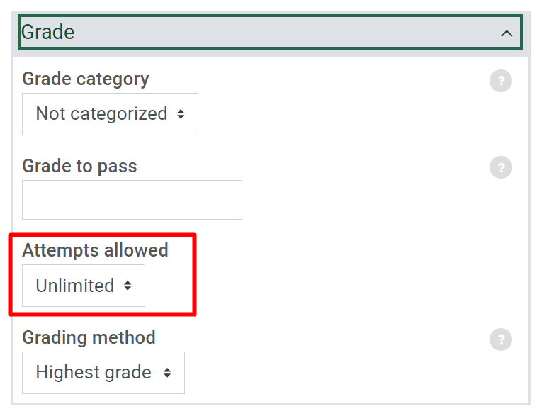
- Layout lets you choose how you want the quiz to appear. The options are described below:
- Every question – shows one question per page with the student clicking next to load the next question. This is good if you are concerned about a student printing off the quiz.
- Never, all questions on one page – shows the entire quiz on one page. Let’s the student answer in random order if they prefer.
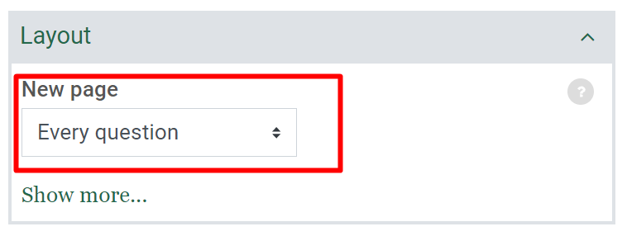
- Question behavior determines how a student interacts with the quiz.
- Shuffle within questions – shuffles the answer choices.
- How questions behave – deferred feedback requires the student to submit the entire quiz before anything is graded. This is the most common choice.
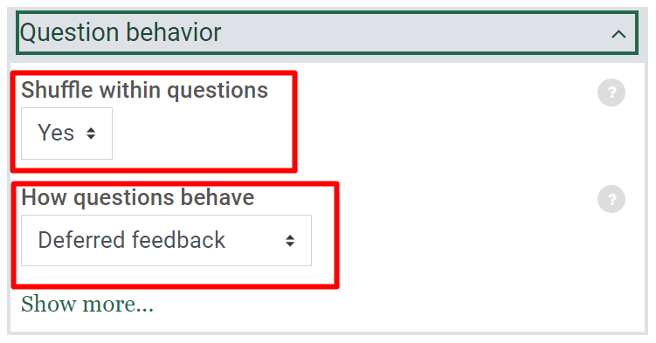
- Review options controls what students see at different times of the quiz process.
- During the attempt: Allow students to see the selected information while they are answering a question.
- Immediately after the attempt: Allow students to see the selected information immediately after the quiz attempt. The settings apply for the first two minutes after the student selects Submit all and finish.
- Later, while the quiz is still open: Allow students to see the selected information later, while the quiz is still open. The student must view the information before the quiz close date passes.
- After the quiz is closed: Allow students to see the selected information after the quiz close date has passed.

- Uncheck anything you do not want students to view at that time of the quiz process. If unsure, leave the settings at the default.
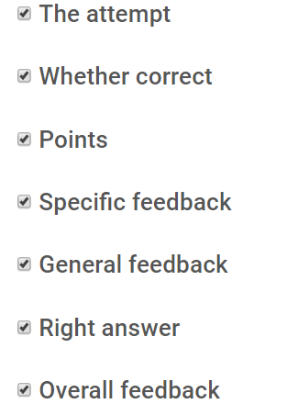
- Appearance is primarily used to set the decimal place. I like to use “0” and let Moodle round so that the student is not confused about rounding. However, some instructor grading scales may not be conducive to this. You decide.
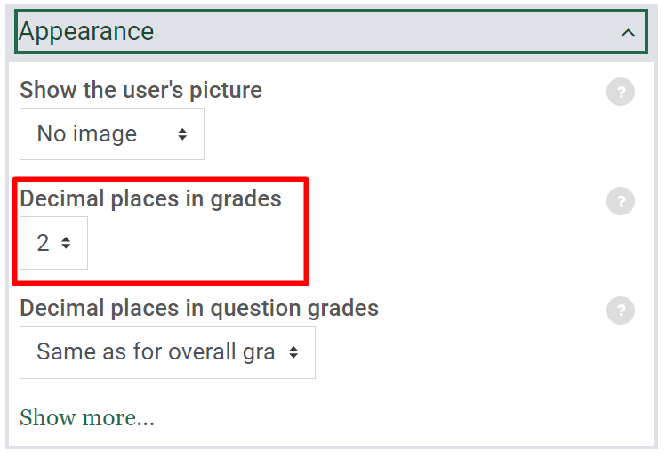
This covers the most common quiz settings, any remaining settings are optional.
- Click the Save and display button to save the quiz settings and begin adding quiz questions.

Part III – Adding Questions to the Quiz from the Question Bank
- Click Edit quiz to get started.
- Change the Maximum grade to 100 and click Save.
- Check the box to Shuffle the questions in the quiz for each student.
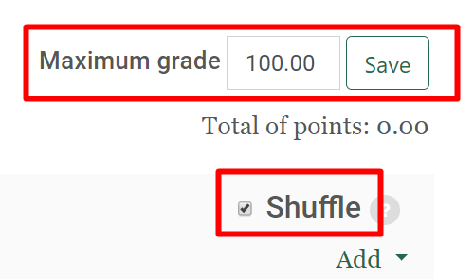
- Next, click Add
  - Select “from question bank” to add all or select specific questions from a question bank.
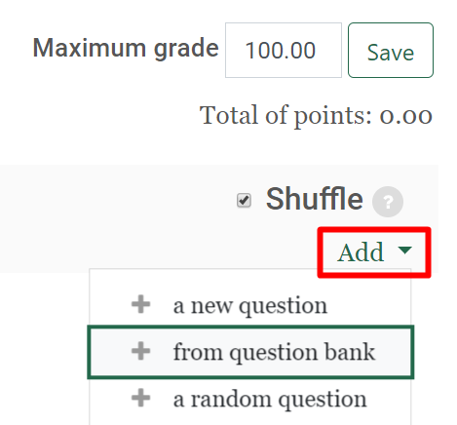
  - Select “a random question” to add a fixed number of random questions from a question bank.
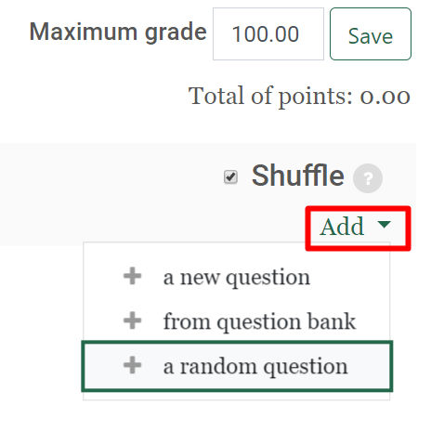
- When finished, click your Course Name to return to your course and then click on your Quiz to preview it.
