URLs

Adding Resources to Moodle

The URL Resource allows you to create a link to websites outside of the Moodle course site.
To add a URL, click the Create learning activity button link at the bottom of the section you want the URL to appear in.
Select the Resources tab, and click the URL icon.
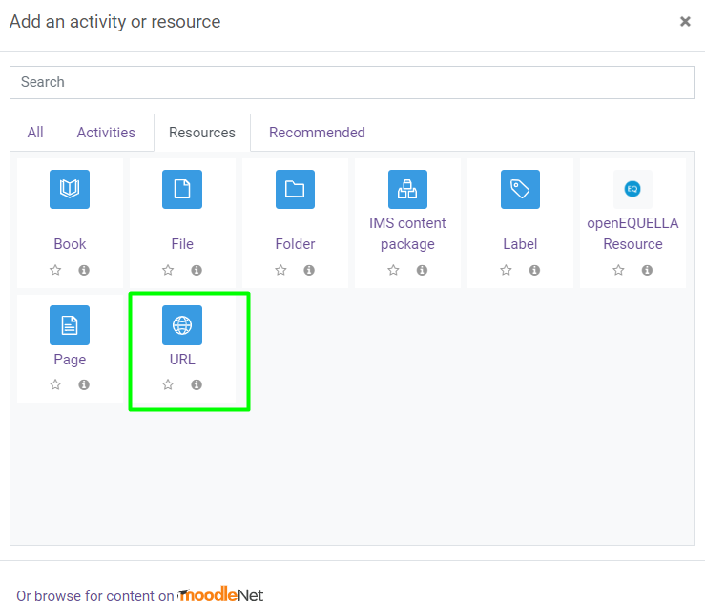
Enter the Name that will appear as the link to your URL resource. Copy and paste the URL in the External URL box.
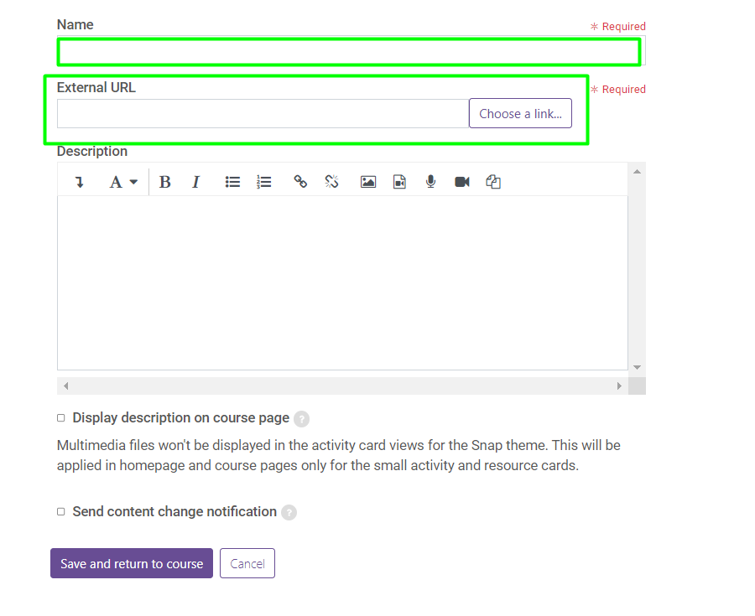
Restrict Access and Activity Completion settings can be configured for the URL Resource.
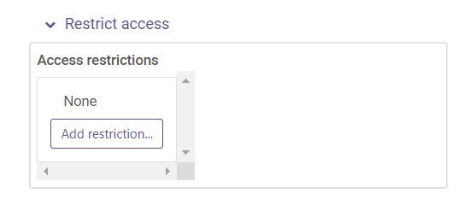
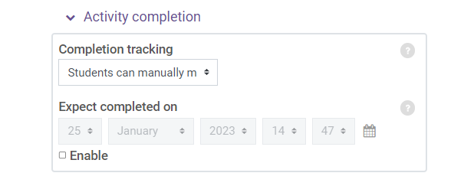

When finished, click Save and return to course.

