User Overrides
How to add them in Moodle

To make quiz or assignment adjustments for an individual student, follow these steps to add a user override for the student.

Overrides can be set to allow an individual student to have a date or time extension on a quiz or assignment, allow extra time on a quiz, or allow additional attempts on a quiz.

Quiz User Override Instructions
- Go to the assessment you want to input an override for, and open it.
- Click the Admin gear, and then click Overrides.
- Click the Add User Override button.
- In the Search box, type the student name and then select the student.
  - If you want to allow an extension past the original due date, check the box to Enable the Close the Quiz date and set the new deadline for the extension.
  - If you need to give a student extra time, check the box to Enable the Time limit and set the total time to allot for the student.
  - If you want to allow a student an additional attempt, change the Attempts allowed to 2.
  - If you want to keep an absent student from taking the assessment while not in class, make the date in Close the quiz the day prior so that the individual student cannot access it.
  - NOTE: In Moodle 4.0,if you have your browser set to autofill login info and do not want the students to use a password to access the assessment, you have the option to clear your login cache or you can follow the instructions on the “User Override with Cache” document
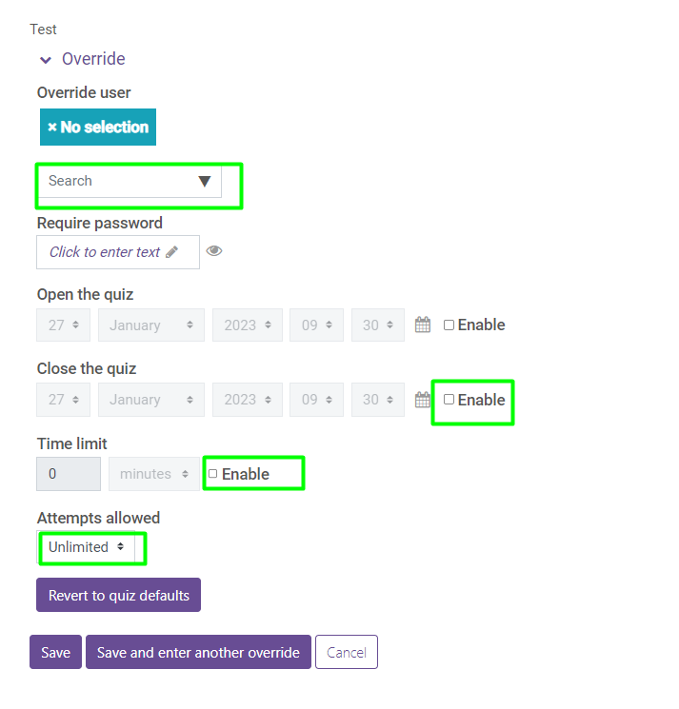
- Click Save.

Assignment User Override Instructions (basically the same as assessments)
- Go to the assignment you want to input an override for, and open it.
- Click the Admin gear, and then click Overrides.
- Click the Add User Override button.
- In the Search box, type the student name and then select the student.
- To allow an extension past the original due date, check the box to Enable the Cut-off date and set the new deadline for the extension.
- Click Save.

