How to Add a Final Grade Column in the Moodle Gradebook

- Click the Admin Gear, click Gradebook Setup.
- Scroll to the bottom and click “Add Grade Item”.
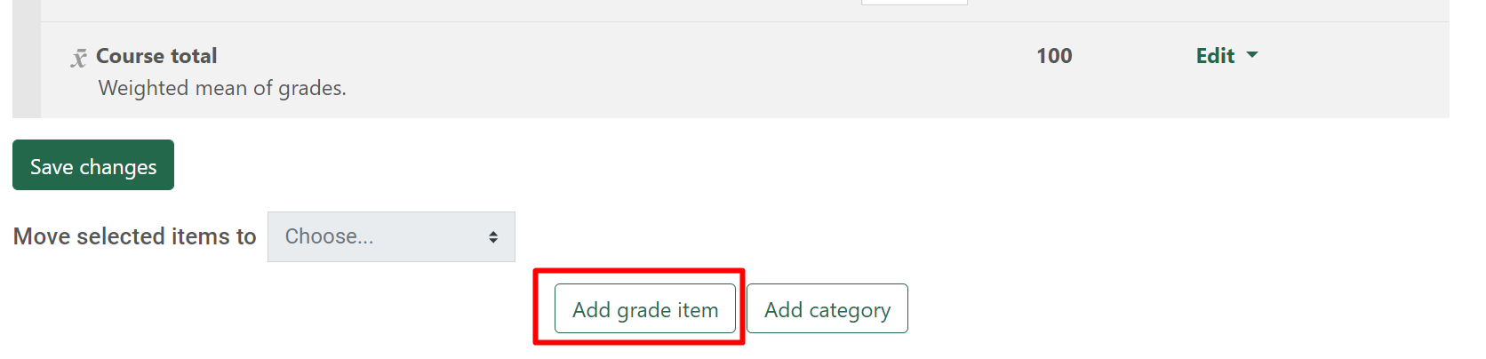
- Adjust the following settings:
  - Item name = Final Grade
  - Grade type = Scale
  - Scale = Final Grade Scale
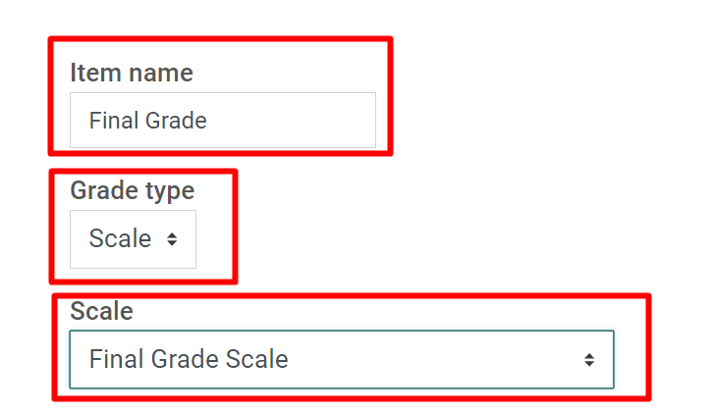
- Scroll down and click Save Changes.

