How to Allow an Extra Attempt on Assignment Activities

- Navigate to the Assignment Activity in your course.
- Click the pencil to edit the assignment settings.
- Expand the “Submission Settings” category.
- Attempts reopened should be set to “Manually”.
- Maximum attempts should be set to “Unlimited”.
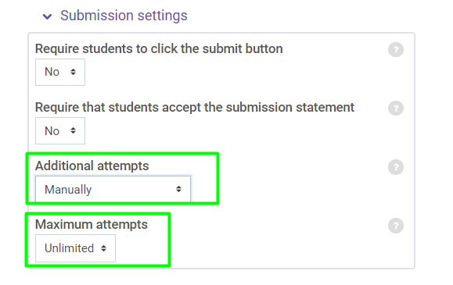
- Next, go to the activity in your course and click the “x of x Submitted” link.
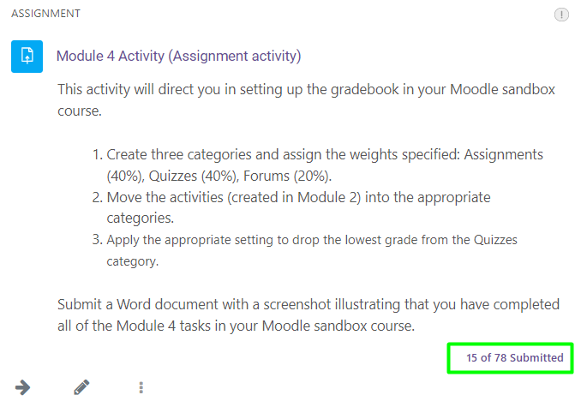
- Click the “Grade” button for the student you want to assign an extra attempt for.
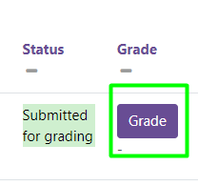
- In the Edit column, click the drop-down Edit to view the Attempt Settings. Click Allow another attempt.
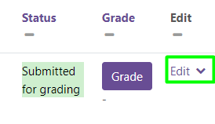
- Click Save Changes.

