How to Drop the Lowest Grade from a Category
Go to Admin Gear and click Gradebook setup.
Click Edit, then Edit Settings for the category you want to drop the lowest grade from. In this example, I am dropping the lowest grade from the Quizzes category.
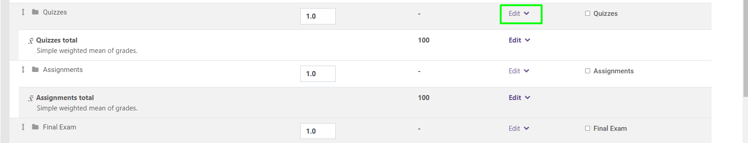
In the Grade Category section, click Show more.
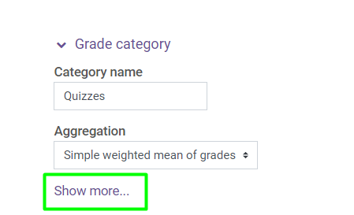
At Drop the lowest enter “1”.
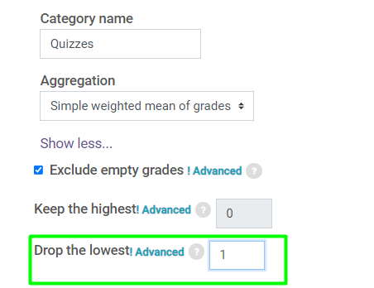
Click Save Changes.
One or more grades can be dropped from a single or multiple categories. (Example: drop the lowest quiz and assignment grade.)

