Import Course Content in Moodle

How to
You can copy individual assignments or entire courses using the import feature in Moodle.
You must have access to both courses when importing content. If you are an adjunct, you may need to ask a full-time instructor who teaches the same course to copy the content for you, or you can make a request to the Instructional Support department to be added to the previous course as a non-editing teacher so that you can copy the content yourself.

Steps to Import Content from a Previous Course
- In your new course shell, click the Admin gear.
- Click Import.
- Use the search courses box to find and select the course you want to copy content from, and then click Continue.
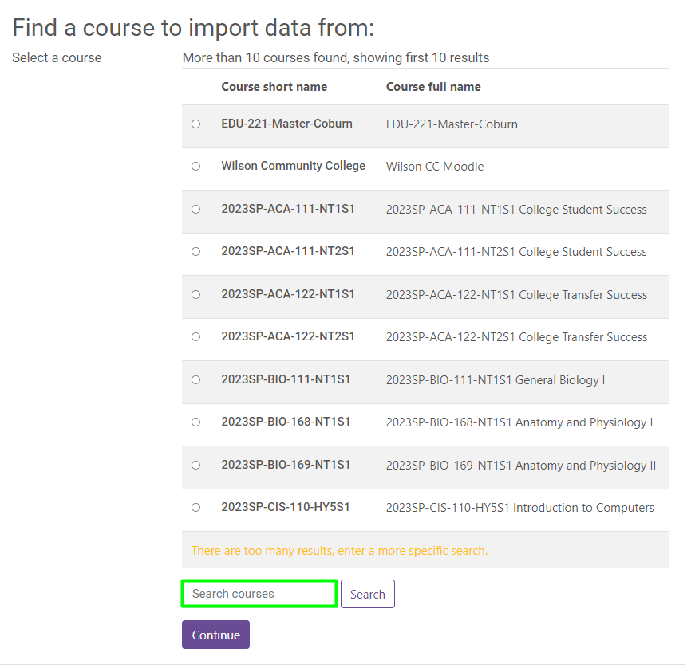

- Uncheck Include blocks and click Next
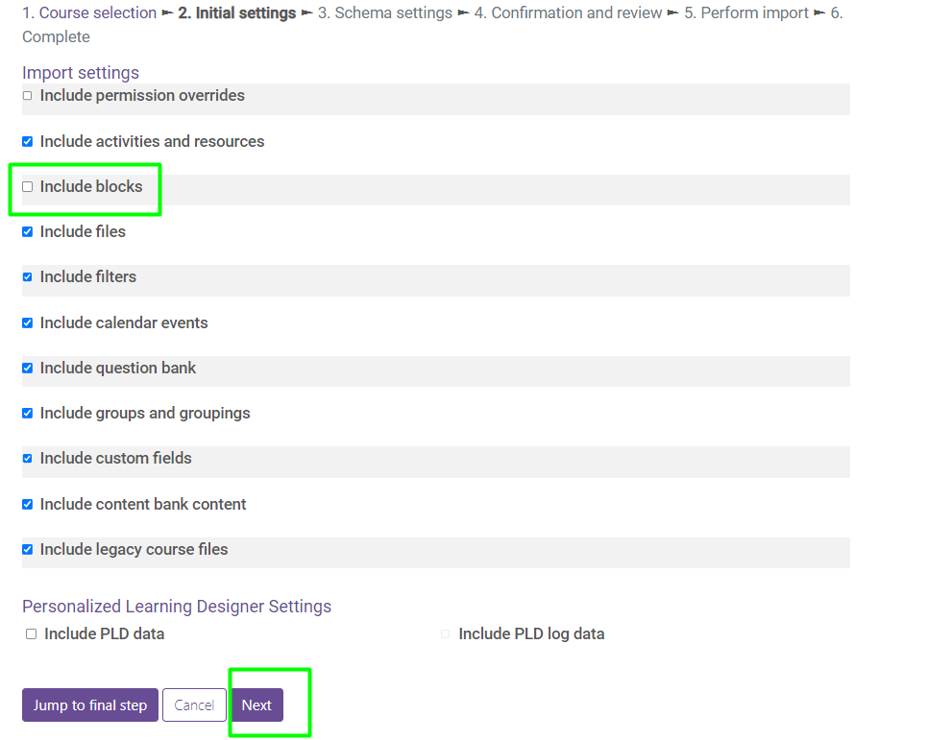
- Uncheck the following items, along with any other content that you do not want to copy from the old course (updated versions of these items will be in the new course shells).
  - Announcements
  - Enrollment Verification
  - College Resources
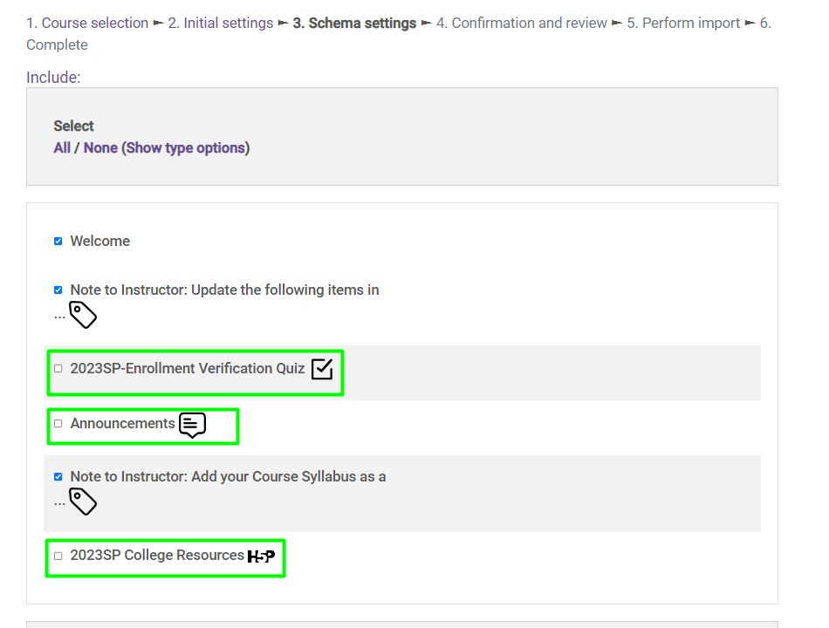
- Scroll to the bottom, and click Next
- Scroll to the bottom, and click Perform Import
- When the process finishes, click Continue

Tips and Tricks
Take note of the following potential importing issues and how to resolve them.
- The welcome message does not import. This will need to be copied and pasted from another course or entered from scratch.
- The Gradebook Setup will only import from a previous course if no edits have been made in the new shell prior to importing.
- The Topic 1 and Topic 2 section names do not import. The content in these sections does import, but the section names do not, these will need to be manually updated after import.
- Change the “Course Start Date” in the Master Course to match the start date in the course shell you are importing to. The start dates must match or the activity dates throughout the course may be altered during import.

