Import a Quiz or Testbank

How to Import into Moodle using a Text file

A specific format, called Aiken, must be followed in order to prepare questions in a file that can be uploaded into Moodle as a Quiz.
The Aiken format lets you create multiple-choice or true-false questions in a plain text file and import it into Moodle.
Step 1: Compose your questions in Notepad using the following format:
The Loch Ness Monster is a type of…
A. Homonid
B. Lizard
C. Ape
D. Plesiosauria
ANSWER: D

The Coelacanth was considered a cryptid until 1938.
A. True
B. False
ANSWER: A

Question Format Guidelines
- Do not number questions.
- Questions must be on one line.
- Each answer must start with a single uppercase letter followed by a period, then a space.
- The answer line must immediately follow, starting with the word ANSWER in all caps, colon, then the letter of the correct answer in all caps.
Step 2: Save as .txt (plain text)
Step 3: Import into Moodle
- Click the Admin gear, click Question Bank, then click Import.
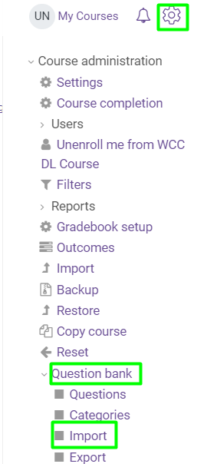
- For File Format, select Aiken Format.
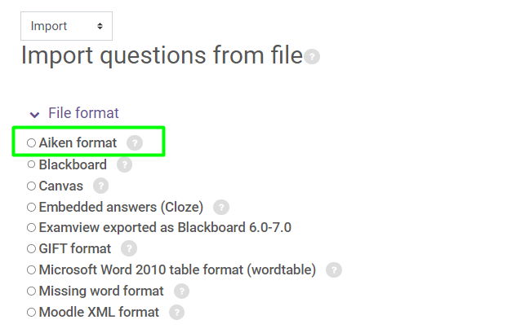
- Under Import questions from file, click Choose a file...
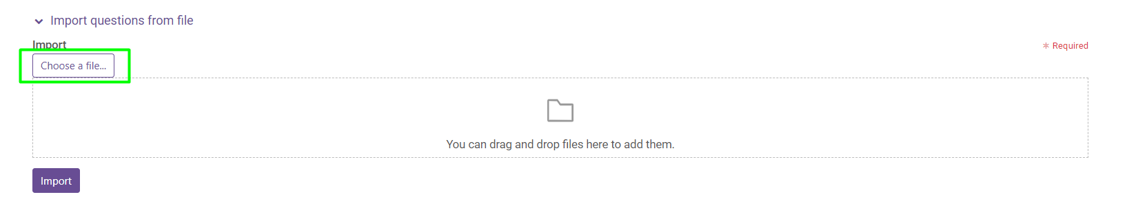
- Click Upload File, then Browse, select your file and click Open.
- Click Upload this File.
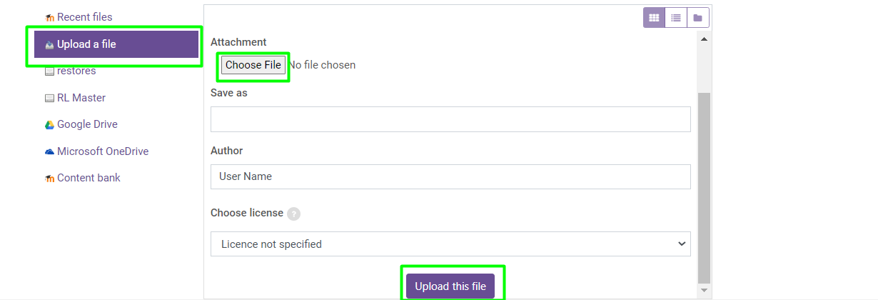
- Click Import. You will see the message "importing (#of) questions from file, with a list of the questions. If you do not see the number of questions expected, check your import file for typos or errors in the question format that could cause it to read two questions as one.
- Click Continue. Your question bank will open.

