How to Import a Testbank into Moodle from a Publisher

Testbanks from publishers can usually be imported using one of the following methods:
Method 1:
Use this method if your testbank is labeled as a Blackboard testbank, or is a .zip file.
- Click the Admin gear, click the chevron for Question Bank, then click Import.
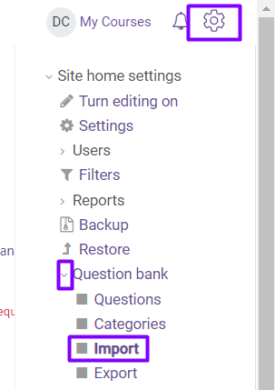
- For File Format, select Blackboard.
- Under Import questions from file, click Choose a file...
Note: if your zip file has individual zipped chapters, you may need to import each zipped chapter individually.
- Click Upload File, then Browse, select your file and click Open.
- Click Upload this File.
- Click Import. You will see the message "importing (#of) questions from file”, with a list of the questions.
- Click Continue. Your question bank will open.
Method 2:
Use this method if your testbank is labeled as a Moodle testbank, or is an .xml file.
- Click the Admin gear, click the chevron for Question Bank, then click Import.
- For File Format, select Moodle XML format.
- Under Import questions from file, click Choose a file...
- Click Upload File, then Browse, select your file and click Open.
- Click Upload this File.
- Click Import. You will see the message "importing (#of) questions from file”, with a list of the questions.
- Click Continue. Your question bank will open.

