How to Include Empty Grades in the Moodle Gradebook

- Click the Admin Gear, click Gradebook Setup.
- For each weighted category click Edit, Edit Settings.
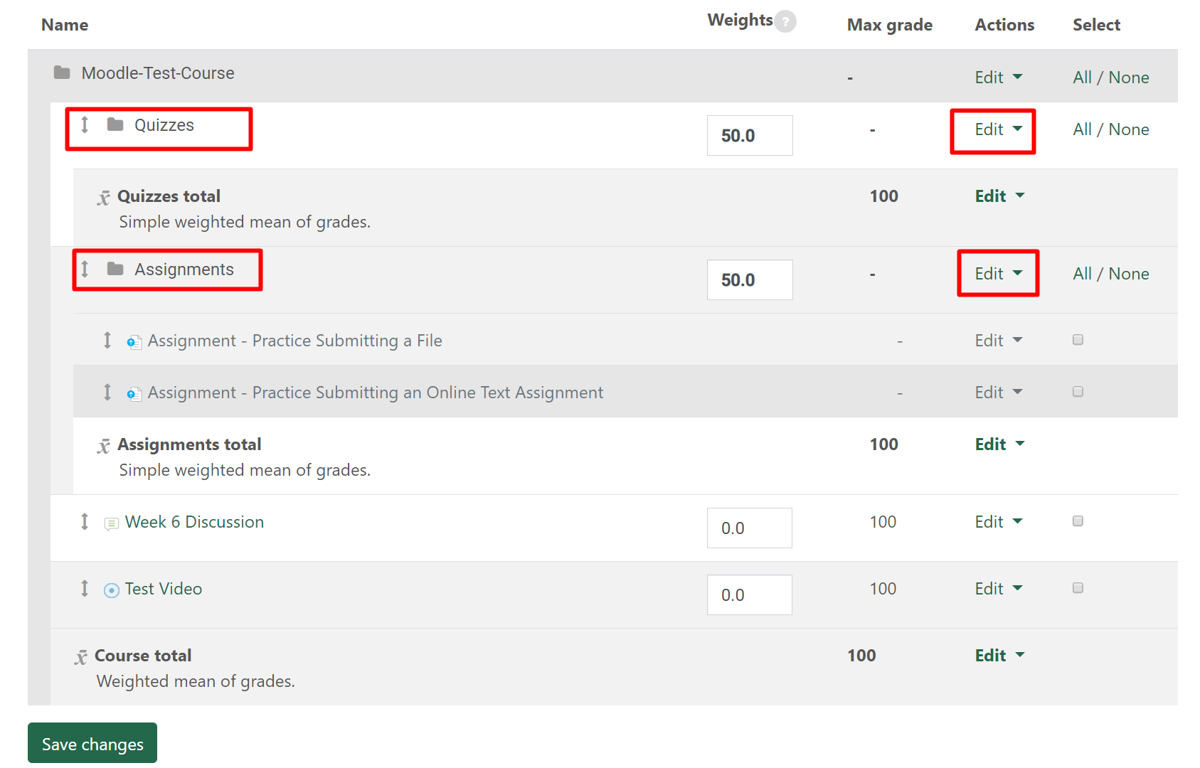
- Click the first “show more” link to expand the options.
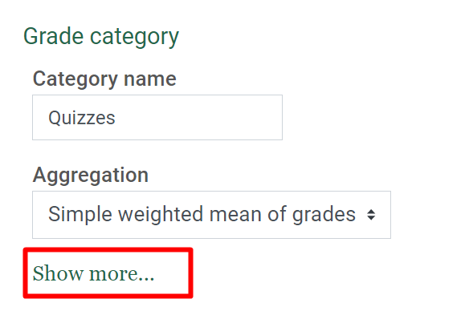
- Uncheck “exclude empty grades”, click Save Changes.
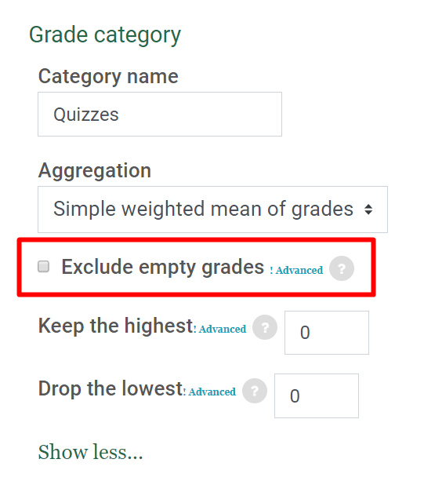
- Repeat for each weighted category.
- Save Changes made in the Gradebook.

