How to Schedule Google Meet Web Conferences in Outlook

- Start Outlook.

(Note: you must use the downloaded Outlook client to schedule a Google Meet session, this will not work with the web-based version of Outlook/O365.)

- To schedule a meeting, at the Home tab, click the New Items dropdown and select Meeting.
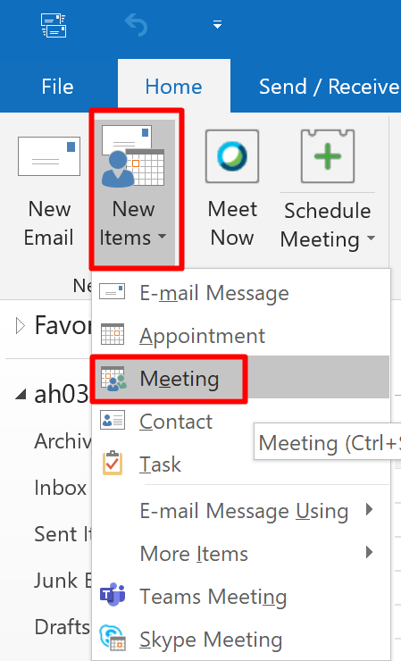
- In the Meeting window, click the Google Meet icon and select Add a Meeting.
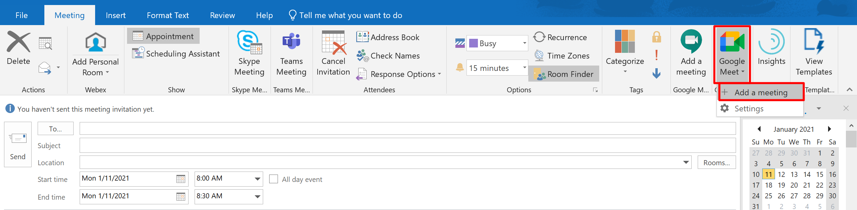
- You will then be asked to connect your Google account with Outlook. Sign in using your Wilson CC email address (i.e. xx####@wilsoncc.edu).
This adds the Google Meet link in your message, instructors will use the same link to access the Google Meet as participants.
Note on Recording sessions – If you record a session, make sure you end the recording when the session is over, the recording will then be emailed to the address you used to create the recording, and it will be saved to your Google Drive in the “Meet Recordings” folder.

