How to Set up a Group Chat in Microsoft Teams

- Open Teams
- Click Chat
- Click the New Chat icon
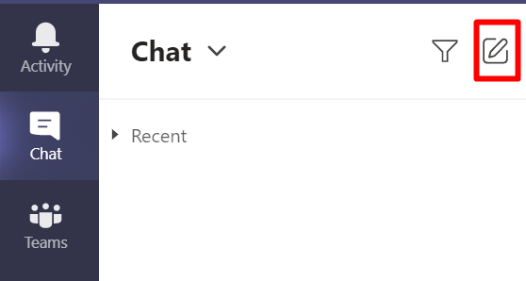
- Click the down arrow to expand options
- Enter Group Name
- Enter names or email addresses
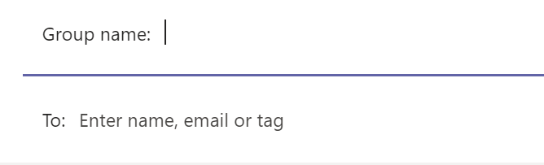
- Press enter to save the group

Pop-Out Chat
To avoid confusion with other chat threads in Teams, you may want to pop-out the group chat when actively participating.
- Click the chat you want to use
- Click the pop-out chat icon
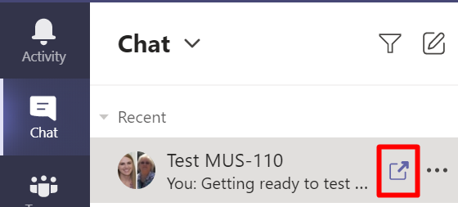

Remove Users
- Pop-out the chat you want to use
- Click the View and Add Participants icon in the top right
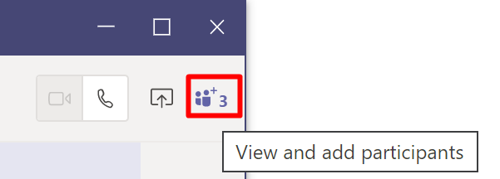
- Hover over the user you want to remove and click the X beside their name
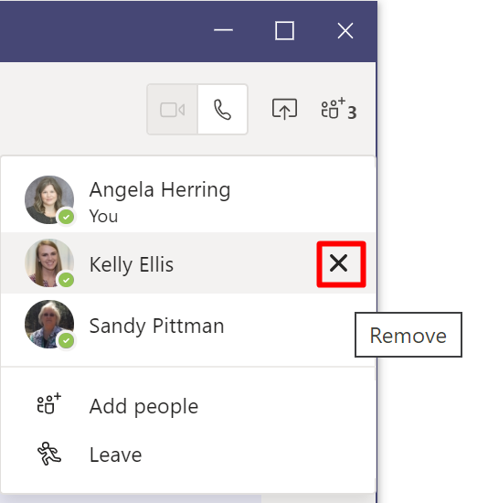

Add Users
- Pop-out the chat you want to use
- Click the View and Add Participants icon in the top right
- Click Add People
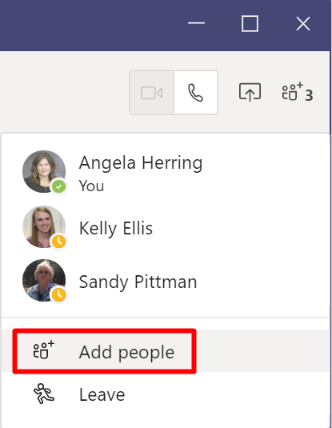
- Type the users name or email address and click Add
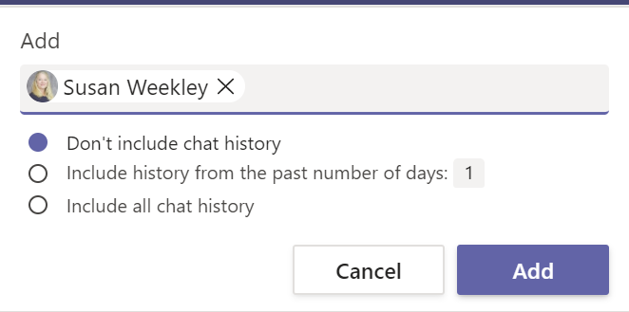

Schedule a Group Chat Meeting
Scheduling a group chat meeting will send an invite, to all participants in the group, with a link to join via Teams video, and put a meeting reminder in their Outlook calendar.
- Pop-out the chat you want to use
- Click the Schedule a Meeting icon at the bottom of the chat window
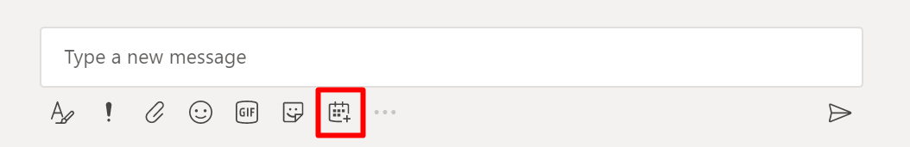
- Set the outlined parameters in the image below and click Send
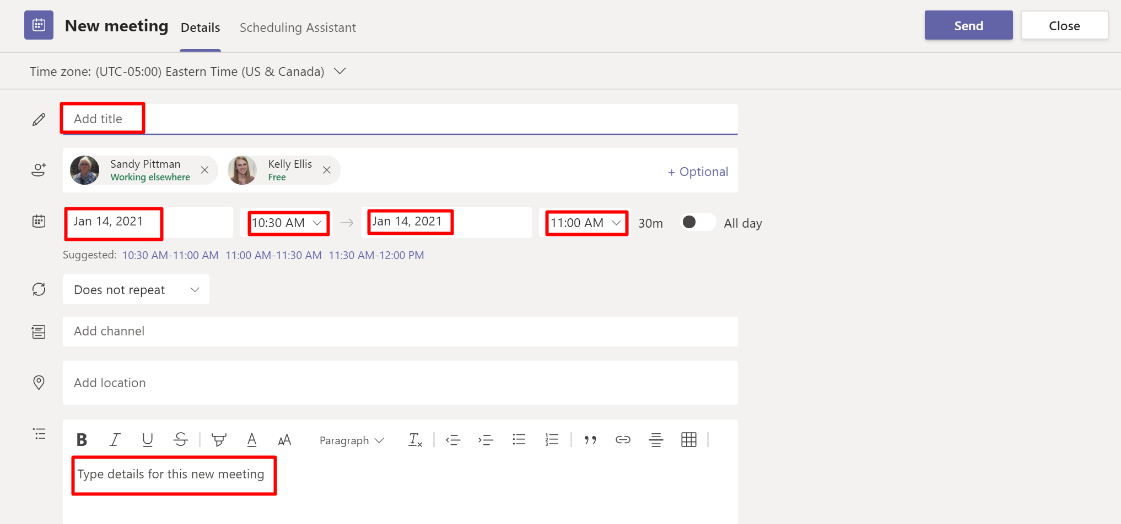
- If this is a weekly or recurring meeting those options can be set by clicking the does not repeat drop down arrow and selecting the appropriate setting.
