Restrict Access
How to Setup
Restrict access is used in conjunction with Activity Completion to require students to complete or view one resource or activity before another one becomes available.
**Note: See the document “How to Use Completion Tracking in Moodle” before using Restrict Access.

Using Restrict Access to Restrict Section Availability by Date
- Go to the section in the Contents that you want to add a date restriction to.
- Click the “Edit Section” icon under the section name.
- Expand the Restrict Access category and click the Add Restriction button.
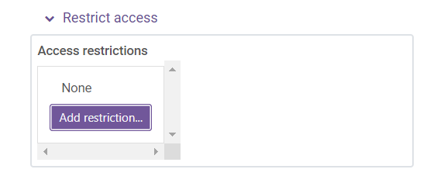
- Click the Date button from the list of options.
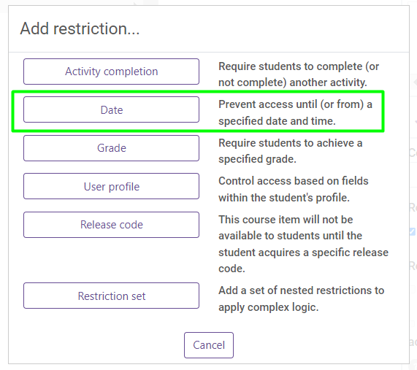
- Choose the date you want the content to become available to students.
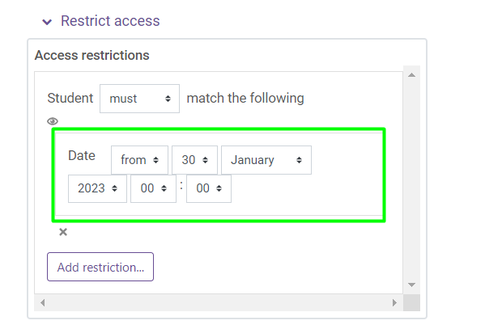
In the example above, students will not see this section in the “Contents” until January 1, 2023.
Sections and activities can also be restricted by whether a student completes or views a previous section, activity, or resource. An example of this type of restriction is described below.

Using Restrict Access to Restrict Activity or Resource Availability by Activity Completion
- Go to the activity or resource that you want to add a restriction to.
- Click the Pencil icon under the activity or resource name.
- Expand the Restrict Access category and click the Add Restriction button.
- Click the Activity Completion button from the list of options.
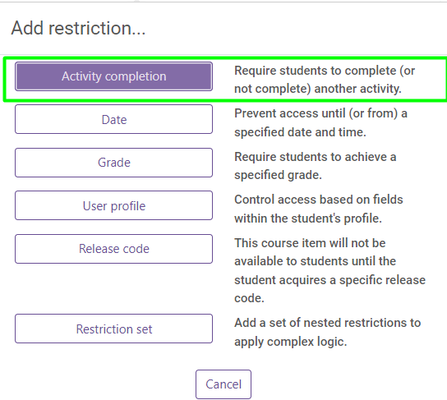
- Choose “the activity” you want students to complete before viewing the selected content and click Save and return to course.
