Moodle Gradebook Setup

How to Setup a Weighted Grade System
A weighted grading system allows you assign different percentage weights to categories to compute the course average. This is the most commonly used grade system.
Go to your course and click the Admin gear in the top right, and then click Gradebook setup.
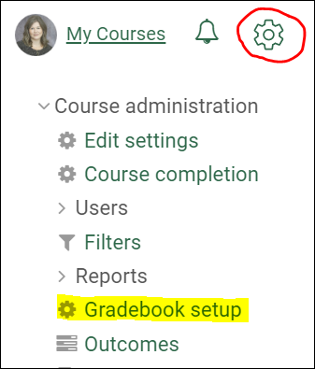

Add Categories
The first task in setting up the Moodle gradebook is to add all of your categories. To add a category, scroll to the bottom of the Gradebook setup screen and click the Add category button.
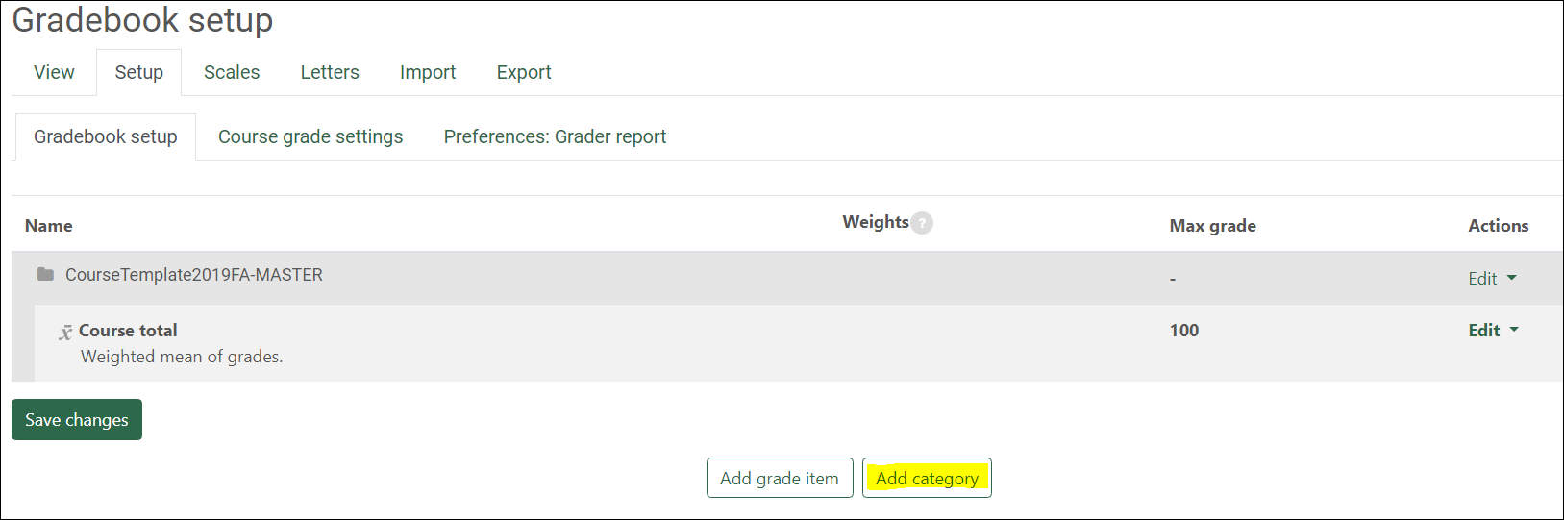
- Name your category to match the grading evaluation categories posted in your syllabus.
In this example, I will use the following grading evaluation categories and weight distribution:
- Quizzes - 50%
- Assignments - 25%
- Final Exam 25%
- Select Simple weighted mean of grades as the Aggregation and click Save Changes.
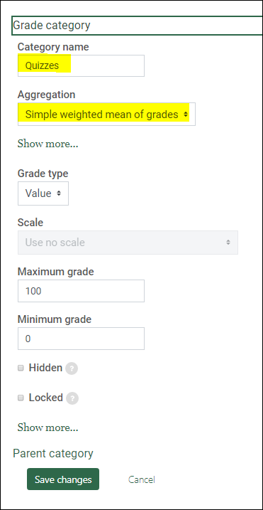
Repeat to add all categories in your gradebook. Click Save Changes.

Move Grade Items into Categories
Next, you will move grade items into the appropriate category by checking the box in the Select column for each grade item in a particular category. For example, check all of your quizzes, then scroll to the bottom and use the Move selected items to dropdown to select the category to move the selected grade items into. Repeat to move all grade items into the correct category. Click Save Changes.
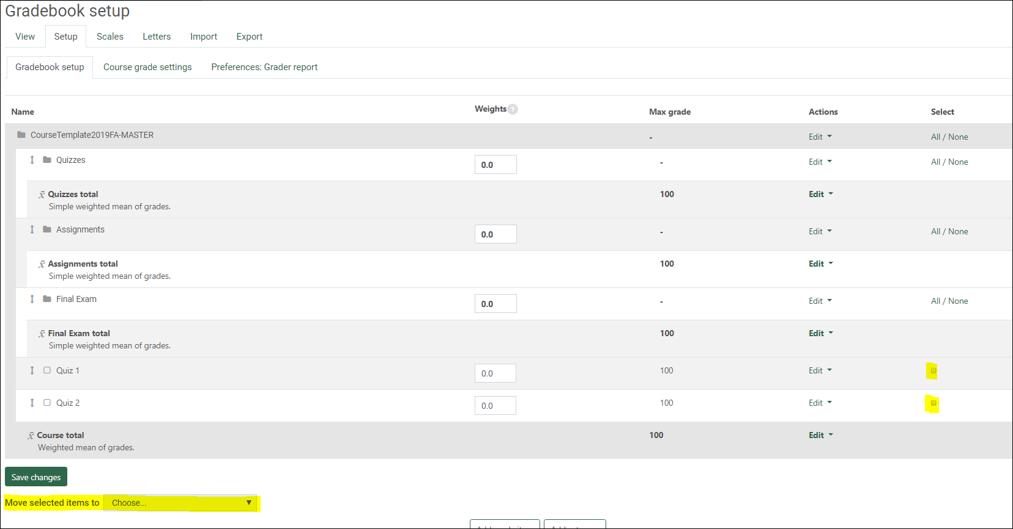

Assign Weights to Categories
The aggregation for the main course category must be set to weighted mean of grades in order for the weight boxes to display. To change this, click Edit, Edit Settings next to the main course category.
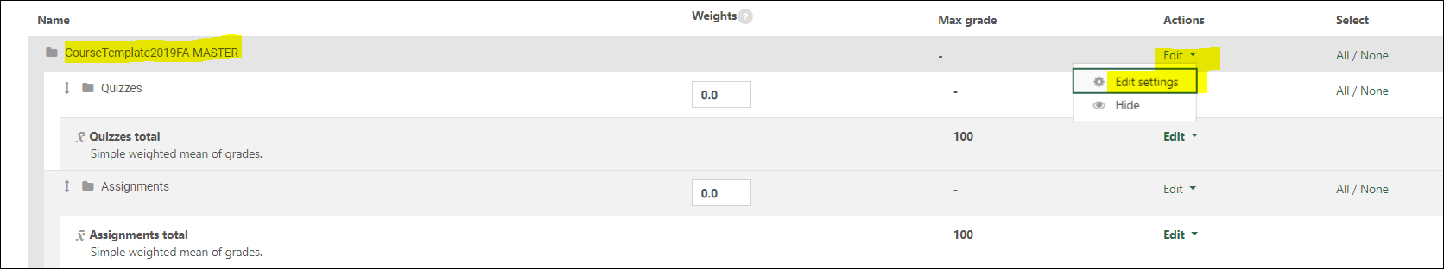
Change the aggregation to Weighted mean of grades.
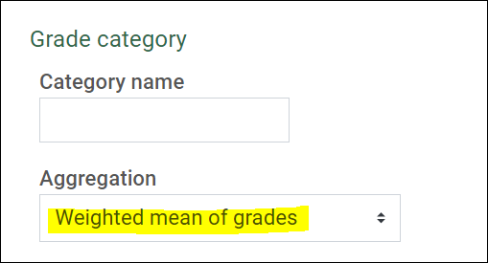
All other categories should have the aggregation Simple weighted mean of grades.
Enter the weight for each category in the boxes in the Weights column. Any items that are not in a category, and should not be counted in the course average, should have a weight of zero. Weights should add up to 100. Click Save changes.
