Completion Tracking in Moodle
How to
Completion tracking allows students to track their progress in a course with checkboxes in the main content area and within each section of your course. If enabled, the checkboxes will appear. You may also have to enable completion tracking within each resource or activity you add to the course.
**Note that completion tracking is the setting that determines if the progress bar is displayed under each section in the Contents.

To enable Completion Tracking in a course:
- Access the Course Dashboard by clicking the link at the bottom of the Contents area in your course. Then click on the Course Settings block.
- Expand the Completion Tracking category.
- Change the Enable Completion Tracking setting to “Yes”.
- Change the Show activity completion conditions to “Yes”.
- Click Save Changes.
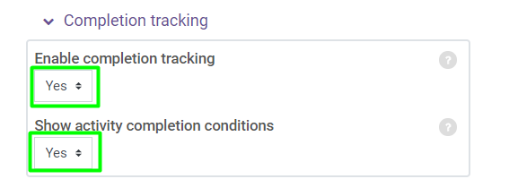

To enable and configure Activity Completion for a Quiz:
- Go to the section in the Contents that contains the quiz you want to edit.
- Click the Pencil icon below the quiz name.
- Expand the Activity Completion category.
- Select the completion tracking option to “Show activity as complete when conditions are met” to have Moodle automatically mark an activity complete after the student meets the specified conditions.
- Next, check Student must receive a grade to complete this activity.
- Click Save and return to course.
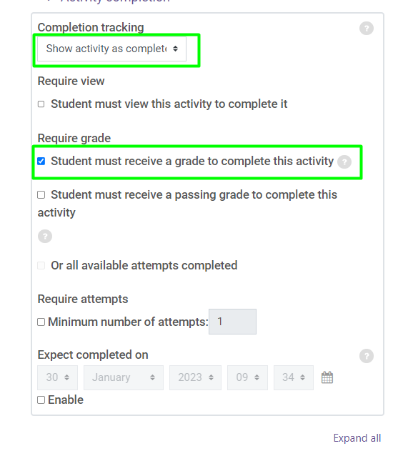

To enable and configure Activity Completion for a URL or other Resource:
- Go to the section in the Contents that contains the resource you want to edit.
- Click the “pencil” icon below the resource name.
- Expand the Activity Completion category.
- Select the completion tracking option to Show activity as complete when conditions are met to have Moodle automatically mark an activity complete after the student meets the specified conditions.
- Next, check Student must view this activity to complete it.
- Click Save and return to course.
