Communicating in Moodle

How to use Chat

The chat activity allows instructors to hold virtual office hours or virtual class meetings. This is only a text-based tool. Chat transcripts can be saved to allow students who miss a chat to review important information later.
- To add a chat, click the Create learning activity button link at the bottom of the section you want the chat to appear in.
- Select the Activities tab, and click the Chat icon.
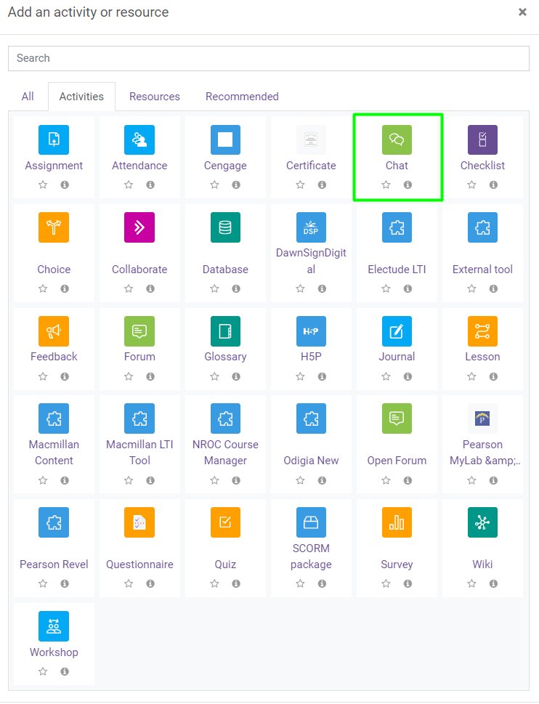
- Name the chat room – it is recommended that you create a new chat for each session you hold.
- Add a description – this is recommended to inform students of the chat purpose.
- Check “display description on course page”.
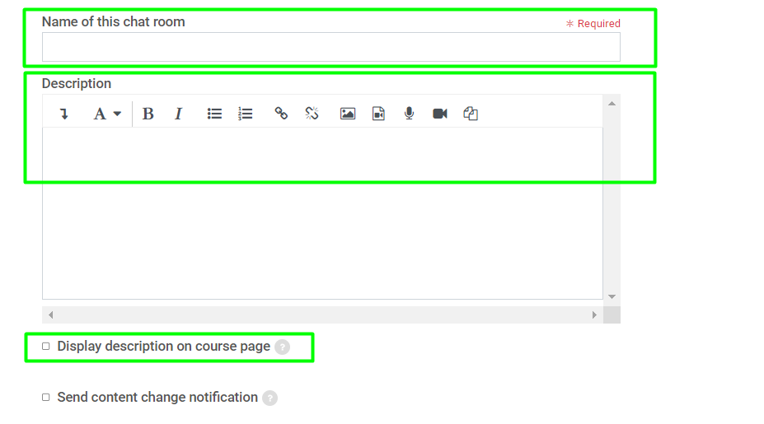
- Set the Visibility to “Show on course page”.
- Chat sessions settings will depend on your preference and intended use, make sure you address each option to determine what best fits your situation.
Note: Make sure you set the option to “save past sessions” so that students that are not able to attend the chat can go back and read the transcript to review important information they may have missed.
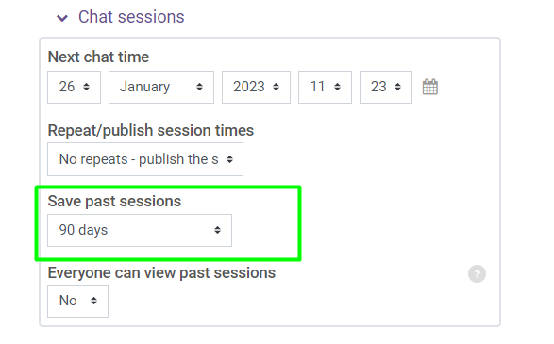
- The remaining settings can be left at the default setting.
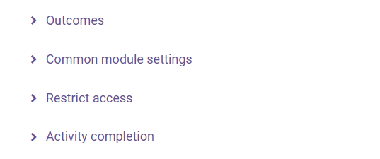
- Click Save and return to course.
- What chat looks like in a course.
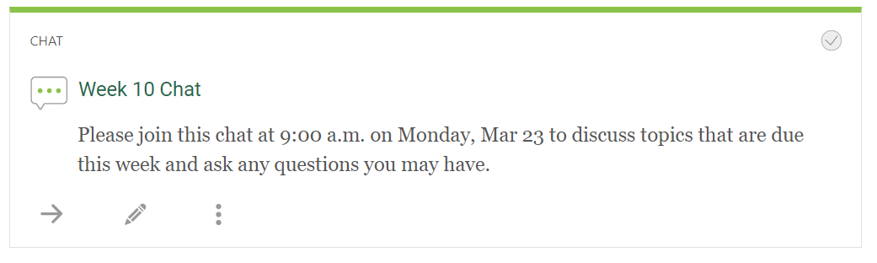
- When the student or instructor enters the chat, a simple interface will be displayed that shows the conversation in the top left area, the participants in the right area, and the chat typing box in the bottom left.
