Communicating in Moodle

Using Collaborate
Collaborate is a fully interactive web conferencing environment within Moodle that enables you to meet and connect with one student or your entire class. You and your students can collaborate using audio, video, screen sharing, and an interactive whiteboard. Sessions can be recorded to allow students that miss the live session to view the recording later.
- To add a Collaborate session, click the Create learning activity button link at the bottom of the section you want the session to appear in.
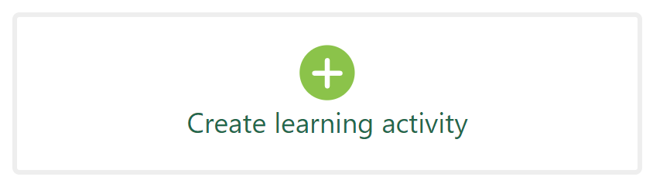
- Select the Activities tab, and click the Collaborate icon.
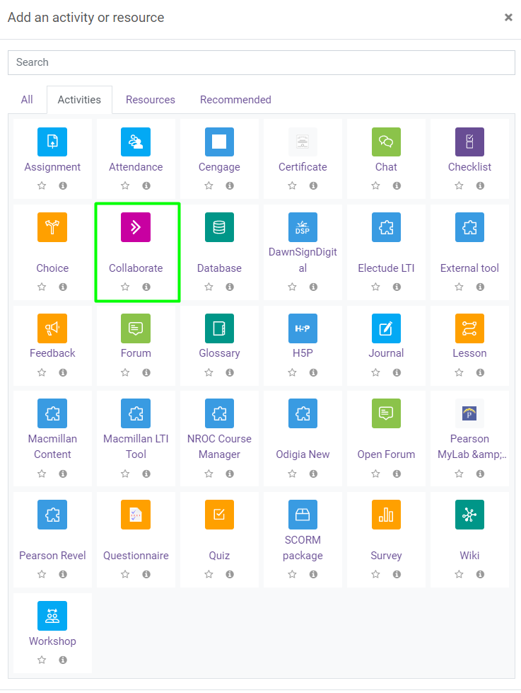

- Add a Session name: It is recommended that you create a new collaborate session for each session you hold.
- Add a description: This is recommended to inform students of the session purpose.
- Check: “Display description on course page”.
- Set the: Start time and the Duration.
- There is no need to allow guests within a Moodle embedded Collaborate session, as all active students in the course will have access.
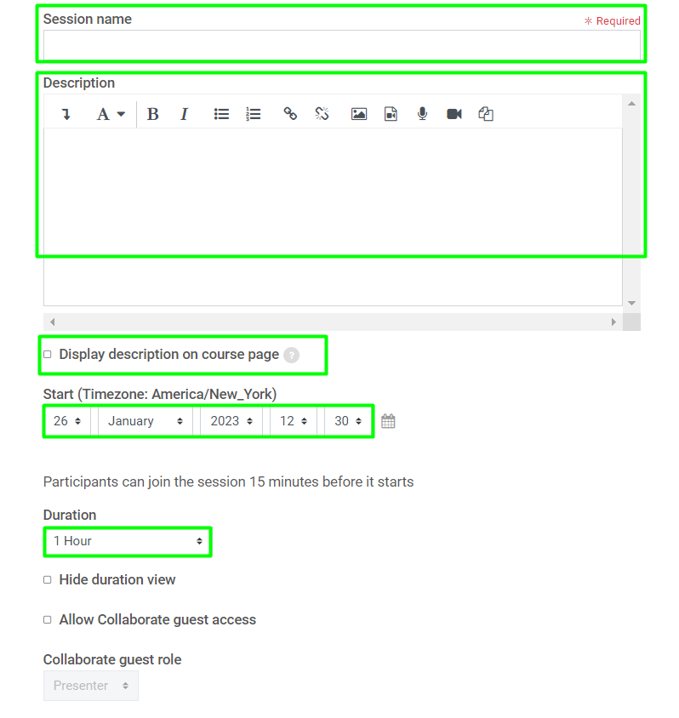
- Set the Visibility to “Show on course page”.
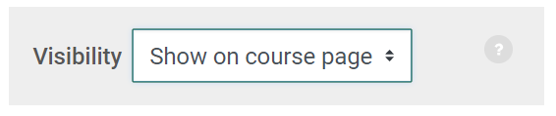
- Instructor Settings: Can be set to meet instructor goals for the Collaborate meeting.
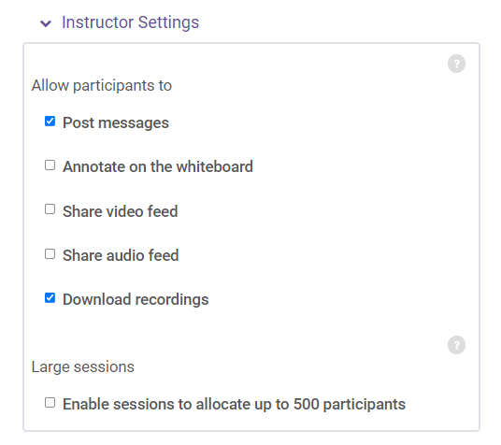
- The remaining settings can be left at the default setting.
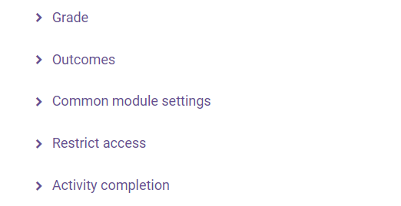
- Click Save and return to course.
- What Collaborate looks like in a course.
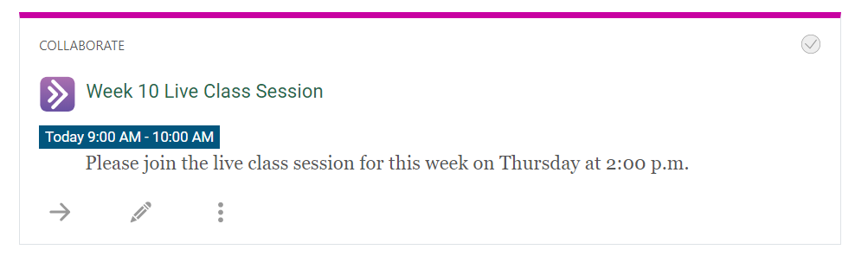
- When the student or instructor enters the Collaborate session, they will need to click the Join Session button.
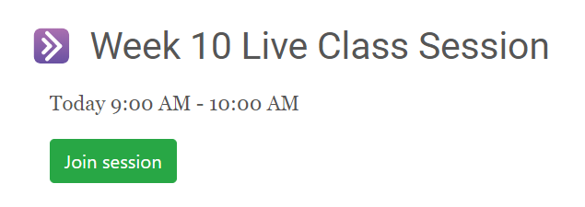
- The Collaborate window allows you to control the interactive environment using the Session menu in the top left, the Collaborate panel in the bottom right, and the user controls in the bottom middle.
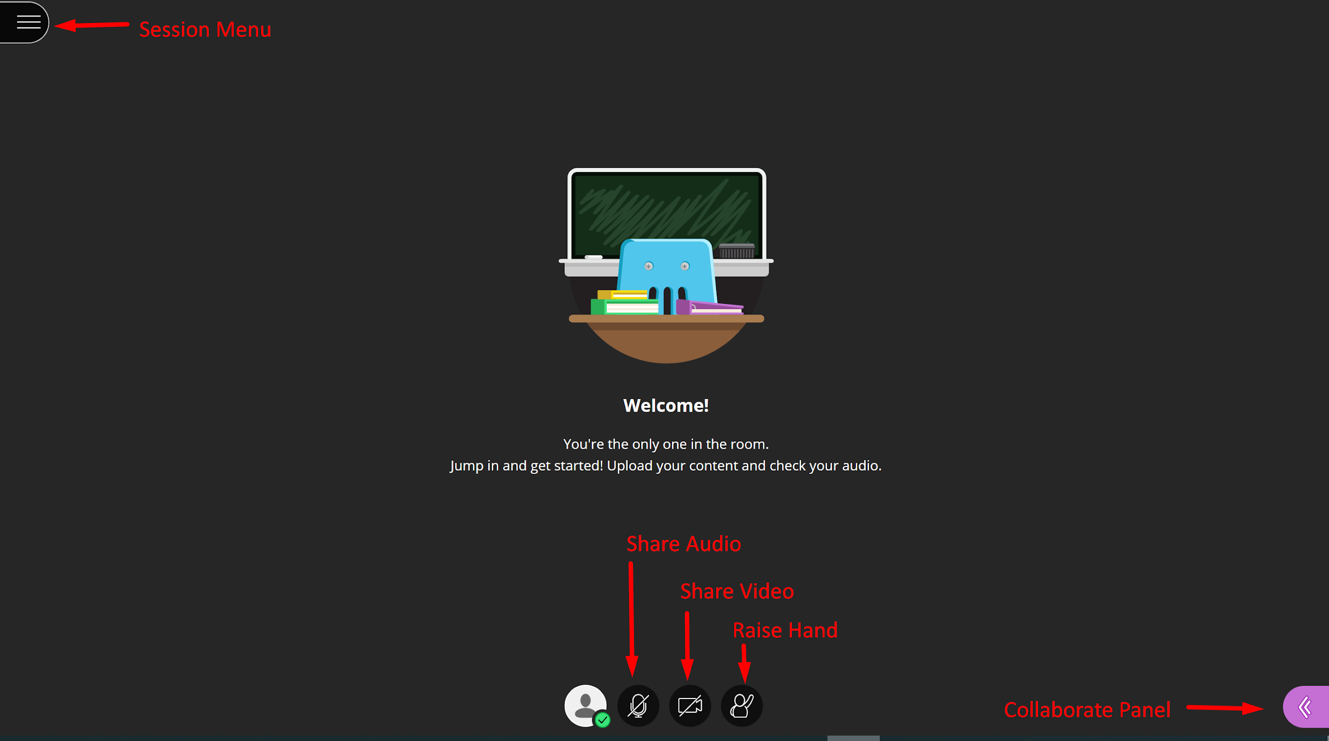

- The tools that are available depend on the permissions set by the moderators.
Tool | Description
 | Open the Session Menu – moderator can start recording, attendees can get help, and leave the session.
 | Share Audio – toggles on/off
 | Share Video – toggles on/off
 | Raise Hand – allows attendees to ask the moderator a question using audio to prevent talking over one another if audio is enabled.
 | Open the Collaborate Panel – access chat, view attendees, share screen, adjust session settings.

- When you enter a session, you will need to Share Audio and open the Collaborate Panel to view attendees and chat.
- Once you are ready to begin, open the Session Menu and select Start Recording.
Session Menu  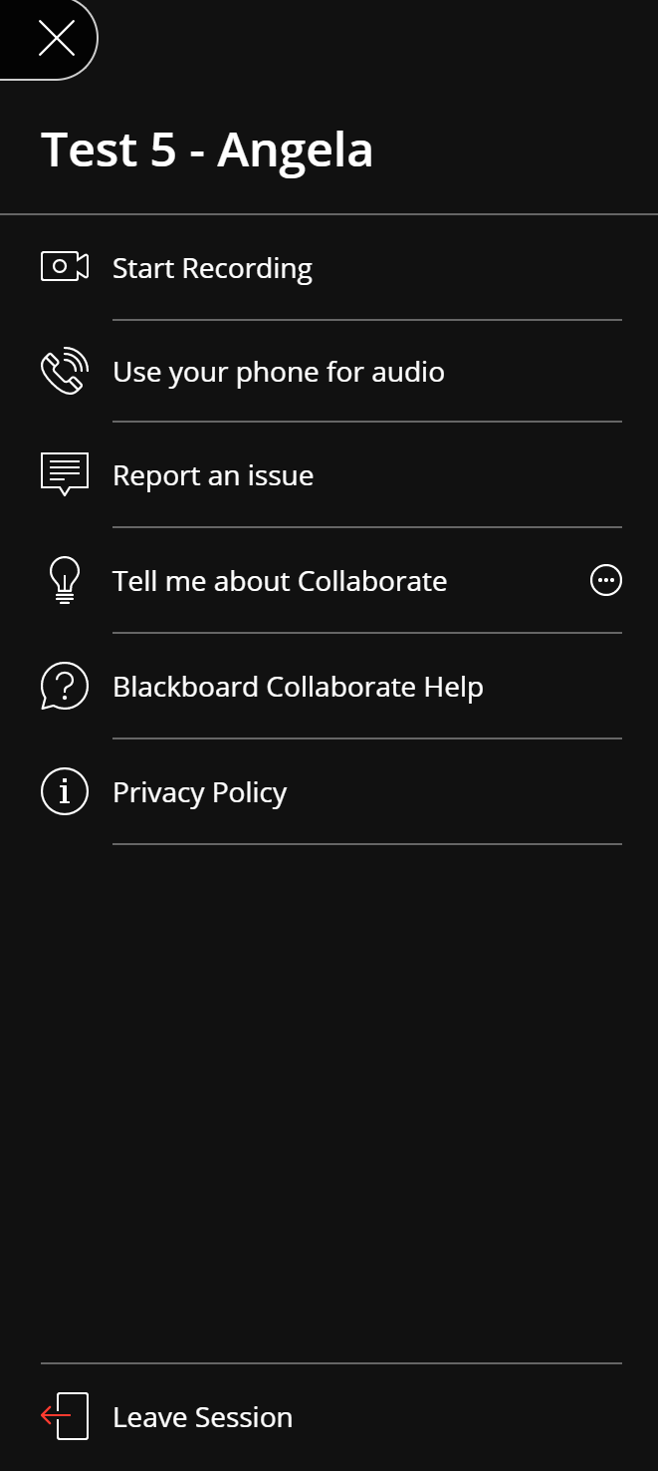 | Collaborate Panel  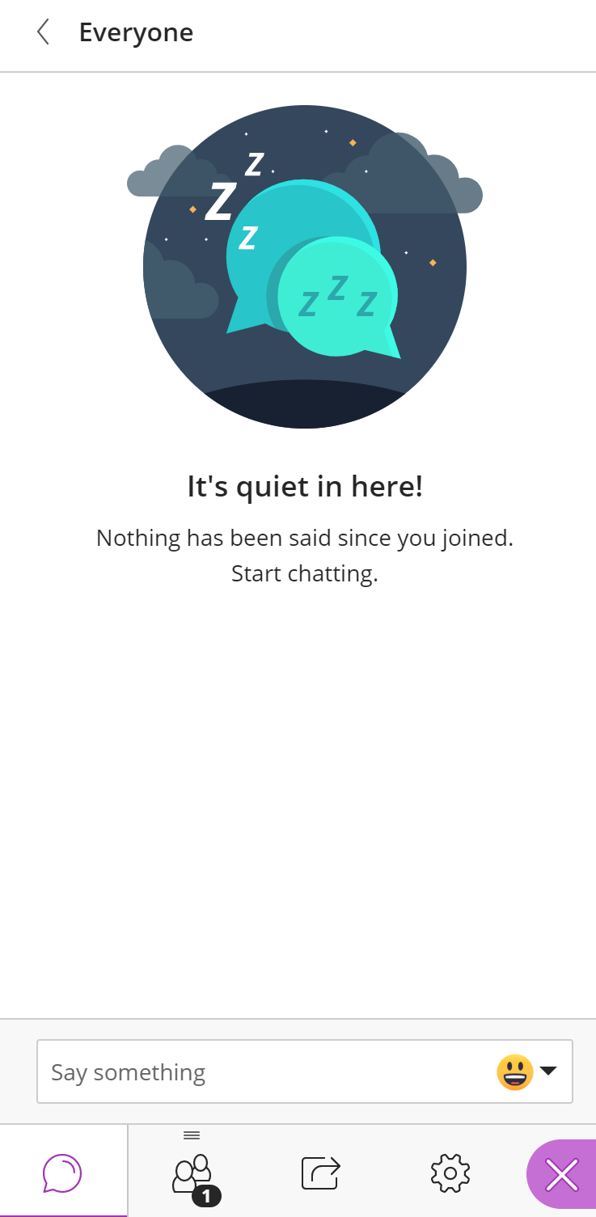

- After you record a session you and your students can view it in the activity. Find the Collaborate activity in your course and select it. All recordings for that activity appear at the bottom of the page. Select the recording to view it.
*Recordings may take 1-2 hours before they appear in Moodle.
