Dates Report Plugin

The Dates Report lets you change the due dates for ALL activities and resources in a course from a single screen!
Activities and Resources that can be updated from the Dates Report include the following:
- Assignment
- Feedback
- File
- Folder
- Forum
- Label
- Page
- Quiz
- URL
*This screen CANNOT be used to change section dates. This should only be done in new courses after the course materials have been imported.

To access the Dates Report from your course:
- Go to the Admin gear, click Reports and then Dates.
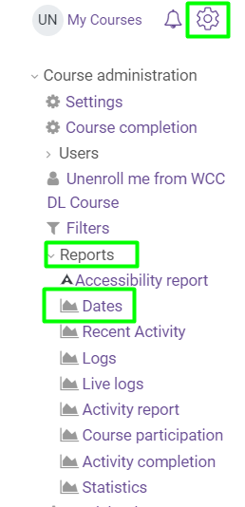
- Click Expand All to show all the dates currently set in the course.
- Update dates.
- Click the Save Changes button

