How to View Course Participants in Moodle

- Course participants can be viewed from the Course Dashboard.
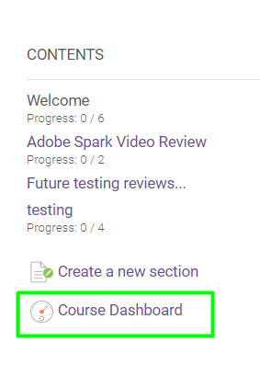

- Click the Participants block.
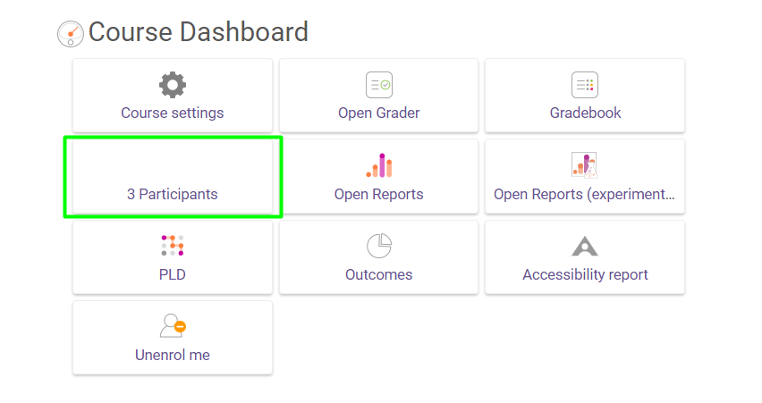

- The default sort order is by student first name; click the Last Name column heading to sort by last name.

- The Status column will let you know if a student is active in your course or not. Students with a Not Current status have been dropped and can no longer access your course.

