How to View Grades for Dropped Students

Access the Gradebook from the Admin gear. Choose Preferences: Grader Report from the drop-down menu.

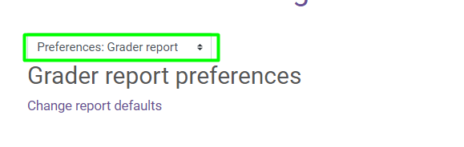

Change the setting for Show only active enrollments to “No”.

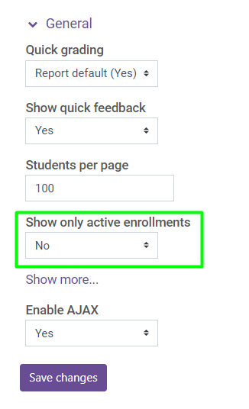

This will show all students in the gradebook so that the instructor can access their course progress and history.

Students that are “not current” will have a “pause” icon next to their name in the “Grader Report”.
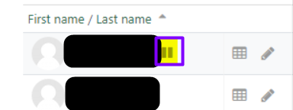

Instructors may turn this feature on or off at their discretion.

