Moodle Student Activity Logs
How to view

You can view every action a student takes in your course through their logs. This is especially helpful if there is a dispute over whether a student completed or even viewed an activity in your course.

To view the logs for an individual student, follow these steps:
- In the course, click the Admin gear.
- Click Reports.
- Click Logs.
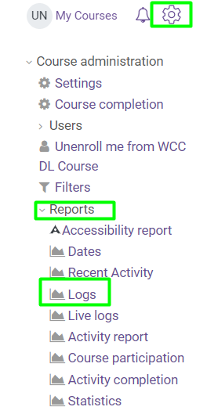
- Select the Participant.
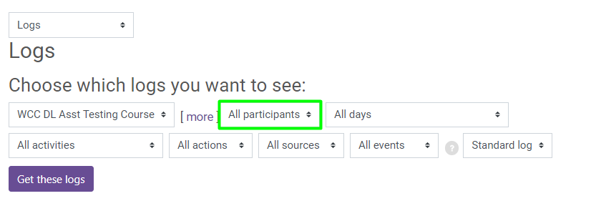
- Click the Get these logs button.

