How to add Respondus Lockdown Browser in Moodle courses

- Log into the course you want to add this feature in and select your course dashboard
**This will have to be completed in each course that you want to use this feature in.**
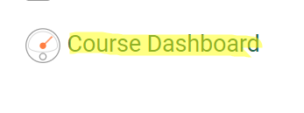
- Select edit blocks
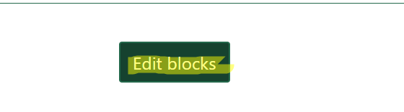
- In the ‘Add a block’ dropdown menu, select Respondus LockDown Browser.
This allows Respondus to show up on your course dashboard as a block just as other blocks do in your course like Quickmail.
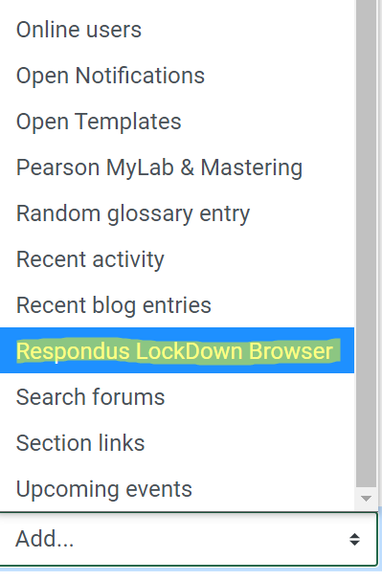
- Once Respondus has been added to your course blocks, select the dashboard under the Respondus block

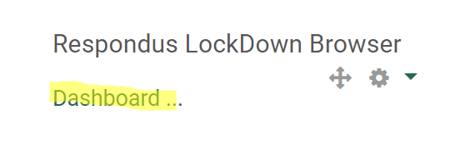
- The dashboard for Respondus will then open with an introduction to LockDown Browser, video tutorials tab, getting started tab, and guides and support for you and your students
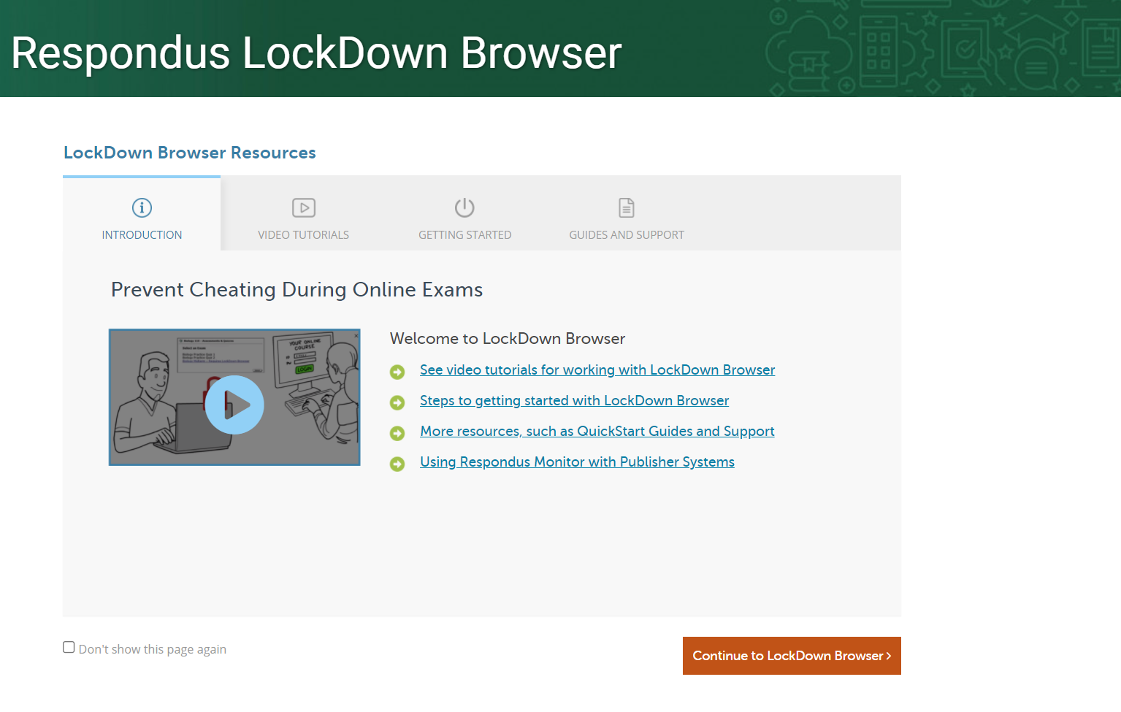
- Once you have reviewed this information and are ready to use the browser on your test/quizzes in your course, select continue to LockDown Browser.
**You can also choose to not show this helpful page again if you would like to continue directly to the Lockdown browser**

