How to enable Respondus LockDown Browser on test/quizzes/exams created in Moodle courses

- After you have added Respondus to your course block in your course, log into the course, and select your course dashboard
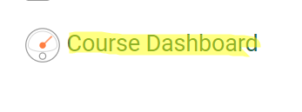

- Select the dashboard for Respondus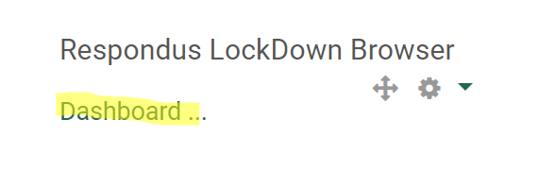
- Select continue to LockDown Browser
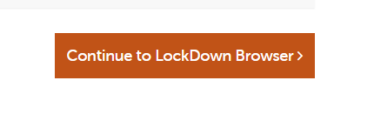
- The quizzes/test/exams will then appear and specify if they are currently required to use LockDown Brower
- To change the requirements on a test, select the dropdown arrow on the quiz and select settings
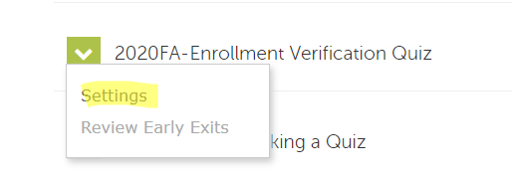
- Select your settings for the quiz/test/exam, expand the advance settings, and select save + close
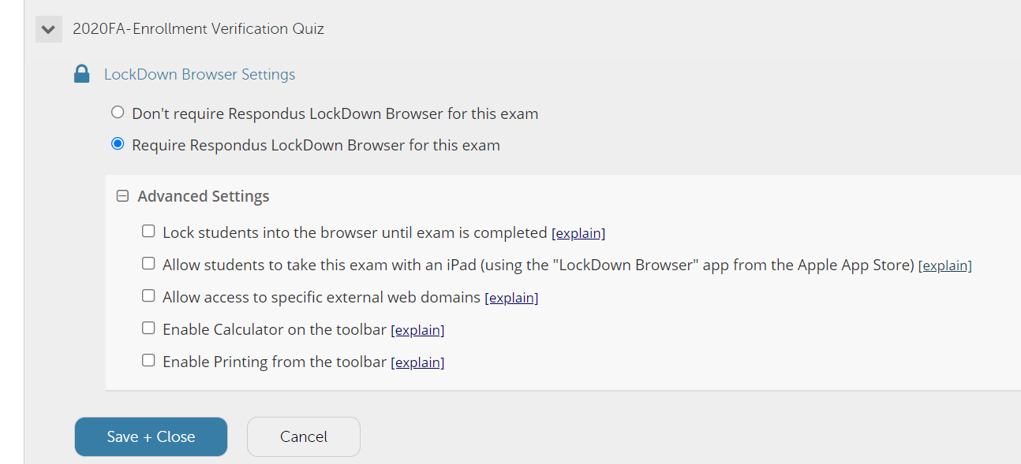

This is how the student’s side will appear when Respondus is required on a test/quiz/exam
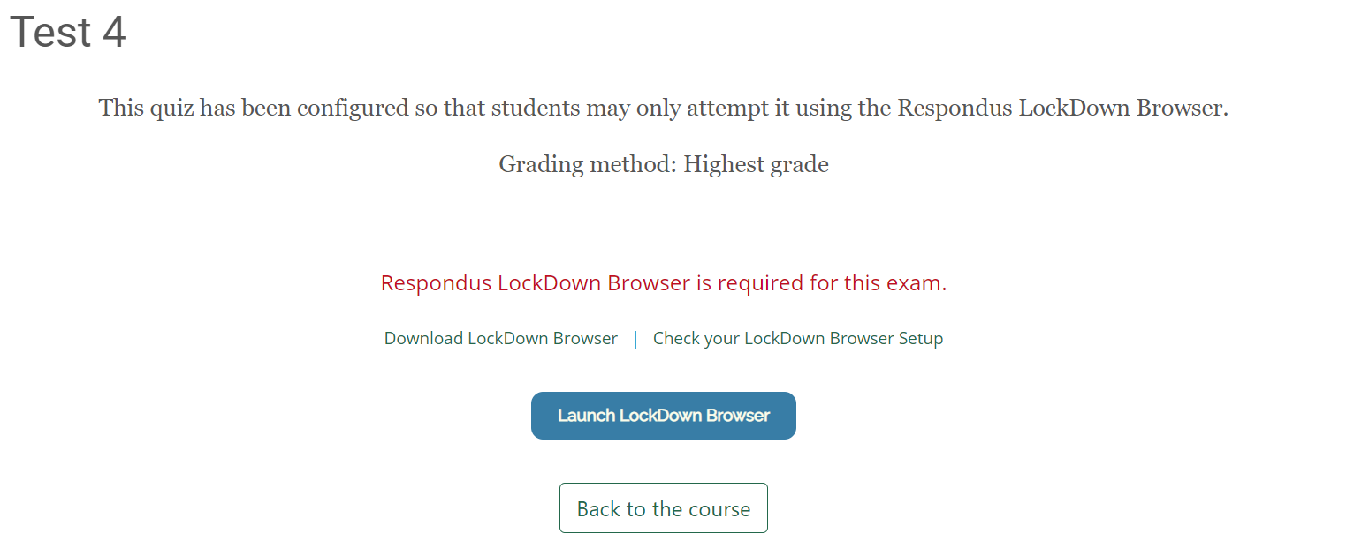
The student will be required to download LockDown Browser or launch the browser if already downloaded.

