How to Hide Sections and Activities in Moodle

Hiding sections in a course is no longer sufficient to prevent student access to activities within that section.

To hide and activities within sections:
1. Click the section you wish to hide and then click the eye on the section title
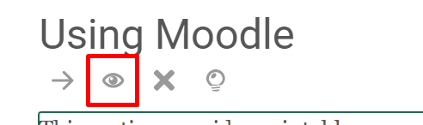
A hidden section will appear with a slant across the eye.
Note -the activities in the hidden section in the course below, the outlined tag indicates that this content is “available but not shown on course page.” 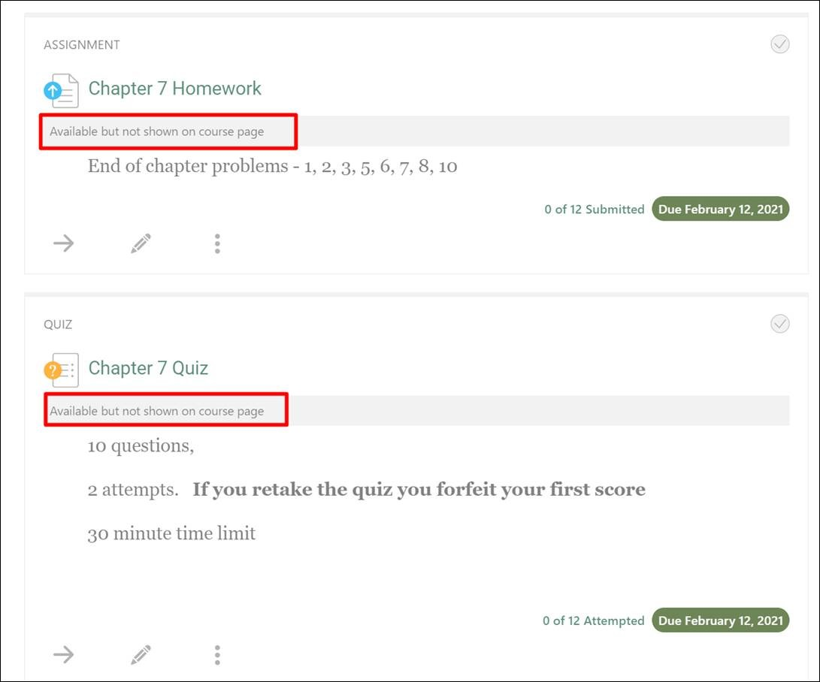
2. Once you have hid the section, go into the section and hide the activities within the section by clicking on the pencil to edit the activity
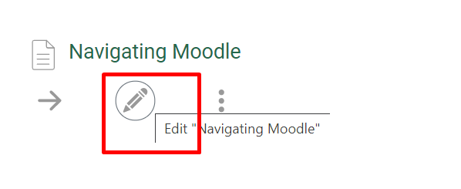
3. Then change the Visibility in each activity in a hidden section to “Hide from students” to prevent student access. 