How to install LockDown Browser as a student

- A course quiz/test/exam in Moodle that requires Respondus LockDown Browser will look like this and will need to be downloaded and installed or launched at the time of the quiz that requires this feature
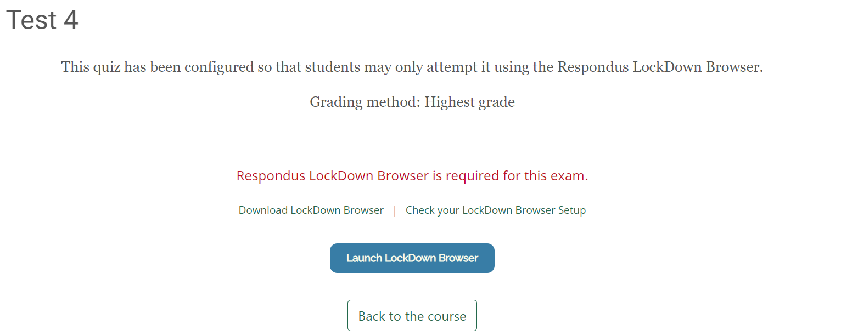
- Select Download LockDown Browser to download if you haven’t previously installed this browser on your computer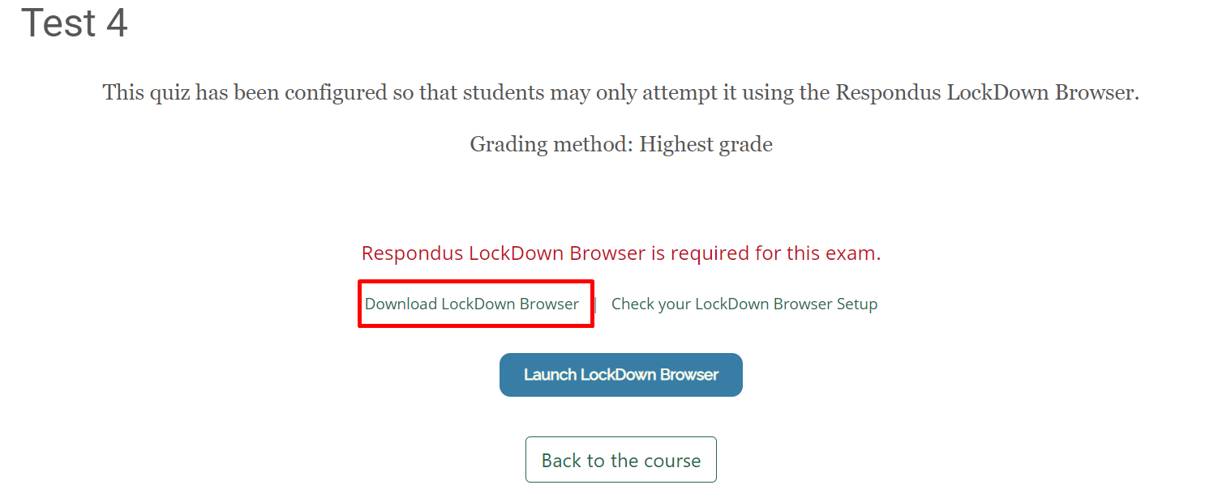
- The following page will open, select install now 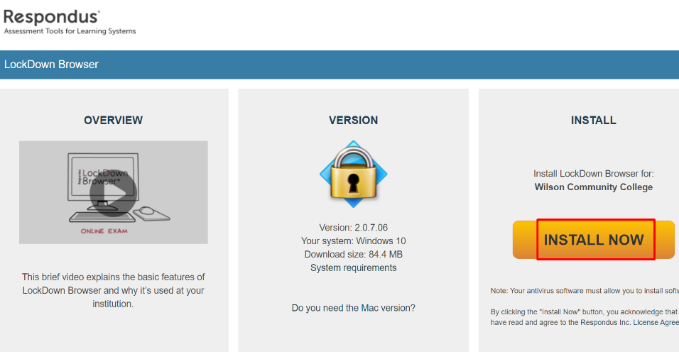
- Installation will then begin and the download will appear at the bottom of your screen
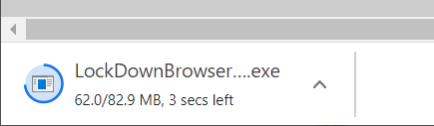
- Follow the steps in the wizard and agree to terms
- After the download and installation is complete, the browser icon will then appear on your computer desktop
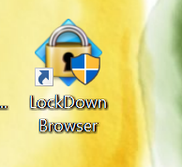
- Now you are ready to begin the quiz in Moodle using Respondus LockDown Browser by launching the browser on your quiz
