Using a Rubric to Grade a Forum

Create a forum using the “Standard forum for general use” forum type.
Setup your forum, following the guidelines in the “Adding Moodle Activities – Forums” how-to guide with the following adjustments:
Whole Forum Grading
- Set the Type to “Point”.
- Set the Grading Method to “Rubric”.
Ratings
- Set to “No ratings”
Any remaining settings are optional.
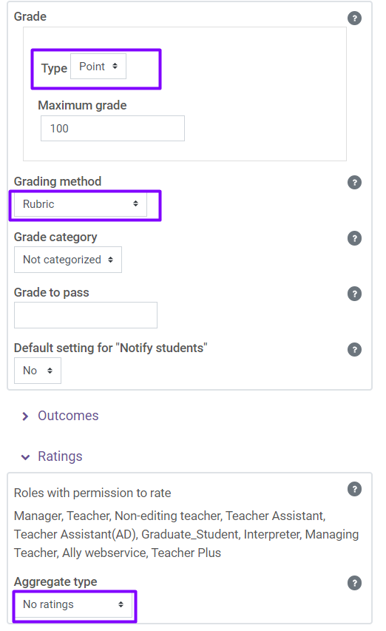
Click the Save and display button to save the settings.
You will get a message that your “advanced grading method is not ready…”.
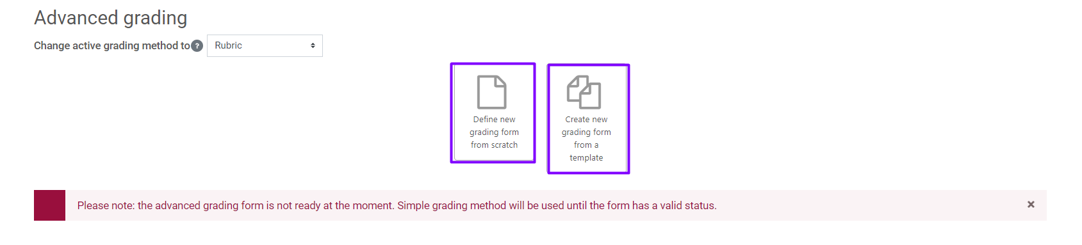
To set up your grading rubric, click “Define new grading form from scratch” or “Create new grading form from a template”.
This will allow you to define your grading criteria.
Tip: include a “0 points” criterion, otherwise you will not be able to give a student a grade of 0.
Additional documentation on setting up and using rubrics for grading can be found at https://docs.moodle.org/400/en/Rubrics

