Using a Rubric to Grade a Forum

Create a forum using the “Standard forum for general use” forum type.
Setup your forum, following the guidelines in the “Adding Moodle Activities – Forums” how-to guide with the following adjustments:
Whole Forum Grading
- Set the Type to “Point”.
- Set the Grading Method to “Rubric”.
Ratings
- Set to “No ratings”
Any remaining settings are optional.
Click the Save and display button to save the settings.
You will get a message that your “advanced grading method is not ready…”.
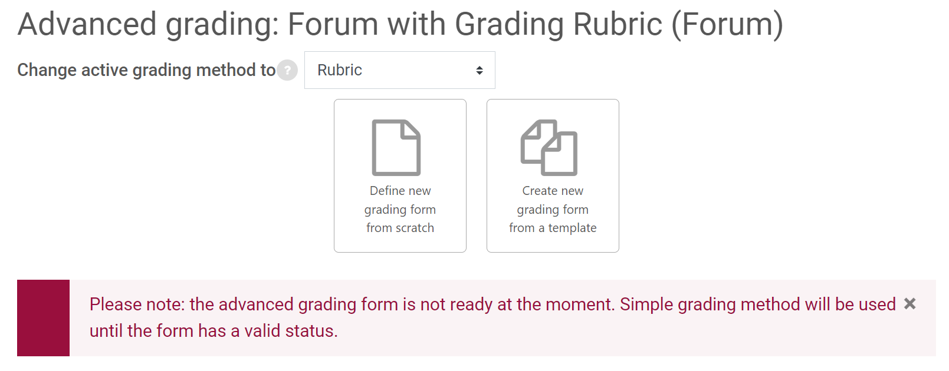
To set up your grading rubric, click the Admin gear in the top right, under Advanced Grading, click “Define Rubric”.
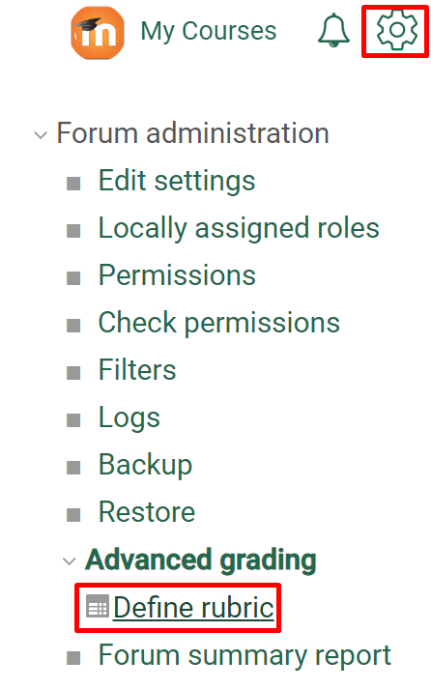
This will allow you to define your grading criteria.
Tip: include a “0 points” criterion, otherwise you will not be able to give a student a grade of 0.
Additional documentation on setting up and using rubrics for grading can be found at https://docs.moodle.org/311/en/Rubrics.

