Use live captions in a Teams meeting

Teams can detect what’s said in a meeting and present real-time captions. Live captions are a preview feature in Microsoft Teams, and they're only available in English (US) for now. Live captions can make your meeting more inclusive to participants who are deaf or hard-of-hearing, people with different levels of language proficiency, and participants in loud places by giving them another way to follow along.
Note: Teams doesn't save captions.
1. Join your Teams meeting by selecting “Join now”
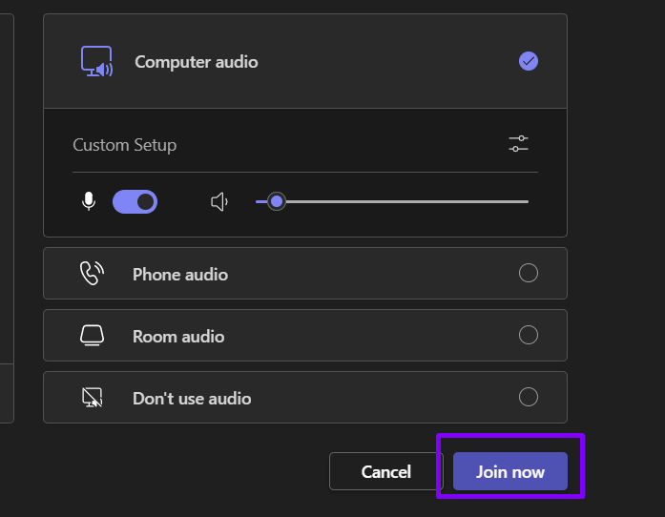
2. To use live captions in a meeting, go to your meeting controls and select More. Then choose Settings and Accessibility.
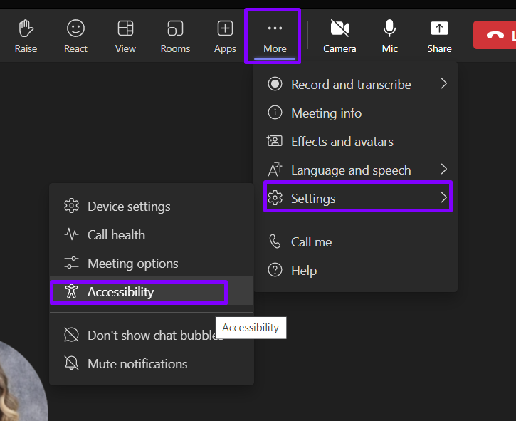
3. Turn on Captions and select your preferred language.
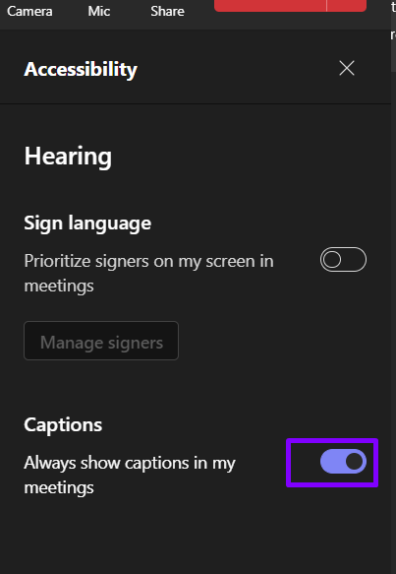
Captions will then appear at the bottom of the meetings screen.
4. To stop using live captions, follow step 2 and Turn off captions.

