Use live captions in a Teams meeting
Teams can detect what’s said in a meeting and present real-time captions. Live captions are a preview feature in Microsoft Teams, and they're only available in English (US) for now. Live captions can make your meeting more inclusive to participants who are deaf or hard-of-hearing, people with different levels of language proficiency, and participants in loud places by giving them another way to follow along.
Note: Teams doesn't save captions.
1. Join your Teams meeting by selecting “Join now”
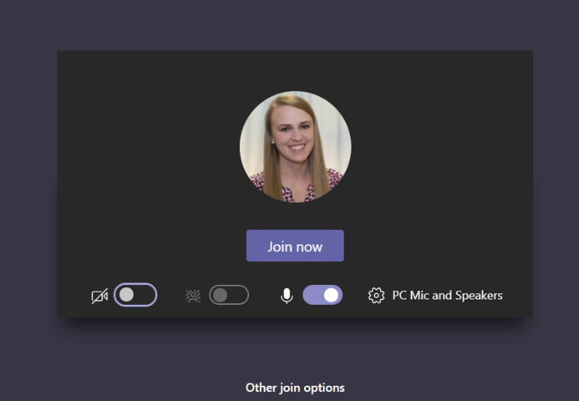
2. To use live captions in a meeting, go to your meeting controls and select “more actions”
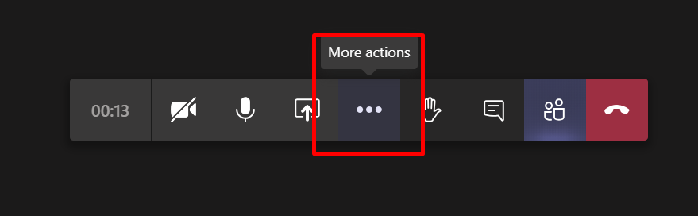
3. Select “Turn on live captions (preview)”
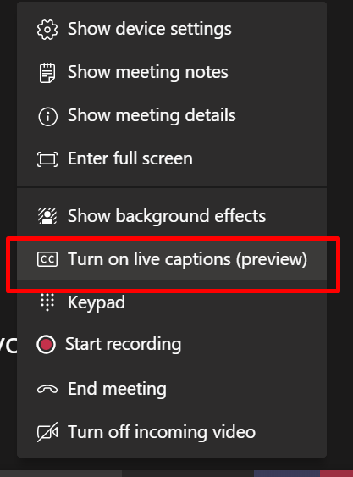
Captions will then appear at the bottom of the meetings screen.
4. To stop using live captions, go to the meeting controls and select “More actions”
5. Select “Turn off live captions (preview)”
