If you get the following message while trying to access a Wilson Community College Google form, it means you are not logged in to your Wilson CC Google account.

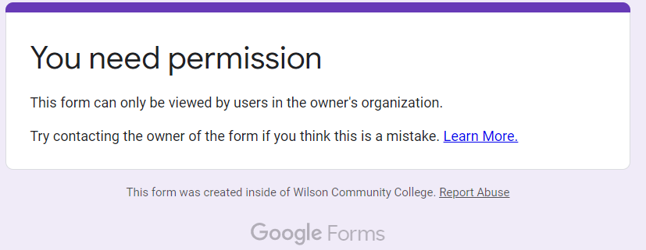

**Logging in to Google**

Go to [www.google.com](http://www.google.com) and check in the top right of the browser window.  If you are not signed in, you should see a blue sign in button like this

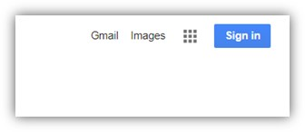

Click on that blue Sign in button and enter your Wilson CC email address **ending in @wilsoncc.edu**

Enter your password when prompted.  It will be the same as what you use to log into your email.

Wilson CC enforces 2-step verification on our Google accounts. You may be sent a text message as part of the 2-step verification process.

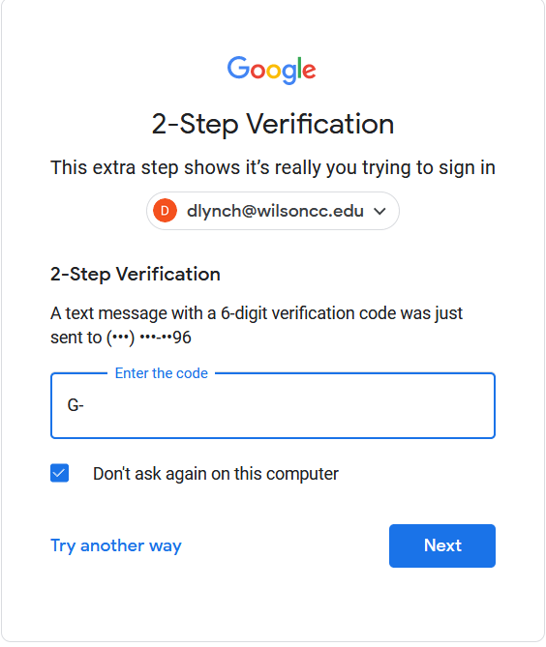

The text message sent from Google will contain the 6 digit number that you will need to enter.

Click Next after entering the code and you should then be logged in.

Once you are logged in, you should see a circle with your first initial in it at the top right of your browser window. It will look like this:

